Cifar10 - reduzido
http://www.cs.toronto.edu/%7Ekriz/cifar.html
/home/hae/deep/tiny_dnn/cifar/meu
[Esta apostila é uma versão reduzida de um documento não disponibilizado.]

The CIFAR-10 dataset consists of 60000 32x32 colour images in 10 classes, with 6000 images per class. There are 50000 training images and 10000 test images.
The dataset is divided into five training batches and one test batch, each with 10000 images. The test batch contains exactly 1000 randomly-selected images from each class. The training batches contain the remaining images in random order, but some training batches may contain more images from one class than another. Between them, the training batches contain exactly 5000 images from each class.
Here are the classes in the dataset, as well as 10 random images from each:
0=airplane |  |  |  |  |  | 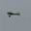 |  |  |  | 
1=automobile |  |  |  |  |  |  |  |  | 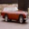 | 
2=bird | 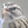 | 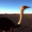 | 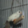 |  | 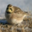 |  | 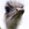 | 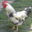 | 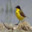 | 
3=cat |  |  | 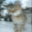 | 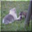 |  |  |  |  |  | 
4=deer |  |  |  | 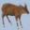 |  |  |  | 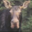 |  | 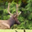
5=dog |  |  |  |  |  |  |  |  |  | 
6=frog |  |  |  |  |  |  |  |  |  | 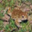
7=horse | 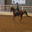 |  |  |  | 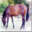 |  | 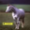 |  |  | 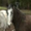
8=ship |  |  |  |  | 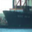 |  |  |  |  | 
9=truck |  | 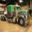 |  |  |  |  |  | 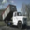 |  | 
The classes are completely mutually exclusive. There is no overlap between automobiles and trucks. "Automobile" includes sedans, SUVs, things of that sort. "Truck" includes only big trucks. Neither includes pickup trucks.
data_batch_1.bin
data_batch_2.bin
data_batch_3.bin
data_batch_4.bin
data_batch_5.bin
test_batch.bin

Os dados estão organizados em sequências de blocos de 3073 bytes, cada bloco representando uma imagem:
32x32 bytes para pixels red.
32x32 bytes para pixels green.
32x32 bytes para pixels blue.
1 byte para rótulo (número de 0 a 9).

Cekeikon possui a função de leitura de Cifar10:
void leCifar10(const string& nomearq,
vector< Mat_<COR> >& images, vector<BYTE>& rotulos);

Tiny_dnn possui outra função de leitura:
vector<vec_t> ax;
vector<label_t> ay;
parse_cifar10("/home/hae/haebase/cifar10/data_batch_1.bin",
&ax, &ay, 0.0, 1.0, 0, 0);

Keras possui a função de leitura:
(ax, ay), (qx, qy) = cifar10.load_data()

Taxa de acerto de ser humano: aproximadamente 94%.
https://karpathy.github.io/2011/04/27/manually-classifying-cifar10/

================================

Meus testes (taxas de acerto):

1-NN (OpenCV/C++): 15%
SVM (OpenCV/C++): 11%
DTree (OpenCV/C++): 13%
Rede neural denso (tiny-dnn/C++): 53%
LeNet (tiny-dnn/C++): 70%
LeNet com data augmentatio (tiny-dnn/C++): 72%
LeNet (Keras/Python): 72%
LeNet com data augmentation (Keras/Python): 75%

ResNet simplificado com menos layers (Keras/Python): 80%
Resnet com menos layers e data augmentation (Keras/Python): 87%
ResNet original (Keras/Python): 92%
Inspirado em Inception (Keras/Python): 90%

============================

Os "recordes" de classificação Cifar-10 estão em:
https://benchmarks.ai/cifar-10
Algumas taxas de acerto são:

Efficient Training of Giant Neural Networks using Pipeline Parallelism (Nov 2018, arXiv 2018) 99.0%
A Survey on Neural Architecture Search (May 2019, arXiv 2019) 98.67%
AutoAugment: Learning Augmentation Policies from Data (May 2018, arXiv 2018) 98.52%
...
Fractional Max-Pooling (Dec 2014) 96.53%
...
Deep Residual Learning for Image Recognition (Dec 2015) 93.57%
...

//visual1.cpp
//Gera imagem com 100x100 imagens de Cifar10
#include <cektiny.h>
int main() {
vector<vec_t> ax;
vector<label_t> ay;
parse_cifar10("/home/hae/haebase/cifar10/data_batch_1.bin", &ax, &ay, 0.0, 1.0, 0, 0);
Mat_<COR> v(100*44, 100*44, COR(192,192,192));
for (unsigned l1=0; l1<100; l1++)
for (unsigned c1=0; c1<100; c1++) {
Mat_<COR> AX;
converte(ax[l1*100+c1],AX,32,32);
for (unsigned l2=0; l2<32; l2++)
for (unsigned c2=0; c2<32; c2++) {
v(l1*44+l2+12,c1*44+c2+12)=AX(l2,c2);
}
}
for (unsigned l1=0; l1<100; l1++)
for (unsigned c1=0; c1<100; c1++) {
putTxt(v,l1*44,c1*44,to_string(ay[l1*100+c1]));
}
imp(v,"visual1.png");
}

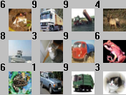

O programa-exemplo CNN do tiny-dnn atinge taxa de acerto de 69,44% após 30 epochs, usando parâmetros padrões. Cada epoch demora 127s.

/*
train.cpp
Copyright (c) 2013, Taiga Nomi and the respective contributors
All rights reserved.
Use of this source code is governed by a BSD-style license that can be found
in the LICENSE file.
*/
#include <cstdlib>
#include <iostream>
#include <vector>

#include "tiny_dnn/tiny_dnn.h"

template <typename N>
void construct_net(N &nn, tiny_dnn::core::backend_t backend_type) {
using conv = tiny_dnn::convolutional_layer;
using pool = tiny_dnn::max_pooling_layer;
using fc = tiny_dnn::fully_connected_layer;
using relu = tiny_dnn::relu_layer;
using softmax = tiny_dnn::softmax_layer;

const size_t n_fmaps = 32; // number of feature maps for upper layer
const size_t n_fmaps2 = 64; // number of feature maps for lower layer
const size_t n_fc = 64; // number of hidden units in fc layer

nn << conv(32, 32, 5, 3, n_fmaps, tiny_dnn::padding::same, true, 1, 1,
backend_type) // C1
<< pool(32, 32, n_fmaps, 2, backend_type) // P2
<< relu() // activation
<< conv(16, 16, 5, n_fmaps, n_fmaps, tiny_dnn::padding::same, true, 1, 1,
backend_type) // C3
<< pool(16, 16, n_fmaps, 2, backend_type) // P4
<< relu() // activation
<< conv(8, 8, 5, n_fmaps, n_fmaps2, tiny_dnn::padding::same, true, 1, 1,
backend_type) // C5
<< pool(8, 8, n_fmaps2, 2, backend_type) // P6
<< relu() // activation
<< fc(4 * 4 * n_fmaps2, n_fc, true, backend_type) // FC7
<< relu() // activation
<< fc(n_fc, 10, true, backend_type) << softmax(10); // FC10
}

void train_cifar10(std::string data_dir_path,
double learning_rate,
const int n_train_epochs,
const int n_minibatch,
tiny_dnn::core::backend_t backend_type,
std::ostream &log) {
// specify loss-function and learning strategy
tiny_dnn::network<tiny_dnn::sequential> nn;
tiny_dnn::adam optimizer;

construct_net(nn, backend_type);

std::cout << "load models..." << std::endl;

// load cifar dataset
std::vector<tiny_dnn::label_t> train_labels, test_labels;
std::vector<tiny_dnn::vec_t> train_images, test_images;

for (int i = 1; i <= 5; i++) {
parse_cifar10(data_dir_path + "/data_batch_" + std::to_string(i) + ".bin",
&train_images, &train_labels, -1.0, 1.0, 0, 0);
}

parse_cifar10(data_dir_path + "/test_batch.bin", &test_images, &test_labels,
-1.0, 1.0, 0, 0);

std::cout << "start learning" << std::endl;

tiny_dnn::progress_display disp(train_images.size());
tiny_dnn::timer t;

optimizer.alpha *=
static_cast<tiny_dnn::float_t>(sqrt(n_minibatch) * learning_rate);

int epoch = 1;
// create callback
auto on_enumerate_epoch = [&]() {
std::cout << "Epoch " << epoch << "/" << n_train_epochs << " finished. "
<< t.elapsed() << "s elapsed." << std::endl;
++epoch;
tiny_dnn::result res = nn.test(test_images, test_labels);
log << res.num_success << "/" << res.num_total << std::endl;

disp.restart(train_images.size());
t.restart();
};

auto on_enumerate_minibatch = [&]() { disp += n_minibatch; };

// training
nn.train<tiny_dnn::cross_entropy>(optimizer, train_images, train_labels,
n_minibatch, n_train_epochs,
on_enumerate_minibatch, on_enumerate_epoch);

std::cout << "end training." << std::endl;

// test and show results
nn.test(test_images, test_labels).print_detail(std::cout);
// save networks
std::ofstream ofs("cifar-weights");
ofs << nn;
}

static tiny_dnn::core::backend_t parse_backend_name(const std::string &name) {
const std::array<const std::string, 5> names = {
"internal", "nnpack", "libdnn", "avx", "opencl",
};
for (size_t i = 0; i < names.size(); ++i) {
if (name.compare(names[i]) == 0) {
return static_cast<tiny_dnn::core::backend_t>(i);
}
}
return tiny_dnn::core::default_engine();
}

static void usage(const char *argv0) {
std::cout << "Usage: " << argv0 << " --data_path path_to_dataset_folder"
<< " --learning_rate 0.01"
<< " --epochs 30"
<< " --minibatch_size 10"
<< " --backend_type internal" << std::endl;
}

int main(int argc, char **argv) {
double learning_rate = 0.01;
int epochs = 30;
std::string data_path = "";
int minibatch_size = 10;
tiny_dnn::core::backend_t backend_type = tiny_dnn::core::default_engine();

if (argc == 2) {
std::string argname(argv[1]);
if (argname == "--help" || argname == "-h") {
usage(argv[0]);
return 0;
}
}
for (int count = 1; count + 1 < argc; count += 2) {
std::string argname(argv[count]);
if (argname == "--learning_rate") {
learning_rate = atof(argv[count + 1]);
} else if (argname == "--epochs") {
epochs = atoi(argv[count + 1]);
} else if (argname == "--minibatch_size") {
minibatch_size = atoi(argv[count + 1]);
} else if (argname == "--backend_type") {
backend_type = parse_backend_name(argv[count + 1]);
} else if (argname == "--data_path") {
data_path = std::string(argv[count + 1]);
} else {
std::cerr << "Invalid parameter specified - \"" << argname << "\""
<< std::endl;
usage(argv[0]);
return -1;
}
}
if (data_path == "") {
std::cerr << "Data path not specified." << std::endl;
usage(argv[0]);
return -1;
}
if (learning_rate <= 0) {
std::cerr
<< "Invalid learning rate. The learning rate must be greater than 0."
<< std::endl;
return -1;
}
if (epochs <= 0) {
std::cerr << "Invalid number of epochs. The number of epochs must be "
"greater than 0."
<< std::endl;
return -1;
}
if (minibatch_size <= 0 || minibatch_size > 50000) {
std::cerr
<< "Invalid minibatch size. The minibatch size must be greater than 0"
" and less than dataset size (50000)."
<< std::endl;
return -1;
}
std::cout << "Running with the following parameters:" << std::endl
<< "Data path: " << data_path << std::endl
<< "Learning rate: " << learning_rate << std::endl
<< "Minibatch size: " << minibatch_size << std::endl
<< "Number of epochs: " << epochs << std::endl
<< "Backend type: " << backend_type << std::endl
<< std::endl;
try {
train_cifar10(data_path, learning_rate, epochs, minibatch_size,
backend_type, std::cout);
} catch (tiny_dnn::nn_error &err) {
std::cerr << "Exception: " << err.what() << std::endl;
}
}

Rodando train.cpp:

Epoch 1/30 finished. 82.7936s elapsed. 4572/10000
Epoch 2/30 finished. 80.7361s elapsed. 5008/10000
Epoch 3/30 finished. 82.3716s elapsed. 5277/10000
Epoch 9/30 finished. 80.2583s elapsed. 6192/10000
...
Epoch 30/30. 69.5%

//extrai.cpp
//extrai 10 primeiras imagens-testes de cifar10
#include <cektiny.h>

int main() {
vector<vec_t> qx;
vector<label_t> qy;
parse_cifar10("/home/hae/haebase/cifar10/test_batch.bin", &qx, &qy, 0.0, 1.0, 0, 0);

for (unsigned i=0; i<10; i++) {
Mat_<COR> QX;
converte(qx[i],QX,32,32);
imp(QX, format("teste%d-%d.ppm",i,qy[i]));
}
}

/*
teste.cpp - mudei o nome de test.cpp para teste.cpp para nao dar conflito com comando test
Copyright (c) 2013, Taiga Nomi and the respective contributors
All rights reserved.

Use of this source code is governed by a BSD-style license that can be found
in the LICENSE file.
*/
#include <iostream>

#include "tiny_dnn/tiny_dnn.h"

// rescale output to 0-100
template <typename Activation>
double rescale(double x) {
Activation a(1);
return 100.0 * (x - a.scale().first) / (a.scale().second - a.scale().first);
}

void convert_image(const std::string &imagefilename,
double minv,
double maxv,
int w,
int h,
tiny_dnn::vec_t &data) {
tiny_dnn::image<> img(imagefilename, tiny_dnn::image_type::rgb);
tiny_dnn::image<> resized = resize_image(img, w, h);
data.resize(resized.width() * resized.height() * resized.depth());
for (size_t c = 0; c < resized.depth(); ++c) {
for (size_t y = 0; y < resized.height(); ++y) {
for (size_t x = 0; x < resized.width(); ++x) {
data[c * resized.width() * resized.height() + y * resized.width() + x] =
(maxv - minv) * (resized[y * resized.width() + x + c]) / 255.0 + minv;
}
}
}
}

template <typename N>
void construct_net(N &nn) {
using conv = tiny_dnn::convolutional_layer;
using pool = tiny_dnn::max_pooling_layer;
using fc = tiny_dnn::fully_connected_layer;
using relu = tiny_dnn::relu_layer;
using softmax = tiny_dnn::softmax_layer;

const size_t n_fmaps = 32; ///< number of feature maps for upper layer
const size_t n_fmaps2 = 64; ///< number of feature maps for lower layer
const size_t n_fc = 64; ///< number of hidden units in fully-connected layer

nn << conv(32, 32, 5, 3, n_fmaps, tiny_dnn::padding::same) // C1
<< pool(32, 32, n_fmaps, 2) // P2
<< relu(16, 16, n_fmaps) // activation
<< conv(16, 16, 5, n_fmaps, n_fmaps, tiny_dnn::padding::same) // C3
<< pool(16, 16, n_fmaps, 2) // P4
<< relu(8, 8, n_fmaps) // activation
<< conv(8, 8, 5, n_fmaps, n_fmaps2, tiny_dnn::padding::same) // C5
<< pool(8, 8, n_fmaps2, 2) // P6
<< relu(4, 4, n_fmaps2) // activation
<< fc(4 * 4 * n_fmaps2, n_fc) // FC7
<< fc(n_fc, 10) << softmax(10); // FC10
}

void recognize(const std::string &dictionary, const std::string &src_filename) {
tiny_dnn::network<tiny_dnn::sequential> nn;

construct_net(nn);

// load nets
std::ifstream ifs(dictionary.c_str());
ifs >> nn;

// convert imagefile to vec_t
tiny_dnn::vec_t data;
convert_image(src_filename, -1.0, 1.0, 32, 32, data);

// recognize
auto res = nn.predict(data);
std::vector<std::pair<double, int>> scores;

// sort & print top-3
for (int i = 0; i < 10; i++)
scores.emplace_back(rescale<tiny_dnn::tanh_layer>(res[i]), i);

sort(scores.begin(), scores.end(), std::greater<std::pair<double, int>>());

for (int i = 0; i < 3; i++)
std::cout << scores[i].second << "," << scores[i].first << std::endl;
}

int main(int argc, char **argv) {
if (argc != 2) {
std::cout << "please specify image file\n";
return 0;
}
recognize("cifar-weights", argv[1]);
}

$ teste teste0-3.ppm
3,73.1406
8,65.3283
2,59.1444
Classificando teste0-3.ppm (cuja classificacao correta é classe 3), deu maior chance (73) de ser de classe 3.

$ teste teste1-8.ppm
8,109.325
1,52.2745
0,50.4843
Classificando teste1-8.ppm (cuja classificacao correta é classe 8), deu maior chance (109) de ser de classe 8.

Tentando resolver Cifar10 sem usar rede neural convolucional:

//knn.cpp - resolve Cifar-10 usando 1-nn - 2017
#include <cektiny.h>
int main(int argc, char **argv) {
string data_dir_path="/home/hae/haebase/cifar10";
cout << "load models..." << endl;
vector<label_t> train_labels, test_labels;
vector<vec_t> train_images, test_images;
for (int i=1; i<=5; i++) {
parse_cifar10(data_dir_path + "/data_batch_" + std::to_string(i) + ".bin",
&train_images, &train_labels, 0.0, 1.0, 0, 0);
}
parse_cifar10(data_dir_path + "/test_batch.bin", &test_images, &test_labels,
0.0, 1.0, 0, 0);
Mat_<COR> a;
//converte(train_images[0],a,32,32);
//mostra(a);
Mat_<FLT> ax(train_images.size(),32), ay(train_labels.size(),1);
for (int l=0; l<ax.rows; l++) {
for (int c=0; c<ax.cols; c++)
ax(l,c)=train_images[l][c];
ay(l)=train_labels[l];
}
Mat_<FLT> qx(test_images.size(),32), qy(test_labels.size(),1), qp(test_labels.size(),1);
for (int l=0; l<qx.rows; l++) {
for (int c=0; c<qx.cols; c++)
qx(l,c)=test_images[l][c];
qy(l)=test_labels[l];
}
cout << "processing..." << endl;
CvKNearest ind(ax,ay,Mat(),false,1);
ind.find_nearest(qx, 1, &qp); //***
int erros=0;
for (int l=0; l<qx.rows; l++)
if (qy(l)!=qp(l)) erros++;
printf("Erros=%10.2f%%\n",100.0*erros/qx.rows);
}

knn: Erros= 84.57% (acuracidade = 15,43%)
Tempo gasto 4.5 segundos

Trocando a linha *** por:
for (int l=0; l<qx.rows; l++)
qp(l)=ind.find_nearest(qx.row(l), 1);
Erros= 84.57%
Tempo gasto 25 segundos

//svm.cpp - resolve Cifar-10 usando SVM - 2017
#include <cektiny.h>

int main(int argc, char **argv) {
string data_dir_path="/home/hae/haebase/cifar10";

cout << "load models..." << endl;
vector<label_t> train_labels, test_labels;
vector<vec_t> train_images, test_images;
for (int i=1; i<=5; i++) {
parse_cifar10(data_dir_path + "/data_batch_" + std::to_string(i) + ".bin",
&train_images, &train_labels, -1.0, 1.0, 0, 0);
}
parse_cifar10(data_dir_path + "/test_batch.bin", &test_images, &test_labels,
0.0, 1.0, 0, 0);

Mat_<COR> a;
//converte(train_images[0],a,32,32);
//mostra(a);

Mat_<FLT> ax(train_images.size(),32), ay(train_labels.size(),1);
for (int l=0; l<ax.rows; l++) {
for (int c=0; c<ax.cols; c++)
ax(l,c)=train_images[l][c];
ay(l)=train_labels[l];
}

Mat_<FLT> qx(test_images.size(),32), qy(test_labels.size(),1), qp(test_labels.size(),1);
for (int l=0; l<qx.rows; l++) {
for (int c=0; c<qx.cols; c++)
qx(l,c)=test_images[l][c];
qy(l)=test_labels[l];
}

cout << "processing..." << endl;
TimePoint t1=timePoint();
CvSVM ind;
ind.train(ax,ay);
TimePoint t2=timePoint();
for (int l=0; l<qy.rows; l++) {
qp(l)=ind.predict(qx.row(l));
}
TimePoint t3=timePoint();

int erros=0;
for (int l=0; l<qx.rows; l++)
if (qy(l)!=qp(l)) erros++;
printf("Erros=%10.2f%%\n",100.0*erros/qx.rows);

double d1=timeSpan(t1,t2);
double d2=timeSpan(t2,t3);
printf("Treino %fs\n",d1);
printf("Teste %fs\n",d2);
}

SVM: Erros= 88.83% Acuracidade=11,17%
Treino 33.889474s
Teste 24.341276s

//dtree.cpp - resolve Cifar-10 usando dtree - 2017
#include <cektiny.h>
int main(int argc, char **argv) {
string data_dir_path="/home/hae/haebase/cifar10";
cout << "load models..." << endl;
vector<label_t> train_labels, test_labels;
vector<vec_t> train_images, test_images;
for (int i=1; i<=5; i++) {
parse_cifar10(data_dir_path + "/data_batch_" + std::to_string(i) + ".bin",
&train_images, &train_labels, 0.0, 1.0, 0, 0);
}
parse_cifar10(data_dir_path + "/test_batch.bin", &test_images, &test_labels,
0.0, 1.0, 0, 0);
Mat_<COR> a;
//converte(train_images[0],a,32,32);
//mostra(a);
Mat_<FLT> ax(train_images.size(),32), ay(train_labels.size(),1);
for (int l=0; l<ax.rows; l++) {
for (int c=0; c<ax.cols; c++)
ax(l,c)=train_images[l][c];
ay(l)=train_labels[l];
}
Mat_<FLT> qx(test_images.size(),32), qy(test_labels.size(),1), qp(test_labels.size(),1);
for (int l=0; l<qx.rows; l++) {
for (int c=0; c<qx.cols; c++)
qx(l,c)=test_images[l][c];
qy(l)=test_labels[l];
}
cout << "processing..." << endl;
CvDTree ind;
ind.train(ax,CV_ROW_SAMPLE,ay);
for (int l=0; l<qy.rows; l++) {
qp(l)=ind.predict(qx.row(l))->value;
}
int erros=0;
for (int l=0; l<qx.rows; l++)
if (qy(l)!=qp(l)) erros++;
printf("Erros=%10.2f%%\n",100.0*erros/qx.rows);
}

DTREE: Erro: 86.53% Acuracidade=13,47%
Tempo: 1.729s

//fulcon1.cpp - resolve Cifar-10 usando rede neural fullly-connected - 2017
//Valores de entrada vao de -1 a +1
#include <cektiny.h>
int main(int argc, char **argv) {
string data_dir_path="/home/hae/haebase/cifar10";
cout << "load models..." << endl;
vector<label_t> train_labels, test_labels;
vector<vec_t> train_images, test_images;
for (int i=1; i<=5; i++) {
parse_cifar10(data_dir_path + "/data_batch_" + std::to_string(i) + ".bin",
&train_images, &train_labels, -1.0, 1.0, 0, 0);
}
parse_cifar10(data_dir_path + "/test_batch.bin", &test_images, &test_labels,
-1.0, 1.0, 0, 0);
int n_train_epochs=30;
int n_minibatch=10;
network<sequential> net;
net << fc(3 * 32 * 32, 400) << relu()
<< fc(400, 10) << sigmoid();
adagrad optimizer;
cout << "start training" << endl;
progress_display disp(train_images.size());
timer t;
int epoch = 1;
// create callback
auto on_enumerate_epoch = [&]() {
cout << "Epoch " << epoch << "/" << n_train_epochs << " finished. "
<< t.elapsed() << "s elapsed." << endl;
++epoch;
result res = net.test(test_images, test_labels);
cout << res.num_success << "/" << res.num_total << endl;
disp.restart(train_images.size());
t.restart();
};
auto on_enumerate_minibatch = [&]() { disp += n_minibatch; };
// training
net.train<mse>(optimizer, train_images, train_labels, n_minibatch,
n_train_epochs, on_enumerate_minibatch, on_enumerate_epoch);
cout << "end training." << endl;
}

Epoch 1/30 finished. 110.662s elapsed. 2660/10000
Epoch 30/30 finished. 137.472s elapsed. 5289/10000

Rede neural convencional, com 47% de erro (acuracidade 53%), foi o método que melhor funcionou (excluindo rede neural convolucional)!

Funciona melhor levando preto para -1 e branco para +1 (do que 0 e 1).

Usando rede neural convolucional:

//convol2.cpp - resolve Cifar-10 usando rede neural convolucional - 2017
//Valores de entrada vao de -1 a +1
//Tem sigmoide no fim (que provavelmente não precisa)
#include <cektiny.h>
int main(int argc, char **argv) {
string data_dir_path="/home/hae/haebase/cifar10";
cout << "load models..." << endl;
vector<label_t> train_labels, test_labels;
vector<vec_t> train_images, test_images;
for (int i=1; i<=5; i++) {
parse_cifar10(data_dir_path + "/data_batch_" + std::to_string(i) + ".bin",
&train_images, &train_labels, -1.0, 1.0, 0, 0);
}
parse_cifar10(data_dir_path + "/test_batch.bin", &test_images, &test_labels,
-1.0, 1.0, 0, 0);
int n_train_epochs=30;
int n_minibatch=10;
network<sequential> net;
const size_t n_fmaps = 32; // number of feature maps for upper layer
const size_t n_fc = 2*64; // number of hidden units in fc layer
net << conv(32, 32, 5, 3, n_fmaps) // C1
<< max_pool(28, 28, n_fmaps, 2) // P2
<< relu() // activation
<< conv(14, 14, 5, n_fmaps, n_fmaps) // C3
<< max_pool(10, 10, n_fmaps, 2) // P4
<< relu() // activation
<< fc(5 * 5 * n_fmaps, n_fc) // FC7
<< relu() // activation
<< fc(n_fc, 10) << sigmoid(); // FC10
adagrad optimizer;
cout << "start training" << endl;
progress_display disp(train_images.size());
timer t;
int epoch = 1;
// create callback
auto on_enumerate_epoch = [&]() {
cout << "Epoch " << epoch << "/" << n_train_epochs << " finished. "
<< t.elapsed() << "s elapsed. ";
++epoch;
result res = net.test(test_images, test_labels);
cout << res.num_success << "/" << res.num_total << endl;
disp.restart(train_images.size());
t.restart();
};
auto on_enumerate_minibatch = [&]() { disp += n_minibatch; };
// training
net.train<mse>(optimizer, train_images, train_labels, n_minibatch,
n_train_epochs, on_enumerate_minibatch, on_enumerate_epoch);
cout << "end training." << endl;
}

Epoch 1/30 finished. 54.9571s elapsed. 5391/10000
Epoch 2/30 finished. 51.9364s elapsed. 5745/10000
Epoch 3/30 finished. 52.8793s elapsed. 6001/10000
Epoch 30/30 finished. 71.7676s elapsed. 6912/10000

//convol6.cpp - resolve Cifar-10 usando rede neural convolucional - 2017
//Vai de -1 a +1
//Aumenta dados de treino usando deslocamentos de 1 pixels
//Aumentei size_t n_fc = 8*64;
#include <cektiny.h>

int main(int argc, char **argv) {
string data_dir_path="/home/hae/haebase/cifar10";

cout << "load models..." << endl;
vector<label_t> train_labels, test_labels;
vector<vec_t> train_images, test_images;
for (int i=1; i<=5; i++) {
parse_cifar10(data_dir_path + "/data_batch_" + std::to_string(i) + ".bin",
&train_images, &train_labels, -1.0, 1.0, 0, 0);
}
parse_cifar10(data_dir_path + "/test_batch.bin", &test_images, &test_labels,
-1.0, 1.0, 0, 0);

aumentaTreino(train_images,train_labels,32,32,3);

int n_train_epochs=30;
int n_minibatch=10;
network<sequential> net;

const size_t n_fmaps = 32; // number of feature maps for upper layer
const size_t n_fc = 8*64; // number of hidden units in fc layer

net << conv(32, 32, 5, 3, n_fmaps) // C1
<< max_pool(28, 28, n_fmaps, 2) // P2
<< relu() // activation
<< conv(14, 14, 5, n_fmaps, n_fmaps) // C3
<< max_pool(10, 10, n_fmaps, 2) // P4
<< relu() // activation
<< fc(5 * 5 * n_fmaps, n_fc) // FC7
<< relu() // activation
<< dropout(n_fc,0.5)
<< fc(n_fc, 10) << sigmoid(); // FC10

adagrad optimizer;

cout << "start training" << endl;
progress_display disp(train_images.size());
timer t;

int epoch = 1;
// create callback
auto on_enumerate_epoch = [&]() {
cout << "Epoch " << epoch << "/" << n_train_epochs << " finished. "
<< t.elapsed() << "s elapsed. ";
++epoch;
result res = net.test(test_images, test_labels);
cout << res.num_success << "/" << res.num_total << endl;

disp.restart(train_images.size());
t.restart();
};

auto on_enumerate_minibatch = [&]() { disp += n_minibatch; };

// training
net.train<mse>(optimizer, train_images, train_labels, n_minibatch,
n_train_epochs, on_enumerate_minibatch, on_enumerate_epoch);
cout << "end training." << endl;
}

//convol6.cpp
Epoch 1/30 finished. 1236s elapsed. 6535/10000
Epoch 2/30 finished. 1282.37s elapsed. 6859/10000
Epoch 3/30 finished. 1275.74s elapsed. 7016/10000
...
Epoch 30/30 finished. 1297.15s elapsed. 7243/10000

É lento demais. Tem que usar GPU!
CNN: Acuracidade de 72,4% ou erro de 27,6%

Em Keras (adaptando de cnn_noact2b.py de MNIST):

#cnn1.py
#from __future__ import print_function
import keras
from keras.datasets import cifar10
from keras.models import Sequential
from keras.layers import Dropout, Conv2D, MaxPooling2D, Dense, Flatten
from keras import optimizers
import numpy as np
#np.random.seed(7)

batch_size = 100
num_classes = 10
epochs = 30

# input image dimensions
nl, nc = 32,32

# the data, split between train and test sets
(ax, ay), (qx, qy) = cifar10.load_data()

#print('channels_last - formato de TensorFlow');
ax = ax.reshape(ax.shape[0], nl, nc, 3)
qx = qx.reshape(qx.shape[0], nl, nc, 3)
input_shape = (nl, nc, 3)

ax = ax.astype('float32')
qx = qx.astype('float32')
ax /= 255 #0 a 1
qx /= 255 #0 a 1
#print('ax shape:', ax.shape)

# convert class vectors to binary class matrices
ay = keras.utils.to_categorical(ay, num_classes)
qy = keras.utils.to_categorical(qy, num_classes)

model = Sequential()
model.add(Conv2D(20, kernel_size=(5,5), activation='relu', input_shape=input_shape))
model.add(MaxPooling2D(pool_size=(2,2)))
model.add(Conv2D(40, kernel_size=(5,5), activation='relu'))
model.add(MaxPooling2D(pool_size=(2,2)))
model.add(Flatten())
model.add(Dropout(0.25))
model.add(Dense(1000, activation='relu'))
model.add(Dropout(0.25))
model.add(Dense(num_classes, activation='softmax'))

from keras.utils import plot_model
plot_model(model, to_file='cnn1.png', show_shapes=True)
from keras.utils import print_summary
print_summary(model)

opt=optimizers.Adam()
model.compile(optimizer=opt,
loss='categorical_crossentropy',
metrics=['accuracy'])

model.fit(ax, ay,
batch_size=batch_size,
epochs=epochs,
verbose=1,
validation_data=(qx, qy))

score = model.evaluate(qx, qy, verbose=0)
print('Test loss:', score[0])
print('Test accuracy:', score[1])

model.save('cnn1.h5')

(gpu) (CekGPU)hae@Royale ~/deep/keras/cifar10 $ python cnn1.py
Using TensorFlow backend.
(50000, 'train samples')
(10000, 'test samples')
_________________________________________________________________
Layer (type) Output Shape Param #
=================================================================
conv2d_1 (Conv2D) (None, 28, 28, 20) 1520
_________________________________________________________________
max_pooling2d_1 (MaxPooling2 (None, 14, 14, 20) 0
_________________________________________________________________
conv2d_2 (Conv2D) (None, 10, 10, 40) 20040
_________________________________________________________________
max_pooling2d_2 (MaxPooling2 (None, 5, 5, 40) 0
_________________________________________________________________
flatten_1 (Flatten) (None, 1000) 0
_________________________________________________________________
dropout_1 (Dropout) (None, 1000) 0
_________________________________________________________________
dense_1 (Dense) (None, 1000) 1001000
_________________________________________________________________
dropout_2 (Dropout) (None, 1000) 0
_________________________________________________________________
dense_2 (Dense) (None, 10) 10010
=================================================================
Total params: 1,032,570
Trainable params: 1,032,570
Non-trainable params: 0
_________________________________________________________________
...
Epoch 28/200 - 7s 146us/step - loss: 0.2586 - acc: 0.9082 - val_loss: 0.9994 - val_acc: 0.7150
Epoch 29/200 - 7s 137us/step - loss: 0.2594 - acc: 0.9100 - val_loss: 1.0207 - val_acc: 0.7204
Epoch 30/200 - 7s 136us/step - loss: 0.2440 - acc: 0.9147 - val_loss: 1.0302 - val_acc: 0.7230

CNN Keras (rede igual a usada no MNIST - LeNet): Acuracidade de 72,3%.
É praticamente a mesma acuracidade de tiny-dnn/c++ após 30 epochs.

Executando mais epochs, tanto training_loss quanto validation_loss começam a oscilar e acuracidade de validação não melhora muito além de 72,3%.

(PSI3472-2019 Aula 5 Exercício 1) Escreva um programa que: (a) Imprime os 3 primeiros cachorros (categoria 5) e os 3 primeiros gatos (categoria 3) dos dados de teste Cifar10 como imagens PNG: cao1.png, cao2.png, cao3.png, gato1.png, gato2.png, gato3.png. (b) Mostre essas 6 imagens na tela.

Exemplo - mostra e grava a última imagem de treino de Cifar10

#caogato.py
import tensorflow.keras as keras
from tensorflow.keras.datasets import cifar10
from matplotlib import pyplot as plt
import cv2
(ax, ay), (qx, qy) = cifar10.load_data()
plt.imshow(ax[49999])
plt.show()
print(ay[49999])
a=cv2.cvtColor(ax[49999],cv2.COLOR_RGB2BGR);
cv2.imwrite("ax49999.png",a)

(PSI3472-2019 Aula 5 Exercício 2)
a) Rode cnn1.py abaixo (não precisa rodar até o fim - basta rodar alguns epochs para ter ideia).
b) Modifique o programa abaixo para imprimir o que se pede em vermelho.

#cnn1.py
#from __future__ import print_function
import keras
from keras.datasets import cifar10
from keras.models import Sequential
from keras.layers import Dropout, Conv2D, MaxPooling2D, Dense, Flatten
from keras import optimizers
import numpy as np
#np.random.seed(7)

batch_size = 100
num_classes = 10
epochs = 30

# input image dimensions
nl, nc = 32,32

# the data, split between train and test sets
(ax, ay), (qx, qy) = cifar10.load_data()
# Imprima: type(ax), ax.dtype, ax.shape. O mesmo para ay, qx, qy.
# Imprima o primeiro elemento da matriz ax. O mesmo para ay, qx, e qy.

#print('channels_last - formato de TensorFlow');
ax = ax.reshape(ax.shape[0], nl, nc, 3)
qx = qx.reshape(qx.shape[0], nl, nc, 3)
input_shape = (nl, nc, 3)

ax = ax.astype('float32')
qx = qx.astype('float32')
ax /= 255 #0 a 1
qx /= 255 #0 a 1
#print('ax shape:', ax.shape)

# convert class vectors to binary class matrices
ay = keras.utils.to_categorical(ay, num_classes)
qy = keras.utils.to_categorical(qy, num_classes)
# Imprima: type(ax), ax.dtype, ax.shape. O mesmo para ay, qx, qy.
# Imprima o primeiro elemento da matriz ax. O mesmo para ay, qx, e qy.

model = Sequential()
model.add(Conv2D(20, kernel_size=(5,5), activation='relu', input_shape=input_shape))
model.add(MaxPooling2D(pool_size=(2,2)))
model.add(Conv2D(40, kernel_size=(5,5), activation='relu'))
model.add(MaxPooling2D(pool_size=(2,2)))
model.add(Flatten())
model.add(Dropout(0.25))
model.add(Dense(1000, activation='relu'))
model.add(Dropout(0.25))
model.add(Dense(num_classes, activation='softmax'))

from keras.utils import plot_model
plot_model(model, to_file='cnn1.png', show_shapes=True)
from keras.utils import print_summary
print_summary(model)
# Olhe o modelo gravado na imagem cnn1.png e o modelo impresso no terminal.

opt=optimizers.Adam()
model.compile(optimizer=opt,
loss='categorical_crossentropy',
metrics=['accuracy'])

model.fit(ax, ay,
batch_size=batch_size,
epochs=epochs,
verbose=1,
validation_data=(qx, qy))

score = model.evaluate(qx, qy, verbose=0)
print('Test loss:', score[0])
print('Test accuracy:', score[1])

model.save('cnn1.h5')

(PSI3472-2019 Aula 5 Exercício 3) Modifique cnn1.py para obter programa caogato1.py que distingue cachorros dos gatos. Para isso:
a) Coloque dentro dos tensores ax, ay, qx e qy somente as imagens de cachorro (categoria original 5, nova categoria 0) e gato (categoria original 3, nova categoria 1).
b) Modifique o programa cnn1.py para distinguir cachorros dos gatos. Grave os pesos treinados como caogato1.h5.
Nota: Para fazer classificação binária só necessita de um único neurônio de saída que vai gerar 0 ou 1.

Meu resultado cão e gato usando cnn1.py (LeNet) modificado:
Epoch 100: acc: 0.9978 - val_acc: 0.7310

(PSI3472-2019 Aula 5 Exercício 4) Faça um programa que:
a) Lê o modelo caogato.h5 criado no exercício anterior.
b) Lê uma imagem colorida 32x32 (que pode ser de cão ou de gato gerado no exercício 1).
c) Responde se a imagem é de cachorro ou de gato.

Vamos diminuir learning rate quando validation_loss para de diminuir.

#cnn2.py
import keras
from keras.datasets import cifar10
from keras.models import Sequential
from keras.layers import Dropout, Conv2D, MaxPooling2D, Dense, Flatten
from keras import optimizers
from keras.callbacks import ReduceLROnPlateau
import numpy as np
from inspect import currentframe, getframeinfo
import os

...

lr_reducer = ReduceLROnPlateau(factor=np.sqrt(0.1),
cooldown=0,
patience=5,
min_lr=0.5e-6,
verbose=True)

model.fit(ax, ay,
batch_size=batch_size,
epochs=epochs,
verbose=1,
validation_data=(qx, qy),
callbacks=[lr_reducer])

score = model.evaluate(qx, qy, verbose=0)
print('Test loss:', score[0])
print('Test accuracy:', score[1])

model.save(nomeprog+'.h5')

Epoch 27/200 - 7s 135us/step - loss: 0.1959 - acc: 0.9316 - val_loss: 0.8901 - val_acc: 0.7456
Epoch 28/200 - 7s 135us/step - loss: 0.1953 - acc: 0.9328 - val_loss: 0.8910 - val_acc: 0.7447
Epoch 00028: ReduceLROnPlateau reducing learning rate to 3.1622778103685084e-05.
Epoch 29/200 - 7s 135us/step - loss: 0.1844 - acc: 0.9374 - val_loss: 0.8908 - val_acc: 0.7461
Epoch 30/200 - 7s 136us/step - loss: 0.1836 - acc: 0.9364 - val_loss: 0.8867 - val_acc: 0.7462
...

Agora, acuracidade de validação chega a 74,6%. Mas não vai muito além.

Epoch 56/200 - 7s 137us/step - loss: 0.1771 - acc: 0.9384 - val_loss: 0.8960 - val_acc: 0.7462
Epoch 57/200 - 7s 137us/step - loss: 0.1713 - acc: 0.9417 - val_loss: 0.8960 - val_acc: 0.7463
Epoch 58/200 - 7s 136us/step - loss: 0.1745 - acc: 0.9390 - val_loss: 0.8962 - val_acc: 0.7460
Epoch 59/200 - 7s 137us/step - loss: 0.1730 - acc: 0.9404 - val_loss: 0.8963 - val_acc: 0.7457

Repare que acuracidade de treino não consegue passar muito além de 94%. Isto indica que não adiantaria fazer "data augmentation" para diminuir acuracidade de treino mas aumentar acuracidade de validação.

(PSI3472-2019 Aula 5 Exercício se der tempo) Modifique cnn2.py para obter programa caogato2.py que distingue cachorros dos gatos.

Adaptando LeNet, acuracidade de validação de Cifar10 não passa de 74%.
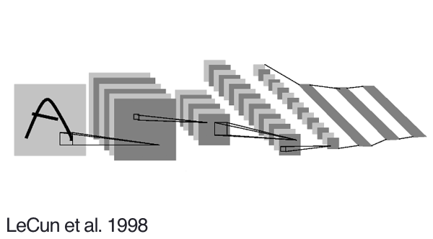

Estruturas de CNN alternativos:

1) AlexNet: É basicamente LeNet para imagens maiores.
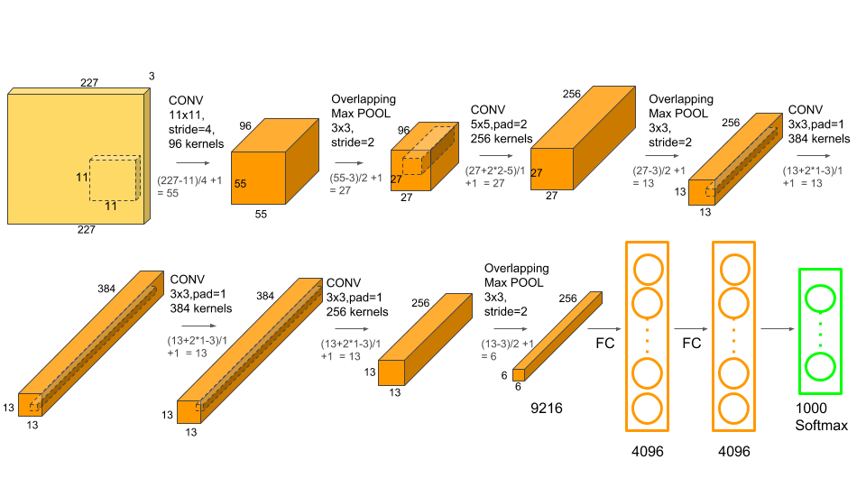

2) VGG: Utiliza somente camadas convolucionais 3x3, mas com mais camadas.
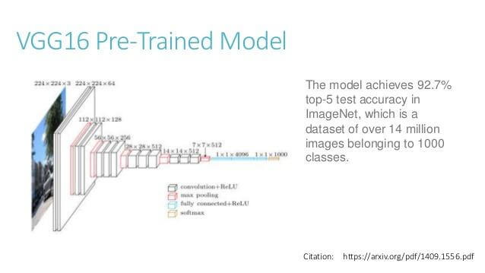

3) ResNet:
Bloco resnet consegue aprender facilmente função identidade.
A entrada é somada à saída do bloco (antes de ativação relu).
Utiliza BatchNormalization e regularização L2 (para obter pesos pequenos).
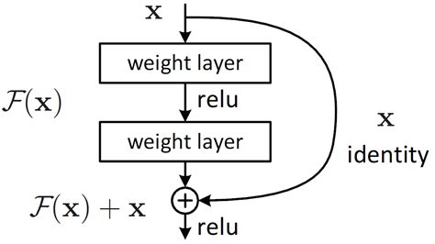

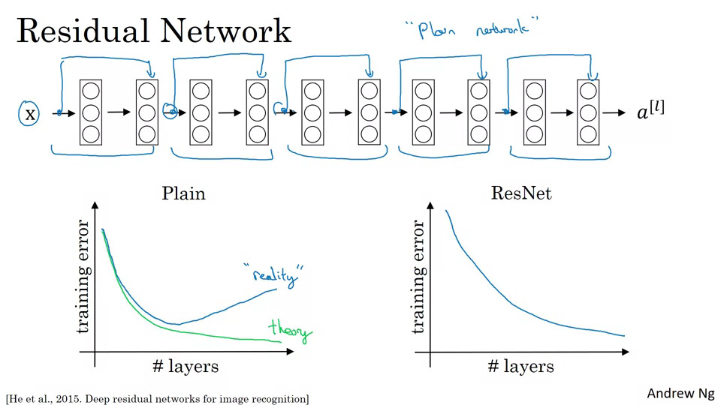

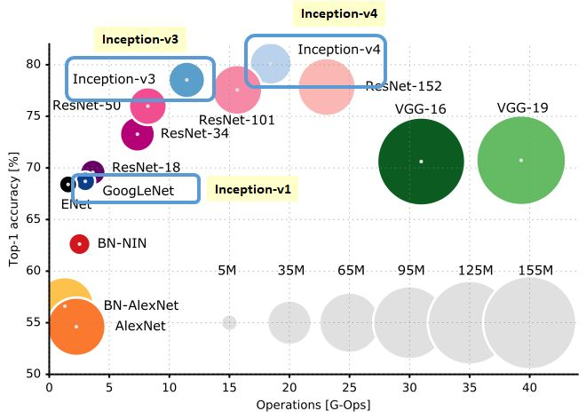
Exemplo de Keras para resolução de Cifar10 usando Resnet:
https://keras.io/examples/cifar10_resnet/
Corrigi bug conforme:
https://github.com/keras-team/keras/issues/12080
Simplifiquei o programa para facilitar entendimento (eliminei os loops que criam a rede). Diminuí o número de layers para acelerar o processamento. Acuracidade final (87%) é um pouco menor que a original (92%), mas o treino é mais rápido.

#resnet_hae1.py
import keras
from keras.datasets import cifar10
from keras.models import Model
from keras.layers import Dense, Conv2D, BatchNormalization, Activation
from keras.layers import AveragePooling2D, Input, Flatten
from keras.regularizers import l2
from keras.optimizers import Adam
from keras.activations import relu
from keras.callbacks import ReduceLROnPlateau
import numpy as np
from inspect import currentframe, getframeinfo
import os

def resnet_layer(inputs,
num_filters=16,
kernel_size=3,
strides=1,
activation='relu',
batch_normalization=True):
x = Conv2D(num_filters,
kernel_size=kernel_size,
strides=strides,
padding='same',
kernel_initializer='he_normal',
kernel_regularizer=l2(1e-4))(inputs)
if batch_normalization:
x = BatchNormalization()(x)
if activation is not None:
x = Activation(activation)(x)
return x

batch_size = 100
num_classes = 10
epochs = 50

# input image dimensions
nl, nc = 32,32

# the data, split between train and test sets
(ax, ay), (qx, qy) = cifar10.load_data()

#print('channels_last - formato de TensorFlow');
ax = ax.reshape(ax.shape[0], nl, nc, 3)
qx = qx.reshape(qx.shape[0], nl, nc, 3)
input_shape = (nl, nc, 3)

ax = ax.astype('float32')
qx = qx.astype('float32')
ax /= 255 #0 a 1
qx /= 255 #0 a 1
#ax -= 0.5 #-0.5 a +0.5
#qx -= 0.5 #-0.5 a +0.5
#print('ax shape:', ax.shape)
print(ax.shape[0], 'train samples')
print(qx.shape[0], 'test samples')

# convert class vectors to binary class matrices
ay = keras.utils.to_categorical(ay, num_classes)
qy = keras.utils.to_categorical(qy, num_classes)

num_filters = 16

inputs = Input(shape=input_shape)
x = resnet_layer(inputs=inputs)

y = resnet_layer(inputs=x,
num_filters=num_filters,
strides=1)
y = resnet_layer(inputs=y,
num_filters=num_filters,
activation=None)
x = keras.layers.add([x, y])
x = Activation('relu')(x)

num_filters *= 2

y = resnet_layer(inputs=x,
num_filters=num_filters,
strides=2)
y = resnet_layer(inputs=y,
num_filters=num_filters,
activation=None)
x = resnet_layer(inputs=x,
num_filters=num_filters,
kernel_size=1,
strides=2,
activation=None,
batch_normalization=False)
x = keras.layers.add([x, y])
x = Activation('relu')(x)

y = resnet_layer(inputs=x,
num_filters=num_filters,
strides=1)
y = resnet_layer(inputs=y,
num_filters=num_filters,
activation=None)
x = keras.layers.add([x, y])
x = Activation('relu')(x)

num_filters *= 2

y = resnet_layer(inputs=x,
num_filters=num_filters,
strides=2)
y = resnet_layer(inputs=y,
num_filters=num_filters,
activation=None)
x = resnet_layer(inputs=x,
num_filters=num_filters,
kernel_size=1,
strides=2,
activation=None,
batch_normalization=False)
x = keras.layers.add([x, y])
x = Activation('relu')(x)

y = resnet_layer(inputs=x,
num_filters=num_filters,
strides=1)
y = resnet_layer(inputs=y,
num_filters=num_filters,
activation=None)
x = keras.layers.add([x, y])
x = Activation('relu')(x)

y = resnet_layer(inputs=x,
num_filters=num_filters,
strides=1)
y = resnet_layer(inputs=y,
num_filters=num_filters,
activation=None)
x = keras.layers.add([x, y])
x = Activation('relu')(x)

# Add classifier on top.
# v1 does not use BN after last shortcut connection-ReLU
x = AveragePooling2D(pool_size=8)(x)
y = Flatten()(x)
outputs = Dense(num_classes,
activation='softmax',
kernel_initializer='he_normal')(y)

# Instantiate model.
model = Model(inputs=inputs, outputs=outputs)

from keras.utils import plot_model
fi = getframeinfo(currentframe()); nomeprog=os.path.splitext(fi.filename)[0];
plot_model(model, to_file=nomeprog+'.png', show_shapes=True)
from keras.utils import print_summary
print_summary(model)

opt=Adam()
model.compile(optimizer=opt,
loss='categorical_crossentropy',
metrics=['accuracy'])

lr_reducer = ReduceLROnPlateau(factor=np.sqrt(0.1),
cooldown=0,
patience=5,
min_lr=0.5e-6,
verbose=True)

model.fit(ax, ay,
batch_size=batch_size,
epochs=epochs,
verbose=1,
validation_data=(qx, qy),
callbacks=[lr_reducer])

score = model.evaluate(qx, qy, verbose=0)
print('Test loss:', score[0])
print('Test accuracy:', score[1])

model.save(nomeprog+'.h5')

(PSI3472-2019 Aula 6 Exercício 1) Modifique resnet_hae1.py de forma que o novo programa consiga reconhecer cachorros e gatos. Para isso:
a) Coloque dentro dos tensores ax, ay, qx e qy somente as imagens de cachorro (categoria original 5, nova categoria 0) e gato (categoria original 3, nova categoria 1).
b) Modifique o programa para distinguir cachorros dos gatos.

Meu resultado cão e gato usando resnet_hae1.py modificado (sem data augmentation):
Epoch 30 - acc: 1.0000 - val_acc: 0.7555
__________________________________________________________________________________________________
Layer (type) Output Shape Param # Connected to
==================================================================================================
input_1 (InputLayer) (None, 32, 32, 3) 0
__________________________________________________________________________________________________
conv2d_1 (Conv2D) (None, 32, 32, 16) 448 input_1[0][0]
__________________________________________________________________________________________________
batch_normalization_1 (BatchNor (None, 32, 32, 16) 64 conv2d_1[0][0]
__________________________________________________________________________________________________
activation_1 (Activation) (None, 32, 32, 16) 0 batch_normalization_1[0][0]
__________________________________________________________________________________________________
conv2d_2 (Conv2D) (None, 32, 32, 16) 2320 activation_1[0][0]
__________________________________________________________________________________________________
batch_normalization_2 (BatchNor (None, 32, 32, 16) 64 conv2d_2[0][0]
__________________________________________________________________________________________________
activation_2 (Activation) (None, 32, 32, 16) 0 batch_normalization_2[0][0]
__________________________________________________________________________________________________
conv2d_3 (Conv2D) (None, 32, 32, 16) 2320 activation_2[0][0]
__________________________________________________________________________________________________
batch_normalization_3 (BatchNor (None, 32, 32, 16) 64 conv2d_3[0][0]
__________________________________________________________________________________________________
add_1 (Add) (None, 32, 32, 16) 0 activation_1[0][0]
batch_normalization_3[0][0]
__________________________________________________________________________________________________
activation_3 (Activation) (None, 32, 32, 16) 0 add_1[0][0]
__________________________________________________________________________________________________
conv2d_4 (Conv2D) (None, 16, 16, 32) 4640 activation_3[0][0]
__________________________________________________________________________________________________
batch_normalization_4 (BatchNor (None, 16, 16, 32) 128 conv2d_4[0][0]
__________________________________________________________________________________________________
activation_4 (Activation) (None, 16, 16, 32) 0 batch_normalization_4[0][0]
__________________________________________________________________________________________________
conv2d_5 (Conv2D) (None, 16, 16, 32) 9248 activation_4[0][0]
__________________________________________________________________________________________________
conv2d_6 (Conv2D) (None, 16, 16, 32) 544 activation_3[0][0]
__________________________________________________________________________________________________
batch_normalization_5 (BatchNor (None, 16, 16, 32) 128 conv2d_5[0][0]
__________________________________________________________________________________________________
add_2 (Add) (None, 16, 16, 32) 0 conv2d_6[0][0]
batch_normalization_5[0][0]
__________________________________________________________________________________________________
activation_5 (Activation) (None, 16, 16, 32) 0 add_2[0][0]
__________________________________________________________________________________________________
conv2d_7 (Conv2D) (None, 16, 16, 32) 9248 activation_5[0][0]
__________________________________________________________________________________________________
batch_normalization_6 (BatchNor (None, 16, 16, 32) 128 conv2d_7[0][0]
__________________________________________________________________________________________________
activation_6 (Activation) (None, 16, 16, 32) 0 batch_normalization_6[0][0]
__________________________________________________________________________________________________
conv2d_8 (Conv2D) (None, 16, 16, 32) 9248 activation_6[0][0]
__________________________________________________________________________________________________
batch_normalization_7 (BatchNor (None, 16, 16, 32) 128 conv2d_8[0][0]
__________________________________________________________________________________________________
add_3 (Add) (None, 16, 16, 32) 0 activation_5[0][0]
batch_normalization_7[0][0]
__________________________________________________________________________________________________
activation_7 (Activation) (None, 16, 16, 32) 0 add_3[0][0]
__________________________________________________________________________________________________
conv2d_9 (Conv2D) (None, 8, 8, 64) 18496 activation_7[0][0]
__________________________________________________________________________________________________
batch_normalization_8 (BatchNor (None, 8, 8, 64) 256 conv2d_9[0][0]
__________________________________________________________________________________________________
activation_8 (Activation) (None, 8, 8, 64) 0 batch_normalization_8[0][0]
__________________________________________________________________________________________________
conv2d_10 (Conv2D) (None, 8, 8, 64) 36928 activation_8[0][0]
__________________________________________________________________________________________________
conv2d_11 (Conv2D) (None, 8, 8, 64) 2112 activation_7[0][0]
__________________________________________________________________________________________________
batch_normalization_9 (BatchNor (None, 8, 8, 64) 256 conv2d_10[0][0]
__________________________________________________________________________________________________
add_4 (Add) (None, 8, 8, 64) 0 conv2d_11[0][0]
batch_normalization_9[0][0]
__________________________________________________________________________________________________
activation_9 (Activation) (None, 8, 8, 64) 0 add_4[0][0]
__________________________________________________________________________________________________
conv2d_12 (Conv2D) (None, 8, 8, 64) 36928 activation_9[0][0]
__________________________________________________________________________________________________
batch_normalization_10 (BatchNo (None, 8, 8, 64) 256 conv2d_12[0][0]
__________________________________________________________________________________________________
activation_10 (Activation) (None, 8, 8, 64) 0 batch_normalization_10[0][0]
__________________________________________________________________________________________________
conv2d_13 (Conv2D) (None, 8, 8, 64) 36928 activation_10[0][0]
__________________________________________________________________________________________________
batch_normalization_11 (BatchNo (None, 8, 8, 64) 256 conv2d_13[0][0]
__________________________________________________________________________________________________
add_5 (Add) (None, 8, 8, 64) 0 activation_9[0][0]
batch_normalization_11[0][0]
__________________________________________________________________________________________________
activation_11 (Activation) (None, 8, 8, 64) 0 add_5[0][0]
__________________________________________________________________________________________________
conv2d_14 (Conv2D) (None, 8, 8, 64) 36928 activation_11[0][0]
__________________________________________________________________________________________________
batch_normalization_12 (BatchNo (None, 8, 8, 64) 256 conv2d_14[0][0]
__________________________________________________________________________________________________
activation_12 (Activation) (None, 8, 8, 64) 0 batch_normalization_12[0][0]
__________________________________________________________________________________________________
conv2d_15 (Conv2D) (None, 8, 8, 64) 36928 activation_12[0][0]
__________________________________________________________________________________________________
batch_normalization_13 (BatchNo (None, 8, 8, 64) 256 conv2d_15[0][0]
__________________________________________________________________________________________________
add_6 (Add) (None, 8, 8, 64) 0 activation_11[0][0]
batch_normalization_13[0][0]
__________________________________________________________________________________________________
activation_13 (Activation) (None, 8, 8, 64) 0 add_6[0][0]
__________________________________________________________________________________________________
average_pooling2d_1 (AveragePoo (None, 1, 1, 64) 0 activation_13[0][0]
__________________________________________________________________________________________________
flatten_1 (Flatten) (None, 64) 0 average_pooling2d_1[0][0]
__________________________________________________________________________________________________
dense_1 (Dense) (None, 10) 650 flatten_1[0][0]
==================================================================================================
Total params: 246,154
Trainable params: 245,034
Non-trainable params: 1,120

__________________________________________________________________________________________________
Train on 50000 samples, validate on 10000 samples
Epoch 1/50 - 36s 728us/step - loss: 1.5561 - acc: 0.4922 - val_loss: 1.6411 - val_acc: 0.4749
Epoch 2/50 - 31s 614us/step - loss: 1.1202 - acc: 0.6433 - val_loss: 1.1984 - val_acc: 0.6246
Epoch 3/50 - 31s 613us/step - loss: 0.9433 - acc: 0.7110 - val_loss: 1.1637 - val_acc: 0.6433
...
Epoch 00024: ReduceLROnPlateau reducing learning rate to 3.1622778103685084e-05.
Epoch 25/50 - 32s 633us/step - loss: 0.1361 - acc: 0.9999 - val_loss: 1.0997 - val_acc: 0.7986
Epoch 26/50 - 31s 630us/step - loss: 0.1347 - acc: 0.9999 - val_loss: 1.1140 - val_acc: 0.7976
Epoch 27/50 - 31s 629us/step - loss: 0.1330 - acc: 1.0000 - val_loss: 1.1118 - val_acc: 0.7989
Epoch 28/50 - 31s 629us/step - loss: 0.1314 - acc: 1.0000 - val_loss: 1.1188 - val_acc: 0.7983
Epoch 29/50 - 32s 630us/step - loss: 0.1298 - acc: 1.0000 - val_loss: 1.1227 - val_acc: 0.7981
...
Epoch 00044: ReduceLROnPlateau reducing learning rate to 5e-07.
Epoch 45/50 - 33s 662us/step - loss: 0.1237 - acc: 1.0000 - val_loss: 1.1340 - val_acc: 0.7989
Epoch 46/50 - 32s 644us/step - loss: 0.1236 - acc: 1.0000 - val_loss: 1.1353 - val_acc: 0.7986
Epoch 47/50 - 33s 655us/step - loss: 0.1237 - acc: 1.0000 - val_loss: 1.1357 - val_acc: 0.7987
Epoch 48/50 - 34s 688us/step - loss: 0.1236 - acc: 1.0000 - val_loss: 1.1356 - val_acc: 0.7991
Epoch 49/50 - 33s 669us/step - loss: 0.1237 - acc: 1.0000 - val_loss: 1.1356 - val_acc: 0.7985
Epoch 50/50 - 33s 654us/step - loss: 0.1235 - acc: 1.0000 - val_loss: 1.1330 - val_acc: 0.7996
Test loss: 1.1329967609405518
Test accuracy: 0.7996

Traning accuracy: 100%. Validation accuracy: 79.96%
80% de acerto é o melhor resultado que obtivemos até agora.

Sem diminuir learning rate ao longo da aprendizagem, não consegue chegar a esta acuracidade.
Há overfitting, pois train_accuracy chega a 100% mas validation_accuracy fica oscilando.

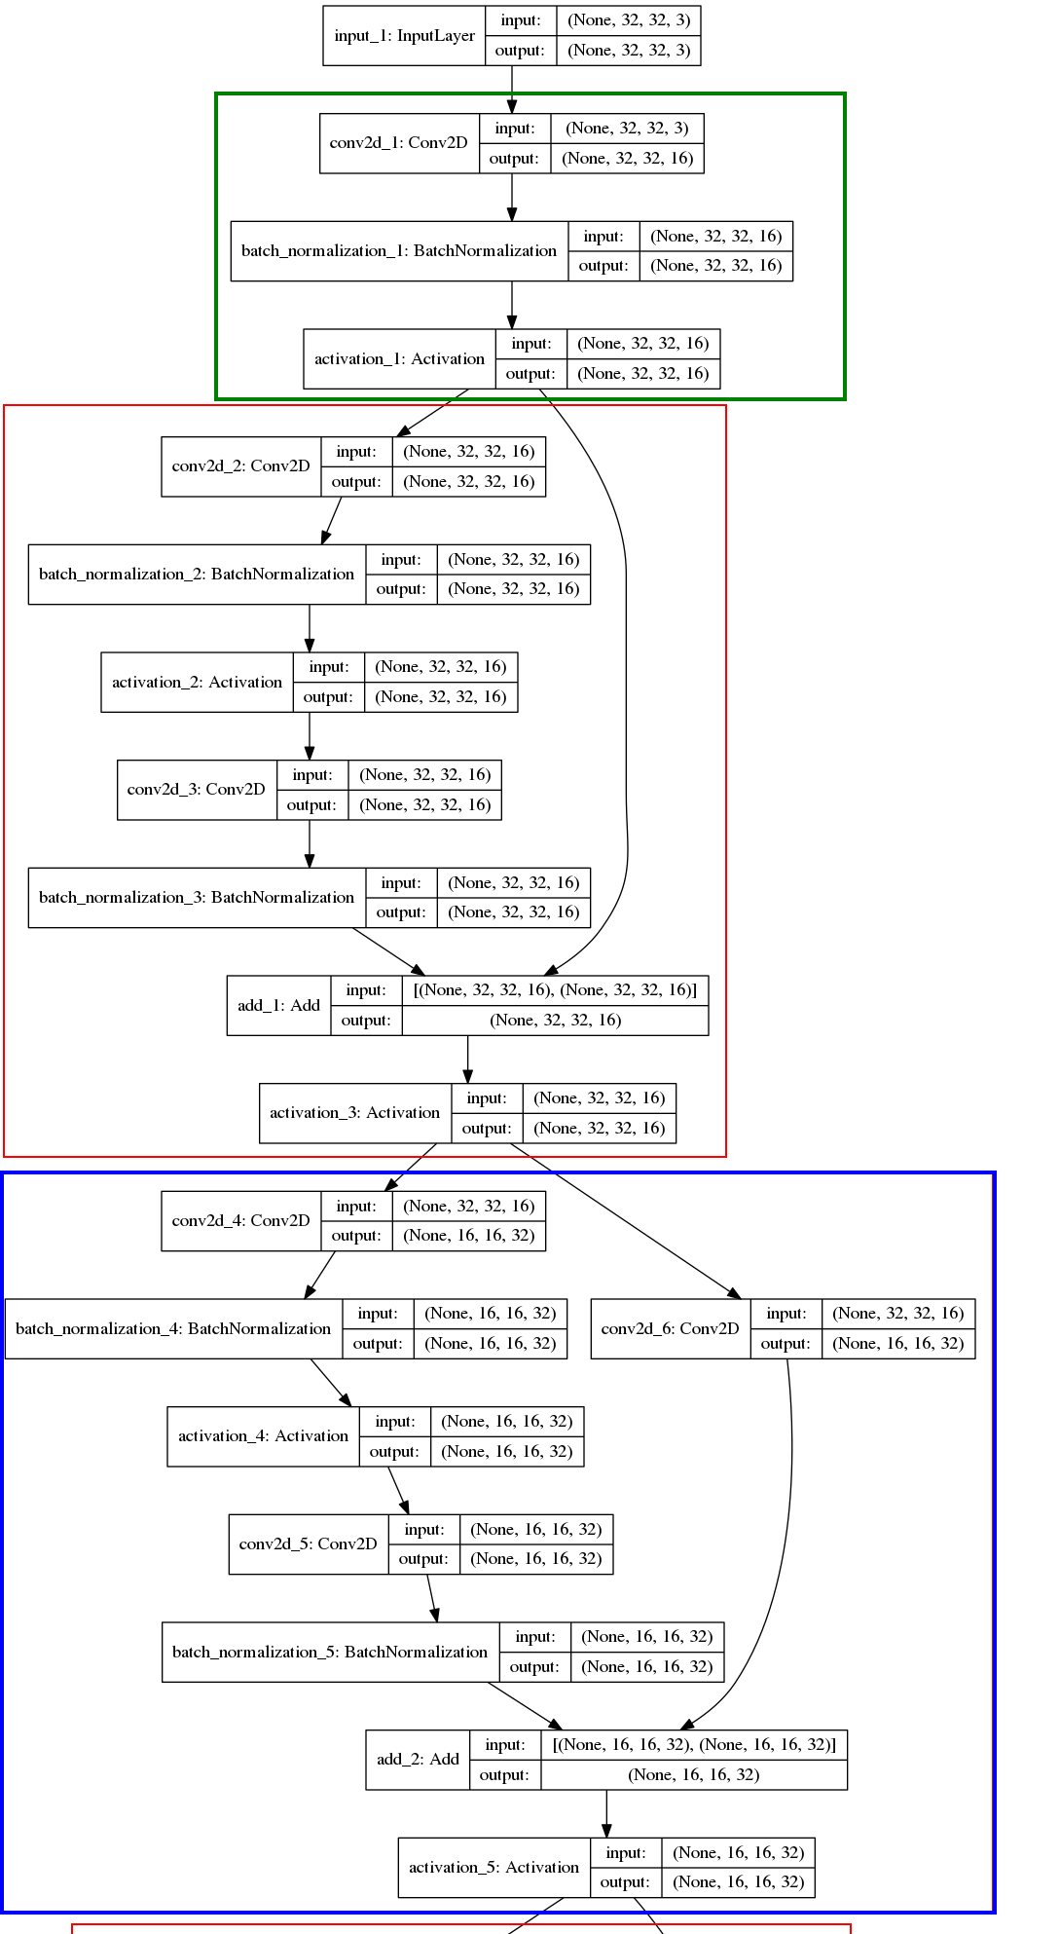
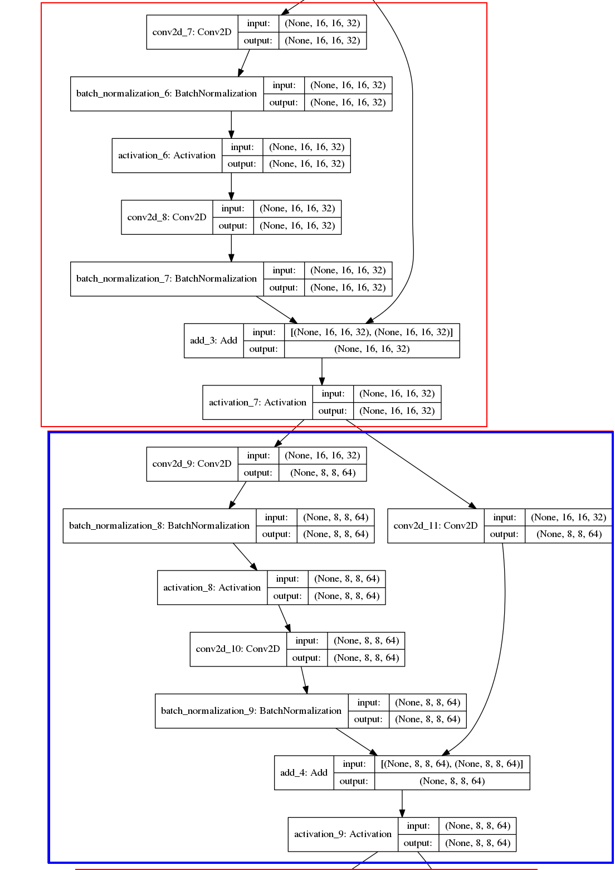

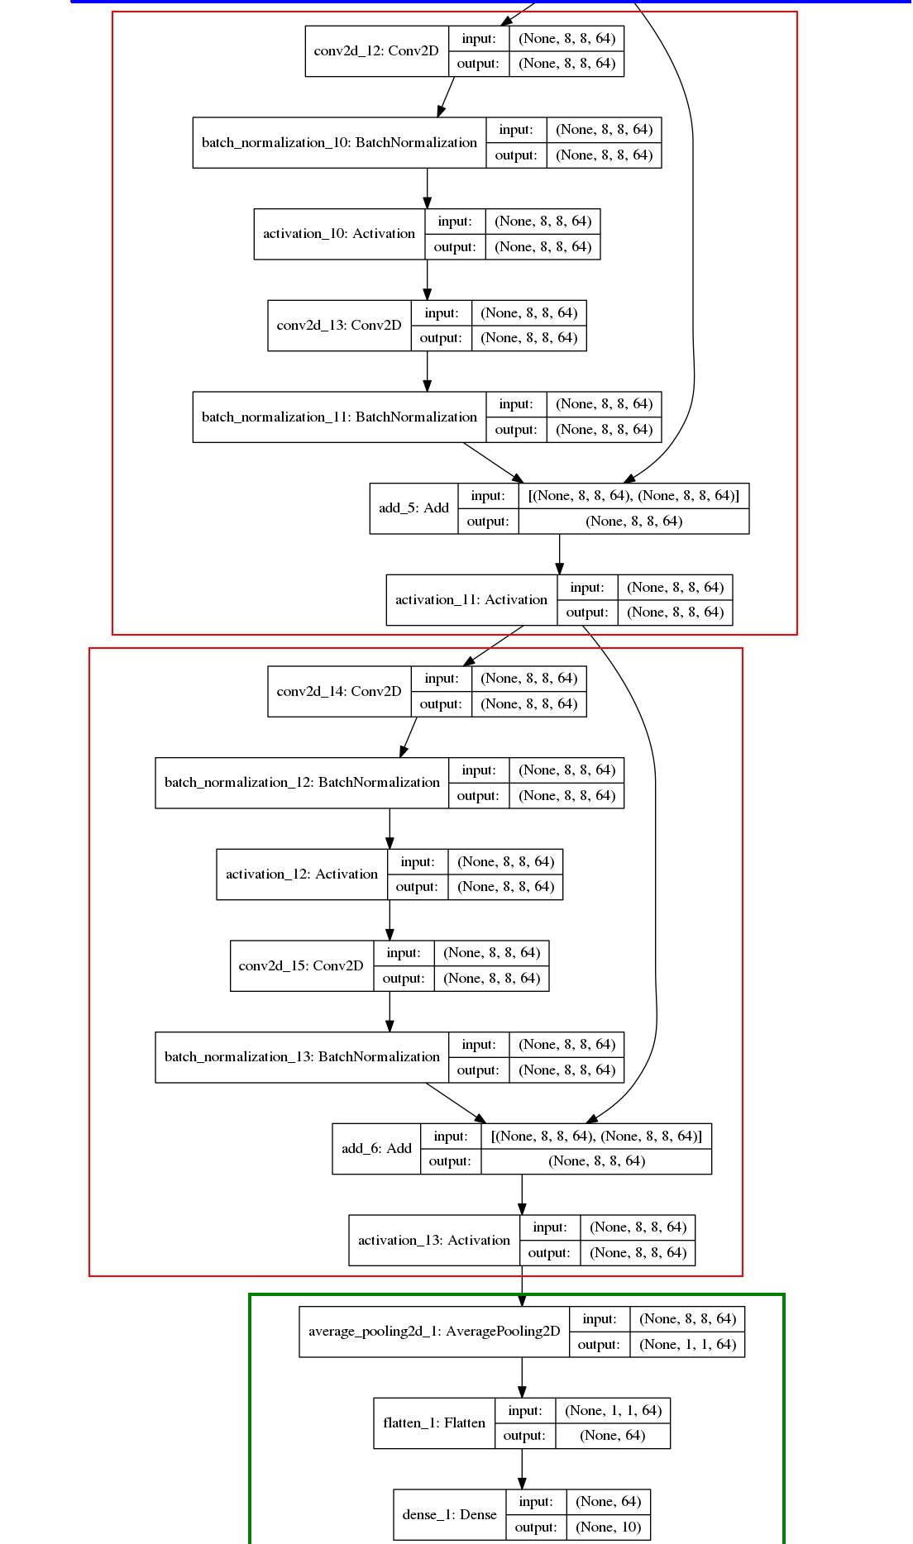
Para evitar overfitting, podemos fazer data augmentation, distorcendo as imagens. Vamos fazer deslocamentos horizontal/vertical e espelhamento direita/esquerda. Porém, para ter ideia intuitiva de como as imagens estão sendo distorcidas, é necessário olhar as imagens originais e as distorcidas. Programa para visualizar como as imagens de CIFAR-10 estão sendo distorcidas:

#gera2.py - Visualizar data augmentation
#Programa para ver imagem original do CIFAR-10
#juntamente com a obtida pelo data augmentation
import keras
from keras.datasets import cifar10
from keras.preprocessing.image import ImageDataGenerator
import numpy as np
from inspect import currentframe, getframeinfo
import os
from matplotlib import pyplot as plt
import sys

#main
# input image dimensions
nl, nc = 32,32

# the data, split between train and test sets
(ax, ay), (qx, qy) = cifar10.load_data()

#print('channels_last - formato de TensorFlow');
ax = ax.reshape(ax.shape[0], nl, nc, 3)
qx = qx.reshape(qx.shape[0], nl, nc, 3)
input_shape = (nl, nc, 3)
ax = ax.astype('float32')
qx = qx.astype('float32')
ax /= 255 #0 a 1
qx /= 255 #0 a 1

# convert class vectors to binary class matrices
num_classes=10
ay = keras.utils.to_categorical(ay, num_classes)
qy = keras.utils.to_categorical(qy, num_classes)

print('Real-time data augmentation.')
# This will do preprocessing and realtime data augmentation:
datagen1 = ImageDataGenerator()
datagen2 = ImageDataGenerator(
# randomly shift images horizontally - Fraction of width
width_shift_range=0.1,
# randomly shift images vertically - Fraction of height
height_shift_range=0.1,
# set range for random shear
fill_mode='nearest',
# value used for fill_mode = "constant"
horizontal_flip=True)

# Compute quantities required for featurewise normalization
# (std, mean, and principal components if ZCA whitening is applied).
# Caso nao use, nao precisa destes comandos.
datagen1.fit(ax)
datagen2.fit(ax)

batch_size=10
#Importante usar a mesma semente
augdata1=datagen1.flow(ax, batch_size=batch_size, seed=7)
augdata2=datagen2.flow(ax, batch_size=batch_size, seed=7)
a1=augdata1.next()
a2=augdata2.next()
for i in range(batch_size):
fig, eixo = plt.subplots(1, 2)
eixo[0].imshow(a1[i])
eixo[1].imshow(a2[i])
plt.show();

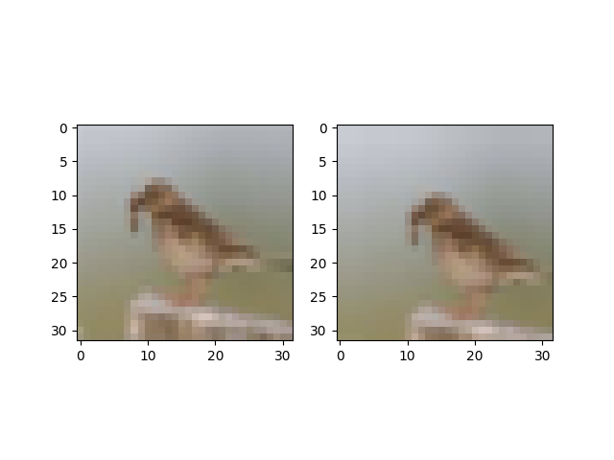

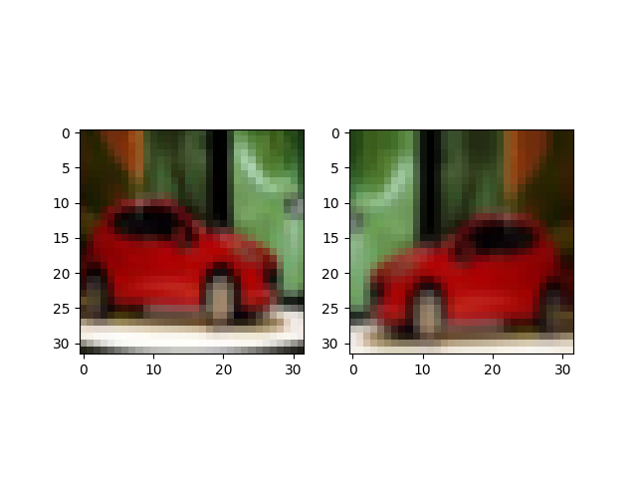

(PSI3472-2019 Aula 6 Exercício 2) Modifique o programa gera2.py para gerar as seguintes distorções aleatórias (um de cada vez):
a) Rotação de até 45 graus.
b) Faz zoom de 0.8 até 1.2.
c) Demonstre o funcionamento de brightness_range
d) Demonstre o funcionamento de channel_shift_range

Faz data augmentation para evitar overfitting.

#resnet_hae2.py
import keras
from keras.datasets import cifar10
from keras.models import Model
from keras.layers import Dense, Conv2D, BatchNormalization, Activation
from keras.layers import AveragePooling2D, Input, Flatten
from keras.regularizers import l2
from keras.optimizers import Adam
from keras.activations import relu
from keras.callbacks import ReduceLROnPlateau
from keras.preprocessing.image import ImageDataGenerator
import numpy as np
from inspect import currentframe, getframeinfo
import os

...

print('Using real-time data augmentation.')
datagen = ImageDataGenerator(
# randomly shift images horizontally - Fraction of width
width_shift_range=0.1,
# randomly shift images vertically - Fraction of height
height_shift_range=0.1,
# set range for random shear
fill_mode='nearest',
# value used for fill_mode = "constant"
horizontal_flip=True)

# Compute quantities required for featurewise normalization
# (std, mean, and principal components if ZCA whitening is applied).
datagen.fit(ax)
model.fit_generator(datagen.flow(ax, ay, batch_size=batch_size),
epochs=epochs,
verbose=True,
validation_data=(qx, qy),
callbacks=[lr_reducer],
steps_per_epoch=ax.shape[0]//batch_size)

score = model.evaluate(qx, qy, verbose=0)
print('Test loss:', score[0])
print('Test accuracy:', score[1])

model.save(nomeprog+'.h5')

Epoch 46/50 - 37s 73ms/step - loss: 0.3152 - acc: 0.9290 - val_loss: 0.5124 - val_acc: 0.8721
Epoch 00046: ReduceLROnPlateau reducing learning rate to 3.1622778678900043e-06.
Epoch 47/50 - 38s 76ms/step - loss: 0.3136 - acc: 0.9299 - val_loss: 0.5132 - val_acc: 0.8712
Epoch 48/50 - 39s 78ms/step - loss: 0.3145 - acc: 0.9309 - val_loss: 0.5121 - val_acc: 0.8711
Epoch 49/50 - 32s 63ms/step - loss: 0.3132 - acc: 0.9290 - val_loss: 0.5138 - val_acc: 0.8705
Epoch 50/50 - 31s 62ms/step - loss: 0.3154 - acc: 0.9307 - val_loss: 0.5136 - val_acc: 0.8709

Training accuracy: 93%. Validation accuracy: 87%.
Fazendo data augmentation, diminui training accuracy, mas aumenta validation accuracy (que é o que importa).

O programa original resnet, com mais layers e 200 epochs de treino, chega a 92% de acuracidade.

(PSI3472-2019 Aula 6 Exercício 3) Modifique resnet_hae2.py de forma que o novo programa caogato2.py consiga reconhecer cachorros e gatos. Para isso:
a) Coloque dentro dos tensores ax, ay, qx e qy somente as imagens de cachorro (categoria original 5, nova categoria 0) e gato (categoria original 3, nova categoria 1).
b) Modifique o programa para distinguir cachorros dos gatos.

Meu resultado cão e gato usando resnet_hae2.py modificado (com data augmentation):
Epoch 60 - acc: 0.9274 - val_acc: 0.8480

(PSI3472-2019 Aula 6 Exercício 4) Modifique o programa do exercício 3 para aumentar a taxa de acerto de validação/teste, com o tempo de treino/teste no máximo 2 vezes maior que o exercício 3. Qual foi a taxa que conseguiu chegar?

4) Inception-v1 GoogLeNet
https://medium.com/coinmonks/paper-review-of-googlenet-inception-v1-winner-of-ilsvlc-2014-image-classification-c2b3565a64e7

a) Utilidade da convolução 1x1
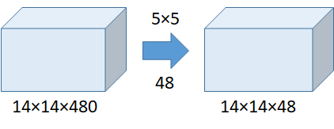
Number of operations = (14×14×48)×(5×5×480) = 112.9M

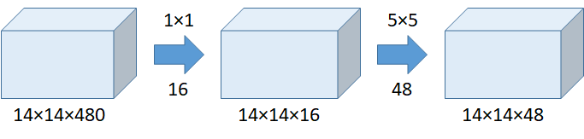
Number of operations for 1×1 = (14×14×16)×(1×1×480) = 1.5M
Number of operations for 5×5 = (14×14×48)×(5×5×16) = 3.8M
Total number of operations = 1.5M + 3.8M = 5.3M

2) Módulo inception
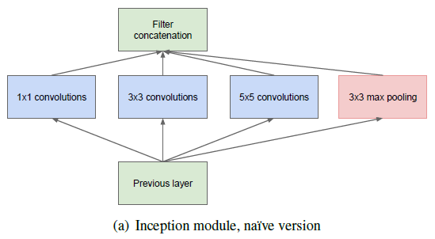
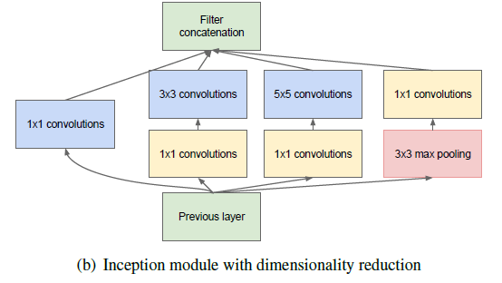

1x1 com 32 saídas
3x3 com 128 saídas
5x5 com 32 saídas
maxpooling 3x3 stride 1 com 64 saídas

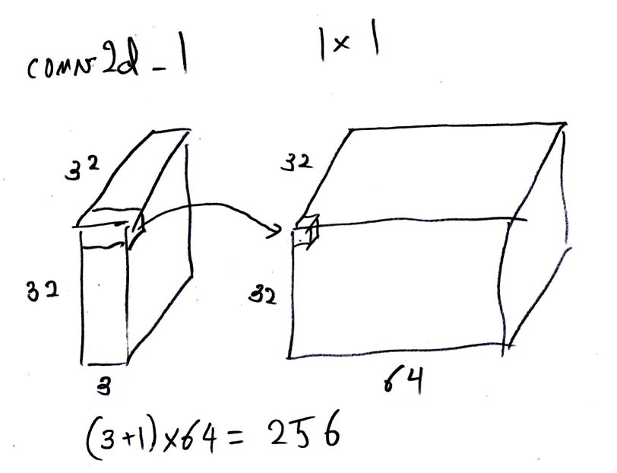

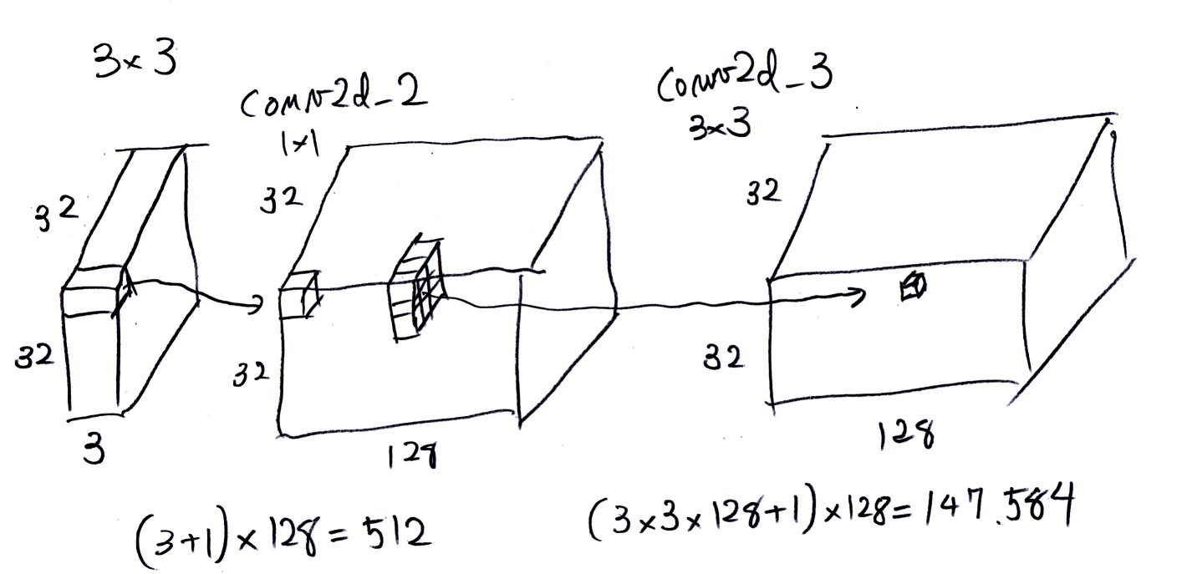

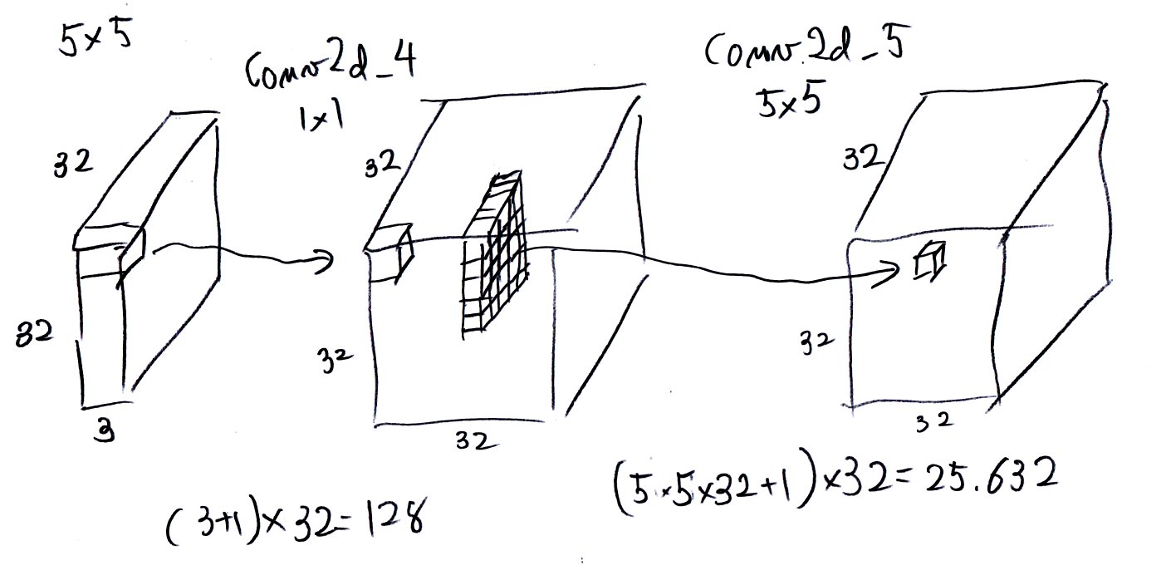

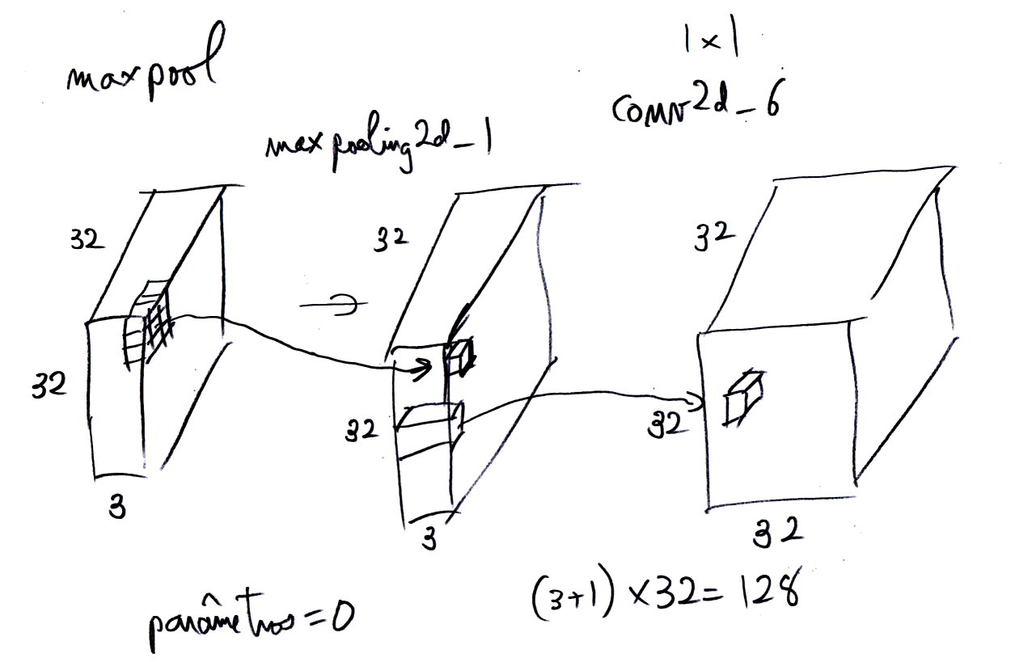

3) No fim, calcula average pooling em vez de camada densa (diminui número de parâmetros).

Rede "inspirada" em inception v1:
Nota: não é inception verdadeira, pois o programa abaixo pode diferir em detalhes.

#inception2.py
#Rede inspirada em inception.
import keras
from keras.datasets import cifar10
from keras.models import Model
from keras.layers import Dense, Conv2D, BatchNormalization, Activation
from keras.layers import AveragePooling2D, MaxPooling2D, Input, Flatten
from keras.regularizers import l2
from keras.optimizers import Adam
from keras.activations import relu
from keras.callbacks import ReduceLROnPlateau
from keras.preprocessing.image import ImageDataGenerator
import numpy as np
from inspect import currentframe, getframeinfo
import os

batch_size = 100
num_classes = 10
epochs = 50

# input image dimensions
nl, nc = 32,32

# the data, split between train and test sets
(ax, ay), (qx, qy) = cifar10.load_data()

#print('channels_last - formato de TensorFlow');
ax = ax.reshape(ax.shape[0], nl, nc, 3)
qx = qx.reshape(qx.shape[0], nl, nc, 3)
input_shape = (nl, nc, 3)

ax = ax.astype('float32')
qx = qx.astype('float32')
ax /= 255 #0 a 1
qx /= 255 #0 a 1

# convert class vectors to binary class matrices
ay = keras.utils.to_categorical(ay, num_classes)
qy = keras.utils.to_categorical(qy, num_classes)

inputs = Input(shape=input_shape)
x=inputs

nfiltros=64
tower_0 = Conv2D(nfiltros, (1,1), padding='same', activation='relu')(x) #conv2d_1

tower_1 = Conv2D(2*nfiltros, (1,1), padding='same', activation='relu')(x) #conv2d_2
tower_1 = Conv2D(2*nfiltros, (3,3), padding='same', activation='relu')(tower_1) #conv2d_3

tower_2 = Conv2D(nfiltros//2, (1,1), padding='same', activation='relu')(x) #conv2d_4
tower_2 = Conv2D(nfiltros//2, (5,5), padding='same', activation='relu')(tower_2)#conv2d_5

tower_3 = MaxPooling2D((3,3), strides=(1,1), padding='same')(x) #max_pooling2d_1
tower_3 = Conv2D(nfiltros//2, (1,1), padding='same', activation='relu')(tower_3)#conv2d_6

x = keras.layers.concatenate([tower_0, tower_1, tower_2, tower_3], axis = 3)

"""
Layer (type) Output Shape Param # Connected to
input_1 (InputLayer) (None, 32, 32, 3) 0
conv2d_2 (Conv2D) (None, 32, 32, 128) 512 input_1[0][0] 512=(3+1)*128
conv2d_4 (Conv2D) (None, 32, 32, 32) 128 input_1[0][0] 128=(3+1)*32
max_pooling2d_1 (MaxPooling2D) (None, 32, 32, 3) 0 input_1[0][0]
conv2d_1 (Conv2D) (None, 32, 32, 64) 256 input_1[0][0] 256=4*64
conv2d_3 (Conv2D) (None, 32, 32, 128) 147584 conv2d_2[0][0] 147584=(3*3*128+1)*128
conv2d_5 (Conv2D) (None, 32, 32, 32) 25632 conv2d_4[0][0] 25632=(5*5*32+1)*32
conv2d_6 (Conv2D) (None, 32, 32, 32) 128 max_pooling2d_1[0][0] 128=(3+1)*32
concatenate_1 (Concatenate) (None, 32, 32, 256) 0 conv2d_1[0][0]
conv2d_3[0][0]
conv2d_5[0][0]
conv2d_6[0][0]
"""

nfiltros=64
tower_0 = Conv2D(nfiltros, (1,1), padding='same', activation='relu')(x)

tower_1 = Conv2D(2*nfiltros, (1,1), padding='same', activation='relu')(x)
tower_1 = Conv2D(2*nfiltros, (3,3), padding='same', activation='relu')(tower_1)

tower_2 = Conv2D(nfiltros//2, (1,1), padding='same', activation='relu')(x)
tower_2 = Conv2D(nfiltros//2, (5,5), padding='same', activation='relu')(tower_2)

tower_3 = MaxPooling2D((3,3), strides=(1,1), padding='same')(x)
tower_3 = Conv2D(nfiltros//2, (1,1), padding='same', activation='relu')(tower_3)

x = keras.layers.concatenate([tower_0, tower_1, tower_2, tower_3], axis = 3)
x = MaxPooling2D(2)(x);

nfiltros=64
tower_0 = Conv2D(nfiltros, (1,1), padding='same', activation='relu')(x)

tower_1 = Conv2D(2*nfiltros, (1,1), padding='same', activation='relu')(x)
tower_1 = Conv2D(2*nfiltros, (3,3), padding='same', activation='relu')(tower_1)

tower_2 = Conv2D(nfiltros//2, (1,1), padding='same', activation='relu')(x)
tower_2 = Conv2D(nfiltros//2, (5,5), padding='same', activation='relu')(tower_2)

tower_3 = MaxPooling2D((3,3), strides=(1,1), padding='same')(x)
tower_3 = Conv2D(nfiltros//2, (1,1), padding='same', activation='relu')(tower_3)

x = keras.layers.concatenate([tower_0, tower_1, tower_2, tower_3], axis = 3)

nfiltros=64
tower_0 = Conv2D(nfiltros, (1,1), padding='same', activation='relu')(x)

tower_1 = Conv2D(2*nfiltros, (1,1), padding='same', activation='relu')(x)
tower_1 = Conv2D(2*nfiltros, (3,3), padding='same', activation='relu')(tower_1)

tower_2 = Conv2D(nfiltros//2, (1,1), padding='same', activation='relu')(x)
tower_2 = Conv2D(nfiltros//2, (5,5), padding='same', activation='relu')(tower_2)

tower_3 = MaxPooling2D((3,3), strides=(1,1), padding='same')(x)
tower_3 = Conv2D(nfiltros//2, (1,1), padding='same', activation='relu')(tower_3)

x = keras.layers.concatenate([tower_0, tower_1, tower_2, tower_3], axis = 3)
x = MaxPooling2D(2)(x);

nfiltros=64
tower_0 = Conv2D(nfiltros, (1,1), padding='same', activation='relu')(x)

tower_1 = Conv2D(2*nfiltros, (1,1), padding='same', activation='relu')(x)
tower_1 = Conv2D(2*nfiltros, (3,3), padding='same', activation='relu')(tower_1)

tower_2 = Conv2D(nfiltros//2, (1,1), padding='same', activation='relu')(x)
tower_2 = Conv2D(nfiltros//2, (5,5), padding='same', activation='relu')(tower_2)

tower_3 = MaxPooling2D((3,3), strides=(1,1), padding='same')(x)
tower_3 = Conv2D(nfiltros//2, (1,1), padding='same', activation='relu')(tower_3)

x = keras.layers.concatenate([tower_0, tower_1, tower_2, tower_3], axis = 3)

nfiltros=64
tower_0 = Conv2D(nfiltros, (1,1), padding='same', activation='relu')(x)

tower_1 = Conv2D(2*nfiltros, (1,1), padding='same', activation='relu')(x)
tower_1 = Conv2D(2*nfiltros, (3,3), padding='same', activation='relu')(tower_1)

tower_2 = Conv2D(nfiltros//2, (1,1), padding='same', activation='relu')(x)
tower_2 = Conv2D(nfiltros//2, (5,5), padding='same', activation='relu')(tower_2)

tower_3 = MaxPooling2D((3,3), strides=(1,1), padding='same')(x)
tower_3 = Conv2D(nfiltros//2, (1,1), padding='same', activation='relu')(tower_3)

x = keras.layers.concatenate([tower_0, tower_1, tower_2, tower_3], axis = 3)
output = AveragePooling2D(8)(x);

output = Flatten()(output)
outputs= Dense(10, activation='softmax')(output)

# Instantiate model.
model = Model(inputs=inputs, outputs=outputs)

from keras.utils import plot_model
fi = getframeinfo(currentframe()); nomeprog=os.path.splitext(fi.filename)[0];
plot_model(model, to_file=nomeprog+'.png', show_shapes=True)
from keras.utils import print_summary
print_summary(model)

opt=Adam()
model.compile(optimizer=opt,
loss='categorical_crossentropy',
metrics=['accuracy'])

lr_reducer = ReduceLROnPlateau(factor=np.sqrt(0.1),
cooldown=0,
patience=5,
min_lr=0.5e-6,
verbose=True)

print('Using real-time data augmentation.')
datagen = ImageDataGenerator(
# randomly shift images horizontally - Fraction of width
width_shift_range=0.1,
# randomly shift images vertically - Fraction of height
height_shift_range=0.1,
# set range for random shear
fill_mode='nearest',
# value used for fill_mode = "constant"
horizontal_flip=True)

# Compute quantities required for featurewise normalization
# (std, mean, and principal components if ZCA whitening is applied).
datagen.fit(ax)
model.fit_generator(datagen.flow(ax, ay, batch_size=batch_size),
epochs=epochs,
verbose=True,
validation_data=(qx, qy),
callbacks=[lr_reducer],
steps_per_epoch=ax.shape[0]//batch_size)

score = model.evaluate(qx, qy, verbose=0)
print('Test loss:', score[0])
print('Test accuracy:', score[1])

model.save(nomeprog+'.h5')

Epoch 47/50 - 224s 448ms/step - loss: 0.0401 - acc: 0.9860 - val_loss: 0.5631 - val_acc: 0.8940
Epoch 48/50 - 222s 445ms/step - loss: 0.0401 - acc: 0.9858 - val_loss: 0.5628 - val_acc: 0.8950
Epoch 00048: ReduceLROnPlateau reducing learning rate to 3.1622778678900043e-06.
Epoch 49/50 - 222s 444ms/step - loss: 0.0419 - acc: 0.9856 - val_loss: 0.5583 - val_acc: 0.8957
Epoch 50/50 - 222s 444ms/step - loss: 0.0408 - acc: 0.9860 - val_loss: 0.5604 - val_acc: 0.8947

Training accuracy: 98%. Validation accuracy: 89%.
Porém, o treino demora bem mais do que resnet: 31s/epoch versus 222s/epoch.

Layer (type) Output Shape Param # Connected to
==================================================================================================
input_1 (InputLayer) (None, 32, 32, 3) 0
__________________________________________________________________________________________________
conv2d_2 (Conv2D) (None, 32, 32, 128) 512 input_1[0][0]
__________________________________________________________________________________________________
conv2d_4 (Conv2D) (None, 32, 32, 32) 128 input_1[0][0]
__________________________________________________________________________________________________
max_pooling2d_1 (MaxPooling2D) (None, 32, 32, 3) 0 input_1[0][0]
__________________________________________________________________________________________________
conv2d_1 (Conv2D) (None, 32, 32, 64) 256 input_1[0][0]
__________________________________________________________________________________________________
conv2d_3 (Conv2D) (None, 32, 32, 128) 147584 conv2d_2[0][0]
__________________________________________________________________________________________________
conv2d_5 (Conv2D) (None, 32, 32, 32) 25632 conv2d_4[0][0]
__________________________________________________________________________________________________
conv2d_6 (Conv2D) (None, 32, 32, 32) 128 max_pooling2d_1[0][0]
__________________________________________________________________________________________________
concatenate_1 (Concatenate) (None, 32, 32, 256) 0 conv2d_1[0][0]
conv2d_3[0][0]
conv2d_5[0][0]
conv2d_6[0][0]
__________________________________________________________________________________________________
conv2d_8 (Conv2D) (None, 32, 32, 128) 32896 concatenate_1[0][0]
__________________________________________________________________________________________________
conv2d_10 (Conv2D) (None, 32, 32, 32) 8224 concatenate_1[0][0]
__________________________________________________________________________________________________
max_pooling2d_2 (MaxPooling2D) (None, 32, 32, 256) 0 concatenate_1[0][0]
__________________________________________________________________________________________________
conv2d_7 (Conv2D) (None, 32, 32, 64) 16448 concatenate_1[0][0]
__________________________________________________________________________________________________
conv2d_9 (Conv2D) (None, 32, 32, 128) 147584 conv2d_8[0][0]
__________________________________________________________________________________________________
conv2d_11 (Conv2D) (None, 32, 32, 32) 25632 conv2d_10[0][0]
__________________________________________________________________________________________________
conv2d_12 (Conv2D) (None, 32, 32, 32) 8224 max_pooling2d_2[0][0]
__________________________________________________________________________________________________
concatenate_2 (Concatenate) (None, 32, 32, 256) 0 conv2d_7[0][0]
conv2d_9[0][0]
conv2d_11[0][0]
conv2d_12[0][0]
__________________________________________________________________________________________________
max_pooling2d_3 (MaxPooling2D) (None, 16, 16, 256) 0 concatenate_2[0][0]
__________________________________________________________________________________________________
conv2d_14 (Conv2D) (None, 16, 16, 128) 32896 max_pooling2d_3[0][0]
__________________________________________________________________________________________________
conv2d_16 (Conv2D) (None, 16, 16, 32) 8224 max_pooling2d_3[0][0]
__________________________________________________________________________________________________
max_pooling2d_4 (MaxPooling2D) (None, 16, 16, 256) 0 max_pooling2d_3[0][0]
__________________________________________________________________________________________________
conv2d_13 (Conv2D) (None, 16, 16, 64) 16448 max_pooling2d_3[0][0]
__________________________________________________________________________________________________
conv2d_15 (Conv2D) (None, 16, 16, 128) 147584 conv2d_14[0][0]
__________________________________________________________________________________________________
conv2d_17 (Conv2D) (None, 16, 16, 32) 25632 conv2d_16[0][0]
__________________________________________________________________________________________________
conv2d_18 (Conv2D) (None, 16, 16, 32) 8224 max_pooling2d_4[0][0]
__________________________________________________________________________________________________
concatenate_3 (Concatenate) (None, 16, 16, 256) 0 conv2d_13[0][0]
conv2d_15[0][0]
conv2d_17[0][0]
conv2d_18[0][0]
__________________________________________________________________________________________________
conv2d_20 (Conv2D) (None, 16, 16, 128) 32896 concatenate_3[0][0]
__________________________________________________________________________________________________
conv2d_22 (Conv2D) (None, 16, 16, 32) 8224 concatenate_3[0][0]
__________________________________________________________________________________________________
max_pooling2d_5 (MaxPooling2D) (None, 16, 16, 256) 0 concatenate_3[0][0]
__________________________________________________________________________________________________
conv2d_19 (Conv2D) (None, 16, 16, 64) 16448 concatenate_3[0][0]
__________________________________________________________________________________________________
conv2d_21 (Conv2D) (None, 16, 16, 128) 147584 conv2d_20[0][0]
__________________________________________________________________________________________________
conv2d_23 (Conv2D) (None, 16, 16, 32) 25632 conv2d_22[0][0]
__________________________________________________________________________________________________
conv2d_24 (Conv2D) (None, 16, 16, 32) 8224 max_pooling2d_5[0][0]
__________________________________________________________________________________________________
concatenate_4 (Concatenate) (None, 16, 16, 256) 0 conv2d_19[0][0]
conv2d_21[0][0]
conv2d_23[0][0]
conv2d_24[0][0]
__________________________________________________________________________________________________
max_pooling2d_6 (MaxPooling2D) (None, 8, 8, 256) 0 concatenate_4[0][0]
__________________________________________________________________________________________________
conv2d_26 (Conv2D) (None, 8, 8, 128) 32896 max_pooling2d_6[0][0]
__________________________________________________________________________________________________
conv2d_28 (Conv2D) (None, 8, 8, 32) 8224 max_pooling2d_6[0][0]
__________________________________________________________________________________________________
max_pooling2d_7 (MaxPooling2D) (None, 8, 8, 256) 0 max_pooling2d_6[0][0]
__________________________________________________________________________________________________
conv2d_25 (Conv2D) (None, 8, 8, 64) 16448 max_pooling2d_6[0][0]
__________________________________________________________________________________________________
conv2d_27 (Conv2D) (None, 8, 8, 128) 147584 conv2d_26[0][0]
__________________________________________________________________________________________________
conv2d_29 (Conv2D) (None, 8, 8, 32) 25632 conv2d_28[0][0]
__________________________________________________________________________________________________
conv2d_30 (Conv2D) (None, 8, 8, 32) 8224 max_pooling2d_7[0][0]
__________________________________________________________________________________________________
concatenate_5 (Concatenate) (None, 8, 8, 256) 0 conv2d_25[0][0]
conv2d_27[0][0]
conv2d_29[0][0]
conv2d_30[0][0]
__________________________________________________________________________________________________
conv2d_32 (Conv2D) (None, 8, 8, 128) 32896 concatenate_5[0][0]
__________________________________________________________________________________________________
conv2d_34 (Conv2D) (None, 8, 8, 32) 8224 concatenate_5[0][0]
__________________________________________________________________________________________________
max_pooling2d_8 (MaxPooling2D) (None, 8, 8, 256) 0 concatenate_5[0][0]
__________________________________________________________________________________________________
conv2d_31 (Conv2D) (None, 8, 8, 64) 16448 concatenate_5[0][0]
__________________________________________________________________________________________________
conv2d_33 (Conv2D) (None, 8, 8, 128) 147584 conv2d_32[0][0]
__________________________________________________________________________________________________
conv2d_35 (Conv2D) (None, 8, 8, 32) 25632 conv2d_34[0][0]
__________________________________________________________________________________________________
conv2d_36 (Conv2D) (None, 8, 8, 32) 8224 max_pooling2d_8[0][0]
__________________________________________________________________________________________________
concatenate_6 (Concatenate) (None, 8, 8, 256) 0 conv2d_31[0][0]
conv2d_33[0][0]
conv2d_35[0][0]
conv2d_36[0][0]
__________________________________________________________________________________________________
average_pooling2d_1 (AveragePoo (None, 1, 1, 256) 0 concatenate_6[0][0]
__________________________________________________________________________________________________
flatten_1 (Flatten) (None, 256) 0 average_pooling2d_1[0][0]
__________________________________________________________________________________________________
dense_1 (Dense) (None, 10) 2570 flatten_1[0][0]
==================================================================================================
Total params: 1,371,850
Trainable params: 1,371,850
Non-trainable params: 0

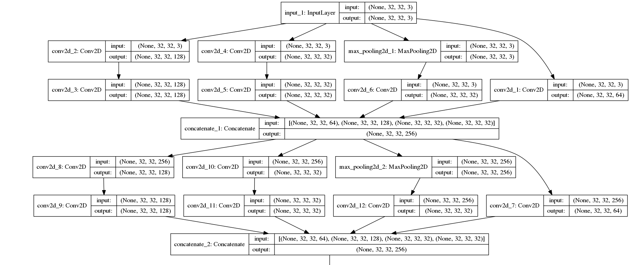

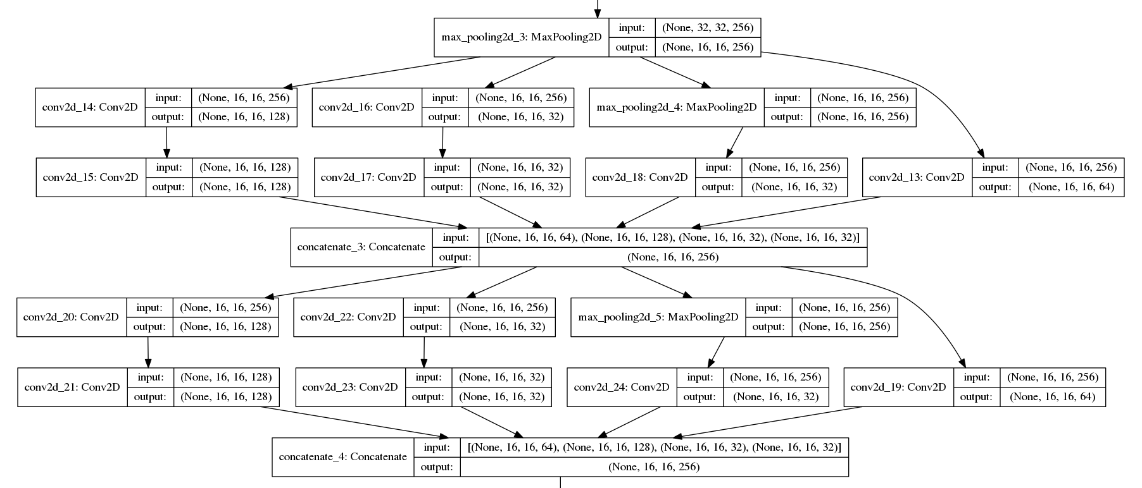

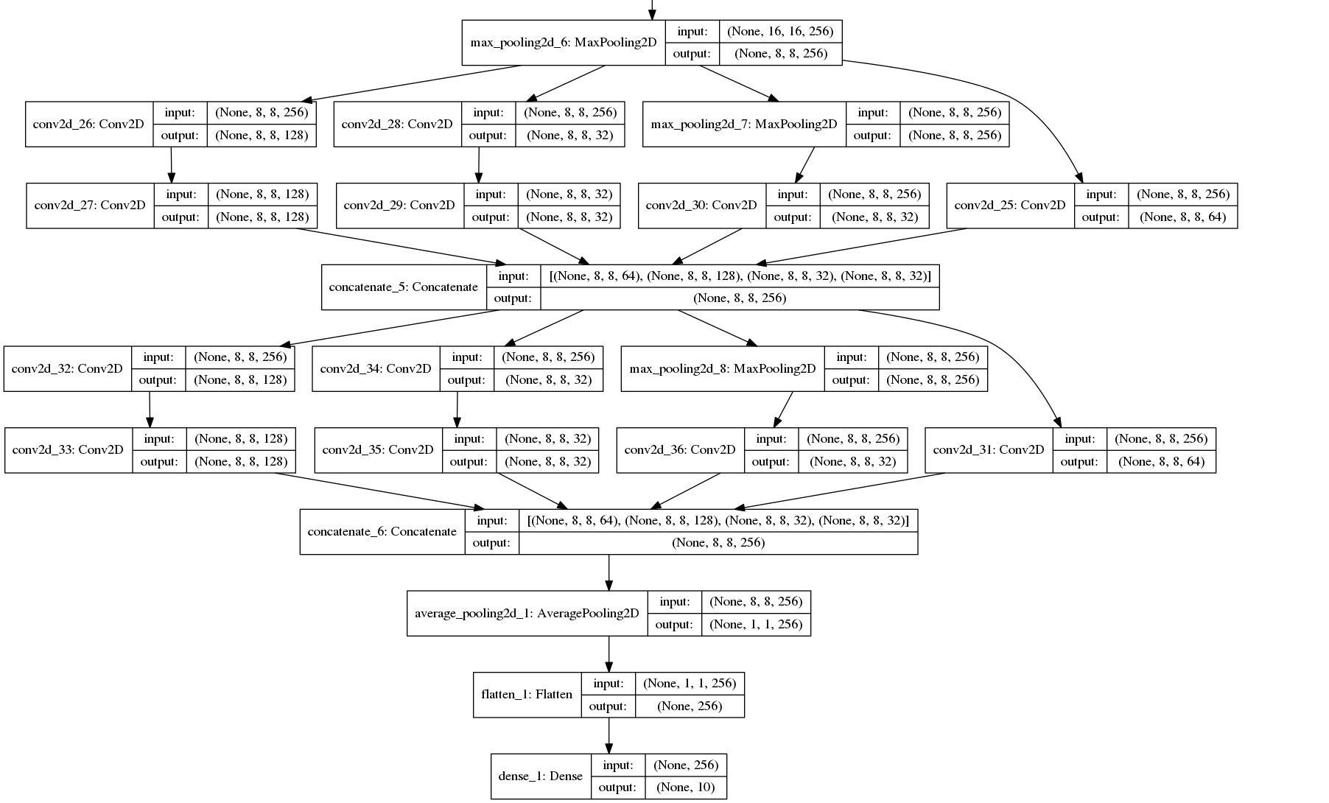

(PSI3472-2019 Aula 7 exercício 1) Modifique inception2.py de forma que o novo programa caogato3.py consiga reconhecer cachorros e gatos.

Meu resultado cão e gato usando inception2.py modificado::
Epoch 60/60 acc: 0.9772 - val_acc: 0.8810

Resumo das acuracidades do problema cão e gato:
 | train accuracy | validation accuracy
LeNet sem data augmentation | 99.78% | 73.10%
ResNet sem data augmentation | 100% | 75.55%
ResNet com data augmentation | 92.74% | 84.80%
Inception com data augmentation | 97.72% | 88.10%

(PSI3472-2019 Aula 7 se der tempo) Aumente a taxa de acerto do caogato3.py usando:
a) Ensemble de 3 redes neurais (o resultado será a categoria com a maioria dos votos).
b) Distorça cada imagem-teste de 3 formas diferentes (o resultado será a categoria com a maioria dos votos).
c) Combine ensemble de 3 redes neurais com 3 distorções.

(PSI3472-2019 Aula 7 exercício 2) O programa caogato1.py (aula 5, exercício 3, baseado em cnn1.py) usa API sequencial para descrever a estrutura da rede (model=Sequential(); etc). Reescreva o programa usado API funcional (inputs=Input(shape=input_shape); etc). Assegure que o novo programa (com API funcional) funciona da mesma forma que o antigo.
Rede inspirada em inception com batchNormalization e conexão residual.
Teria que aumentar número de filtros para aumentar acuracidade.

#inception5.py
#Rede inspirada em inception com batch normalization
#Com residual
#Teria que aumentar numero de filtros para aumentar acuracidade
import keras
from keras.datasets import cifar10
from keras.models import Model
from keras.layers import Dense, Conv2D, BatchNormalization, Activation
from keras.layers import AveragePooling2D, MaxPooling2D, Input, Flatten
from keras.regularizers import l2
from keras.optimizers import Adam
from keras.activations import relu
from keras.callbacks import ReduceLROnPlateau
from keras.preprocessing.image import ImageDataGenerator
import numpy as np
from inspect import currentframe, getframeinfo
import os

batch_size = 100
num_classes = 10
epochs = 50

# input image dimensions
nl, nc = 32,32

# the data, split between train and test sets
(ax, ay), (qx, qy) = cifar10.load_data()

#print('channels_last - formato de TensorFlow');
ax = ax.reshape(ax.shape[0], nl, nc, 3)
qx = qx.reshape(qx.shape[0], nl, nc, 3)
input_shape = (nl, nc, 3)

ax = ax.astype('float32')
qx = qx.astype('float32')
ax /= 255 #0 a 1
qx /= 255 #0 a 1

# convert class vectors to binary class matrices
ay = keras.utils.to_categorical(ay, num_classes)
qy = keras.utils.to_categorical(qy, num_classes)

inputs = Input(shape=input_shape)
x = inputs
nfiltros=64
x = Conv2D(4*nfiltros, (3,3), padding='same', activation='relu')(x)

tower_0 = Conv2D(nfiltros, (1,1), padding='same', activation='linear')(x)

tower_1 = Conv2D(32, (1,1), padding='same', activation='linear')(x)
tower_1 = Conv2D(2*nfiltros, (3,3), padding='same', activation='linear')(tower_1)

tower_2 = Conv2D(16, (1,1), padding='same', activation='linear')(x)
tower_2 = Conv2D(nfiltros//2, (5,5), padding='same', activation='linear')(tower_2)

tower_3 = MaxPooling2D((3,3), strides=(1,1), padding='same')(x)
tower_3 = Conv2D(nfiltros//2, (1,1), padding='same', activation='linear')(tower_3)

y = keras.layers.concatenate([tower_0, tower_1, tower_2, tower_3], axis = 3)
y = BatchNormalization()(y)
x = keras.layers.add([x, y])
x = Activation('relu')(x)

tower_0 = Conv2D(nfiltros, (1,1), padding='same', activation='linear')(x)

tower_1 = Conv2D(32, (1,1), padding='same', activation='linear')(x)
tower_1 = Conv2D(2*nfiltros, (3,3), padding='same', activation='linear')(tower_1)

tower_2 = Conv2D(16, (1,1), padding='same', activation='linear')(x)
tower_2 = Conv2D(nfiltros//2, (5,5), padding='same', activation='linear')(tower_2)

tower_3 = MaxPooling2D((3,3), strides=(1,1), padding='same')(x)
tower_3 = Conv2D(nfiltros//2, (1,1), padding='same', activation='linear')(tower_3)

y = keras.layers.concatenate([tower_0, tower_1, tower_2, tower_3], axis = 3)
y = BatchNormalization()(y)
x = keras.layers.add([x, y])
x = Activation('relu')(x)
x = MaxPooling2D(2)(x);

tower_0 = Conv2D(nfiltros, (1,1), padding='same', activation='linear')(x)

tower_1 = Conv2D(32, (1,1), padding='same', activation='linear')(x)
tower_1 = Conv2D(2*nfiltros, (3,3), padding='same', activation='linear')(tower_1)

tower_2 = Conv2D(16, (1,1), padding='same', activation='linear')(x)
tower_2 = Conv2D(nfiltros//2, (5,5), padding='same', activation='linear')(tower_2)

tower_3 = MaxPooling2D((3,3), strides=(1,1), padding='same')(x)
tower_3 = Conv2D(nfiltros//2, (1,1), padding='same', activation='linear')(tower_3)

y = keras.layers.concatenate([tower_0, tower_1, tower_2, tower_3], axis = 3)
y = BatchNormalization()(y)
x = keras.layers.add([x, y])
x = Activation('relu')(x)

tower_0 = Conv2D(nfiltros, (1,1), padding='same', activation='linear')(x)

tower_1 = Conv2D(32, (1,1), padding='same', activation='linear')(x)
tower_1 = Conv2D(2*nfiltros, (3,3), padding='same', activation='linear')(tower_1)

tower_2 = Conv2D(16, (1,1), padding='same', activation='linear')(x)
tower_2 = Conv2D(nfiltros//2, (5,5), padding='same', activation='linear')(tower_2)

tower_3 = MaxPooling2D((3,3), strides=(1,1), padding='same')(x)
tower_3 = Conv2D(nfiltros//2, (1,1), padding='same', activation='linear')(tower_3)

y = keras.layers.concatenate([tower_0, tower_1, tower_2, tower_3], axis = 3)
y = BatchNormalization()(y)
x = keras.layers.add([x, y])
x = Activation('relu')(x)
x = MaxPooling2D(2)(x);

tower_0 = Conv2D(nfiltros, (1,1), padding='same', activation='linear')(x)

tower_1 = Conv2D(16, (1,1), padding='same', activation='linear')(x)
tower_1 = Conv2D(2*nfiltros, (3,3), padding='same', activation='linear')(tower_1)

tower_2 = Conv2D(8, (1,1), padding='same', activation='linear')(x)
tower_2 = Conv2D(nfiltros//2, (5,5), padding='same', activation='linear')(tower_2)

tower_3 = MaxPooling2D((3,3), strides=(1,1), padding='same')(x)
tower_3 = Conv2D(nfiltros//2, (1,1), padding='same', activation='linear')(tower_3)

y = keras.layers.concatenate([tower_0, tower_1, tower_2, tower_3], axis = 3)
y = BatchNormalization()(y)
x = keras.layers.add([x, y])
x = Activation('relu')(x)

tower_0 = Conv2D(nfiltros, (1,1), padding='same', activation='linear')(x)

tower_1 = Conv2D(8, (1,1), padding='same', activation='linear')(x)
tower_1 = Conv2D(2*nfiltros, (3,3), padding='same', activation='linear')(tower_1)

tower_2 = Conv2D(4, (1,1), padding='same', activation='linear')(x)
tower_2 = Conv2D(nfiltros//2, (5,5), padding='same', activation='linear')(tower_2)

tower_3 = MaxPooling2D((3,3), strides=(1,1), padding='same')(x)
tower_3 = Conv2D(nfiltros//2, (1,1), padding='same', activation='linear')(tower_3)

y = keras.layers.concatenate([tower_0, tower_1, tower_2, tower_3], axis = 3)
y = BatchNormalization()(y)
x = keras.layers.add([x, y])
x = Activation('relu')(x)
output = AveragePooling2D(8)(x);

output = Flatten()(output)
outputs= Dense(10, activation='softmax')(output)

# Instantiate model.
model = Model(inputs=inputs, outputs=outputs)

from keras.utils import plot_model
fi = getframeinfo(currentframe()); nomeprog=os.path.splitext(fi.filename)[0];
plot_model(model, to_file=nomeprog+'.png', show_shapes=True)
from keras.utils import print_summary
print_summary(model)

opt=Adam()
model.compile(optimizer=opt,
loss='categorical_crossentropy',
metrics=['accuracy'])

lr_reducer = ReduceLROnPlateau(factor=0.1**(1/2),
cooldown=0,
patience=5,
min_lr=0.5e-6,
verbose=True)

print('Using real-time data augmentation.')
datagen = ImageDataGenerator(
# randomly shift images horizontally - Fraction of width
width_shift_range=0.1,
# randomly shift images vertically - Fraction of height
height_shift_range=0.1,
# set range for random shear
fill_mode='nearest',
# value used for fill_mode = "constant"
horizontal_flip=True)

# Compute quantities required for featurewise normalization
# (std, mean, and principal components if ZCA whitening is applied).
datagen.fit(ax)
model.fit_generator(datagen.flow(ax, ay, batch_size=batch_size),
epochs=epochs,
verbose=True,
validation_data=(qx, qy),
callbacks=[lr_reducer],
steps_per_epoch=ax.shape[0]//batch_size)

score = model.evaluate(qx, qy, verbose=0)
print('Test loss:', score[0])
print('Test accuracy:', score[1])

model.save(nomeprog+'.h5')

Total params: 459,374
Trainable params: 456,302
Non-trainable params: 3,072

Epoch 00046: ReduceLROnPlateau reducing learning rate to 1.0000000553323957e-06.
Epoch 47/50 - 276s 551ms/step - loss: 0.1001 - acc: 0.9674 - val_loss: 0.3554 - val_acc: 0.8958
Epoch 48/50 - 277s 554ms/step - loss: 0.0991 - acc: 0.9678 - val_loss: 0.3541 - val_acc: 0.8966
Epoch 49/50 - 278s 555ms/step - loss: 0.1009 - acc: 0.9662 - val_loss: 0.3556 - val_acc: 0.8958
Epoch 50/50 - 278s 556ms/step - loss: 0.1019 - acc: 0.9661 - val_loss: 0.3551 - val_acc: 0.8959

