Capítulo 10: Accumulator buffer: antialiasing, foco, motion blur.

Arquivo jitter.h:

/*
jitter.h

This file contains jitter point arrays for 2,3,4,8,15,24 and 66 jitters.

The arrays are named j2, j3, etc. Each element in the array has the form,
for example, j8[0].x and j8[0].y

Values are floating point in the range -.5 < x < .5, -.5 < y < .5, and
have a gaussian distribution around the origin.

Use these to do model jittering for scene anti-aliasing and view volume
jittering for depth of field effects. Use in conjunction with the
accwindow() routine.
*/

typedef struct
{
GLfloat x, y;
} jitter_point;

#define MAX_SAMPLES 66

/* 2 jitter points */
jitter_point j2[] =
{
{ 0.246490, 0.249999},
{-0.246490, -0.249999}
};

/* 3 jitter points */
jitter_point j3[] =
{
{-0.373411, -0.250550},
{ 0.256263, 0.368119},
{ 0.117148, -0.117570}
};

/* 4 jitter points */
jitter_point j4[] =
{
{-0.208147, 0.353730},
{ 0.203849, -0.353780},
{-0.292626, -0.149945},
{ 0.296924, 0.149994}
};

/* 8 jitter points */
jitter_point j8[] =
{
{-0.334818, 0.435331},
{ 0.286438, -0.393495},
{ 0.459462, 0.141540},
{-0.414498, -0.192829},
{-0.183790, 0.082102},
{-0.079263, -0.317383},
{ 0.102254, 0.299133},
{ 0.164216, -0.054399}
};

/* 15 jitter points */
jitter_point j15[] =
{
{ 0.285561, 0.188437},
{ 0.360176, -0.065688},
{-0.111751, 0.275019},
{-0.055918, -0.215197},
{-0.080231, -0.470965},
{ 0.138721, 0.409168},
{ 0.384120, 0.458500},
{-0.454968, 0.134088},
{ 0.179271, -0.331196},
{-0.307049, -0.364927},
{ 0.105354, -0.010099},
{-0.154180, 0.021794},
{-0.370135, -0.116425},
{ 0.451636, -0.300013},
{-0.370610, 0.387504}
};

/* 24 jitter points */
jitter_point j24[] =
{
{ 0.030245, 0.136384},
{ 0.018865, -0.348867},
{-0.350114, -0.472309},
{ 0.222181, 0.149524},
{-0.393670, -0.266873},
{ 0.404568, 0.230436},
{ 0.098381, 0.465337},
{ 0.462671, 0.442116},
{ 0.400373, -0.212720},
{-0.409988, 0.263345},
{-0.115878, -0.001981},
{ 0.348425, -0.009237},
{-0.464016, 0.066467},
{-0.138674, -0.468006},
{ 0.144932, -0.022780},
{-0.250195, 0.150161},
{-0.181400, -0.264219},
{ 0.196097, -0.234139},
{-0.311082, -0.078815},
{ 0.268379, 0.366778},
{-0.040601, 0.327109},
{-0.234392, 0.354659},
{-0.003102, -0.154402},
{ 0.297997, -0.417965}
};

/* 66 jitter points */
jitter_point j66[] =
{
{ 0.266377, -0.218171},
{-0.170919, -0.429368},
{ 0.047356, -0.387135},
{-0.430063, 0.363413},
{-0.221638, -0.313768},
{ 0.124758, -0.197109},
{-0.400021, 0.482195},
{ 0.247882, 0.152010},
{-0.286709, -0.470214},
{-0.426790, 0.004977},
{-0.361249, -0.104549},
{-0.040643, 0.123453},
{-0.189296, 0.438963},
{-0.453521, -0.299889},
{ 0.408216, -0.457699},
{ 0.328973, -0.101914},
{-0.055540, -0.477952},
{ 0.194421, 0.453510},
{ 0.404051, 0.224974},
{ 0.310136, 0.419700},
{-0.021743, 0.403898},
{-0.466210, 0.248839},
{ 0.341369, 0.081490},
{ 0.124156, -0.016859},
{-0.461321, -0.176661},
{ 0.013210, 0.234401},
{ 0.174258, -0.311854},
{ 0.294061, 0.263364},
{-0.114836, 0.328189},
{ 0.041206, -0.106205},
{ 0.079227, 0.345021},
{-0.109319, -0.242380},
{ 0.425005, -0.332397},
{ 0.009146, 0.015098},
{-0.339084, -0.355707},
{-0.224596, -0.189548},
{ 0.083475, 0.117028},
{ 0.295962, -0.334699},
{ 0.452998, 0.025397},
{ 0.206511, -0.104668},
{ 0.447544, -0.096004},
{-0.108006, -0.002471},
{-0.380810, 0.130036},
{-0.242440, 0.186934},
{-0.200363, 0.070863},
{-0.344844, -0.230814},
{ 0.408660, 0.345826},
{-0.233016, 0.305203},
{ 0.158475, -0.430762},
{ 0.486972, 0.139163},
{-0.301610, 0.009319},
{ 0.282245, -0.458671},
{ 0.482046, 0.443890},
{-0.121527, 0.210223},
{-0.477606, -0.424878},
{-0.083941, -0.121440},
{-0.345773, 0.253779},
{ 0.234646, 0.034549},
{ 0.394102, -0.210901},
{-0.312571, 0.397656},
{ 0.200906, 0.333293},
{ 0.018703, -0.261792},
{-0.209349, -0.065383},
{ 0.076248, 0.478538},
{-0.073036, -0.355064},
{ 0.145087, 0.221726}
};
/* accpersp2.cpp
* Versao com anti-aliasing
*/
#include <GL/glut.h>
#include <stdlib.h>
#include <math.h>
#include "jitter.h"

/* accFrustum()
* The first 6 arguments are identical to the glFrustum() call.
*
* pixdx and pixdy are anti-alias jitter in pixels.
* Set both equal to 0.0 for no anti-alias jitter.
* eyedx and eyedy are depth-of field jitter in pixels.
* Set both equal to 0.0 for no depth of field effects.
*
* focus is distance from eye to plane in focus.
* focus must be greater than, but not equal to 0.0.
*
* Note that accFrustum() calls glTranslatef(). You will
* probably want to insure that your ModelView matrix has been
* initialized to identity before calling accFrustum().
*/
void accFrustum(GLdouble left, GLdouble right, GLdouble bottom,
GLdouble top, GLdouble zNear, GLdouble zFar, GLdouble pixdx,
GLdouble pixdy, GLdouble eyedx, GLdouble eyedy, GLdouble focus)
{
GLdouble xwsize, ywsize;
GLdouble dx, dy;
GLint viewport[4];

glGetIntegerv (GL_VIEWPORT, viewport);

xwsize = right - left;
ywsize = top - bottom;

dx = -(pixdx*xwsize/(GLdouble) viewport[2] + eyedx*zNear/focus);
dy = -(pixdy*ywsize/(GLdouble) viewport[3] + eyedy*zNear/focus);

glMatrixMode(GL_PROJECTION);
glLoadIdentity();
glFrustum (left + dx, right + dx, bottom + dy, top + dy, zNear, zFar);
glMatrixMode(GL_MODELVIEW);
glLoadIdentity();
glTranslatef (-eyedx, -eyedy, 0.0);
}

/* accPerspective()
* The first 4 arguments are identical to the gluPerspective() call.
* pixdx and pixdy are anti-alias jitter in pixels.
* Set both equal to 0.0 for no anti-alias jitter.
* eyedx and eyedy are depth-of field jitter in pixels.
* Set both equal to 0.0 for no depth of field effects.
*
* focus is distance from eye to plane in focus.
* focus must be greater than, but not equal to 0.0.
*
* Note that accPerspective() calls accFrustum().
*/
void accPerspective(GLdouble fovy, GLdouble aspect,
GLdouble zNear, GLdouble zFar, GLdouble pixdx, GLdouble pixdy,
GLdouble eyedx, GLdouble eyedy, GLdouble focus)
{
GLdouble fov2,left,right,bottom,top;

fov2 = ((fovy*M_PI) / 180.0) / 2.0;

top = zNear / (cos(fov2) / sin(fov2));
bottom = -top;

right = top * aspect;
left = -right;

accFrustum (left, right, bottom, top, zNear, zFar,
pixdx, pixdy, eyedx, eyedy, focus);
}

/* Initialize lighting and other values.
*/
void init(void)
{
GLfloat mat_ambient[] = { 1.0, 1.0, 1.0, 1.0 };
GLfloat mat_specular[] = { 1.0, 1.0, 1.0, 1.0 };
GLfloat light_position[] = { 0.0, 0.0, 10.0, 1.0 };
GLfloat lm_ambient[] = { 0.2, 0.2, 0.2, 1.0 };

glMaterialfv(GL_FRONT, GL_AMBIENT, mat_ambient);
glMaterialfv(GL_FRONT, GL_SPECULAR, mat_specular);
glMaterialf(GL_FRONT, GL_SHININESS, 50.0);
glLightfv(GL_LIGHT0, GL_POSITION, light_position);
glLightModelfv(GL_LIGHT_MODEL_AMBIENT, lm_ambient);

glEnable(GL_LIGHTING);
glEnable(GL_LIGHT0);
glEnable(GL_DEPTH_TEST);
glShadeModel (GL_FLAT);

glClearColor(0.0, 0.0, 0.0, 0.0);
glClearAccum(0.0, 0.0, 0.0, 0.0);
}

void displayObjects(void)
{
GLfloat torus_diffuse[] = { 0.7, 0.7, 0.0, 1.0 };
GLfloat cube_diffuse[] = { 0.0, 0.7, 0.7, 1.0 };
GLfloat sphere_diffuse[] = { 0.7, 0.0, 0.7, 1.0 };
GLfloat octa_diffuse[] = { 0.7, 0.4, 0.4, 1.0 };

glPushMatrix ();
glTranslatef (0.0, 0.0, -5.0);
glRotatef (30.0, 1.0, 0.0, 0.0);

glPushMatrix ();
glTranslatef (-0.80, 0.35, 0.0);
glRotatef (100.0, 1.0, 0.0, 0.0);
glMaterialfv(GL_FRONT, GL_DIFFUSE, torus_diffuse);
glutSolidTorus (0.275, 0.85, 16, 16);
glPopMatrix ();

glPushMatrix ();
glTranslatef (-0.75, -0.50, 0.0);
glRotatef (45.0, 0.0, 0.0, 1.0);
glRotatef (45.0, 1.0, 0.0, 0.0);
glMaterialfv(GL_FRONT, GL_DIFFUSE, cube_diffuse);
glutSolidCube (1.5);
glPopMatrix ();

glPushMatrix ();
glTranslatef (0.75, 0.60, 0.0);
glRotatef (30.0, 1.0, 0.0, 0.0);
glMaterialfv(GL_FRONT, GL_DIFFUSE, sphere_diffuse);
glutSolidSphere (1.0, 16, 16);
glPopMatrix ();

glPushMatrix ();
glTranslatef (0.70, -0.90, 0.25);
glMaterialfv(GL_FRONT, GL_DIFFUSE, octa_diffuse);
glutSolidOctahedron ();
glPopMatrix ();

glPopMatrix ();
}

void display(void)
{ int ACSIZE=8;
GLint viewport[4];
int jitter;

glGetIntegerv (GL_VIEWPORT, viewport);

glClear(GL_ACCUM_BUFFER_BIT);
for (jitter = 0; jitter < ACSIZE; jitter++) {
glClear(GL_COLOR_BUFFER_BIT | GL_DEPTH_BUFFER_BIT);
accPerspective (50.0,
(GLdouble) viewport[2]/(GLdouble) viewport[3],
1.0, 15.0, j8[jitter].x, j8[jitter].y, 0.0, 0.0, 1.0);
displayObjects ();
glAccum(GL_ACCUM, 1.0/ACSIZE);
}
glAccum (GL_RETURN, 1.0);
glutSwapBuffers();
}

void reshape(int w, int h)
{
glViewport(0, 0, (GLsizei) w, (GLsizei) h);
}

void keyboard(unsigned char key, int x, int y)
{
switch (key) {
case 27:
exit(0);
break;
}
}

/* Main Loop
* Be certain you request an accumulation buffer.
*/
int main(int argc, char** argv)
{
glutInit(&argc, argv);
glutInitDisplayMode (GLUT_DOUBLE | GLUT_RGB
| GLUT_ACCUM | GLUT_DEPTH);
glutInitWindowSize (200,200);
//glutInitWindowPosition (100, 100);
glutCreateWindow (argv[0]);
init();
glutReshapeFunc(reshape);
glutDisplayFunc(display);
glutKeyboardFunc(keyboard);
glutMainLoop();
return 0;
}

Nota: Mudei para GLUT_DOUBLE e glutSwapBuffers(). Não funciona bem do jeito que está no livro.

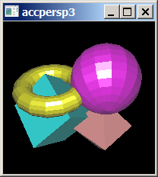
Sem anti-aliasing

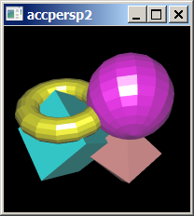
Com anti-aliasing
/* accpersp5.cpp - Grad2014
* Versao com anti-aliasing
*/
#include <cekeikon.h>
#include <GL/glut.h>
#include "jitter.h"

// haePerspective()
//
// The first 4 arguments are identical to the gluPerspective() call.
// The next 9 arguments are identical to the gluLookAt() call.
//
// pixdx and pixdy are anti-alias jitter in pixels.
// Set both equal to 0.0 for no anti-alias jitter.
// eyedx and eyedy are depth-of field jitter in distance units.
// Set both equal to 0.0 for no depth of field effects.
// focus plane is located at center point
void haePerspective(
GLdouble fovy, GLdouble aspect, GLdouble zNear, GLdouble zFar,
GLdouble eyex, GLdouble eyey, GLdouble eyez,
GLdouble centerx, GLdouble centery, GLdouble centerz,
GLdouble upx, GLdouble upy, GLdouble upz,
GLdouble pixdx, GLdouble pixdy,
GLdouble eyedx, GLdouble eyedy)
{
glMatrixMode(GL_PROJECTION);
glLoadIdentity();
gluPerspective(fovy, aspect, zNear, zFar);

GLdouble ywsize = 2.0 * zNear * tan(deg2rad(fovy/2.0));
GLdouble xwsize = aspect * ywsize;
GLint viewport[4];
glGetIntegerv(GL_VIEWPORT, viewport);
GLdouble pelPorMX = (GLdouble)viewport[2]/xwsize;
GLdouble pelPorMY = (GLdouble)viewport[3]/ywsize;

glMatrixMode(GL_MODELVIEW);
glLoadIdentity();
gluLookAt(eyex+pixdx/pelPorMX+eyedx, eyey+pixdy/pelPorMY+eyedy, eyez,
centerx+pixdx/pelPorMX, centery+pixdy/pelPorMY, centerz,
upx, upy, upz);
}

void init(void)
{ glLightModelfv(GL_LIGHT_MODEL_AMBIENT, move( (GLfloat[]){ 0,0,0,0 }) );

glLightfv(GL_LIGHT0, GL_AMBIENT, move( (GLfloat[]){ 1,1,1,1 }) );
glLightfv(GL_LIGHT0, GL_DIFFUSE, move( (GLfloat[]){ 1,1,1,1 }) );
glLightfv(GL_LIGHT0, GL_SPECULAR, move( (GLfloat[]){ 1,1,1,1 }) );
glLightfv(GL_LIGHT0, GL_POSITION, move( (GLfloat[]){ 5,5,5,0 }) );

glEnable(GL_LIGHTING);
glEnable(GL_LIGHT0);
glEnable(GL_DEPTH_TEST);
glShadeModel(GL_FLAT);

glClearColor(0.0, 0.0, 0.0, 0.0);
glClearAccum(0.0, 0.0, 0.0, 0.0);
}

void displayObjects(void)
{ glMaterialfv(GL_FRONT, GL_AMBIENT, move( (GLfloat[]){ 0.2, 0.2, 0.2, 1 }) );
glMaterialfv(GL_FRONT, GL_SPECULAR, move( (GLfloat[]){ 0.8, 0.8, 0.8, 1 }) );
glMaterialf(GL_FRONT, GL_SHININESS, 50.0);
glMaterialfv(GL_FRONT, GL_DIFFUSE, move( (GLfloat[]){ 0.7, 0.0, 0.7, 1.0 }) );
glutSolidSphere(1.0, 32, 32);
}

void display(void)
{ int ACSIZE=8; //mude de 8 para 1 para ver o efeito
#define jitter j8

GLint viewport[4];
glGetIntegerv(GL_VIEWPORT, viewport);
glClear(GL_ACCUM_BUFFER_BIT);

for (int j=0; j<ACSIZE; j++) {
glClear(GL_COLOR_BUFFER_BIT | GL_DEPTH_BUFFER_BIT);

haePerspective(50.0, (GLdouble)viewport[2]/(GLdouble)viewport[3], 1.0, 15.0,
0, 2, 2, 0, 0, 0, 0, 1, 0,
3*jitter[j].x, 3*jitter[j].y, 0.0, 0.0);

displayObjects();
glAccum(GL_ACCUM, 1.0/ACSIZE);
}
glAccum(GL_RETURN, 1.0);
glutSwapBuffers();
}

void reshape(int w, int h)
{ glViewport(0, 0, (GLsizei) w, (GLsizei) h); }

void keyboard(unsigned char key, int x, int y)
{ if (key==27) exit(0); }

int main(int argc, char** argv)
{ glutInit(&argc, argv);
glutInitDisplayMode(GLUT_DOUBLE | GLUT_RGB | GLUT_ACCUM | GLUT_DEPTH);
glutInitWindowSize(200,200);
glutCreateWindow(argv[0]);
init();
glutReshapeFunc(reshape);
glutDisplayFunc(display);
glutKeyboardFunc(keyboard);
glutMainLoop();
return 0;
}

Sem anti-aliasing

Com anti-aliasing
/*
* dof2.cpp - grad2014
* This program demonstrates use of the accumulation buffer to
* create an out-of-focus depth-of-field effect. The teapots
* are drawn several times into the accumulation buffer. The
* viewing volume is jittered, except at the focal point, where
* the viewing volume is at the same position, each time. In
* this case, the gold teapot remains in focus.
*/
#include <GL/glut.h>
#include <stdlib.h>
#include <math.h>
#include "jitter.h"

/* accFrustum()
* The first 6 arguments are identical to the glFrustum() call.
*
* pixdx and pixdy are anti-alias jitter in pixels.
* Set both equal to 0.0 for no anti-alias jitter.
* eyedx and eyedy are depth-of field jitter in pixels.
* Set both equal to 0.0 for no depth of field effects.
*
* focus is distance from eye to plane in focus.
* focus must be greater than, but not equal to 0.0.
*
* Note that accFrustum() calls glTranslatef(). You will
* probably want to insure that your ModelView matrix has been
* initialized to identity before calling accFrustum().
*/
void accFrustum(GLdouble left, GLdouble right, GLdouble bottom,
GLdouble top, GLdouble zNear, GLdouble zFar, GLdouble pixdx,
GLdouble pixdy, GLdouble eyedx, GLdouble eyedy, GLdouble focus)
{
GLdouble xwsize, ywsize;
GLdouble dx, dy;
GLint viewport[4];

glGetIntegerv (GL_VIEWPORT, viewport);

xwsize = right - left;
ywsize = top - bottom;

dx = -(pixdx*xwsize/(GLdouble) viewport[2] + eyedx*zNear/focus);
dy = -(pixdy*ywsize/(GLdouble) viewport[3] + eyedy*zNear/focus);

glMatrixMode(GL_PROJECTION);
glLoadIdentity();
glFrustum (left + dx, right + dx, bottom + dy, top + dy, zNear, zFar);
glMatrixMode(GL_MODELVIEW);
glLoadIdentity();
glTranslatef (-eyedx, -eyedy, 0.0);
}

/* accPerspective()
*
* The first 4 arguments are identical to the gluPerspective() call.
* pixdx and pixdy are anti-alias jitter in pixels.
* Set both equal to 0.0 for no anti-alias jitter.
* eyedx and eyedy are depth-of field jitter in pixels.
* Set both equal to 0.0 for no depth of field effects.
*
* focus is distance from eye to plane in focus.
* focus must be greater than, but not equal to 0.0.
*
* Note that accPerspective() calls accFrustum().
*/
void accPerspective(GLdouble fovy, GLdouble aspect,
GLdouble zNear, GLdouble zFar, GLdouble pixdx, GLdouble pixdy,
GLdouble eyedx, GLdouble eyedy, GLdouble focus)
{
GLdouble fov2,left,right,bottom,top;

fov2 = ((fovy*M_PI) / 180.0) / 2.0;

top = zNear / (cos(fov2) / sin(fov2));
bottom = -top;

right = top * aspect;
left = -right;

accFrustum (left, right, bottom, top, zNear, zFar,
pixdx, pixdy, eyedx, eyedy, focus);
}

void init(void)
{
GLfloat ambient[] = { 0.0, 0.0, 0.0, 1.0 };
GLfloat diffuse[] = { 1.0, 1.0, 1.0, 1.0 };
//GLfloat specular[] = { 1.0, 1.0, 1.0, 1.0 };
GLfloat position[] = { 0.0, 3.0, 3.0, 0.0 };

GLfloat lmodel_ambient[] = { 0.2, 0.2, 0.2, 1.0 };
GLfloat local_view[] = { 0.0 };

glLightfv(GL_LIGHT0, GL_AMBIENT, ambient);
glLightfv(GL_LIGHT0, GL_DIFFUSE, diffuse);
glLightfv(GL_LIGHT0, GL_POSITION, position);

glLightModelfv(GL_LIGHT_MODEL_AMBIENT, lmodel_ambient);
glLightModelfv(GL_LIGHT_MODEL_LOCAL_VIEWER, local_view);

glFrontFace (GL_CW);
glEnable(GL_LIGHTING);
glEnable(GL_LIGHT0);
glEnable(GL_AUTO_NORMAL);
glEnable(GL_NORMALIZE);
glEnable(GL_DEPTH_TEST);

glClearColor(0.0, 0.0, 0.0, 0.0);
glClearAccum(0.0, 0.0, 0.0, 0.0);
}

void renderTeapot (GLfloat x, GLfloat y, GLfloat z,
GLfloat ambr, GLfloat ambg, GLfloat ambb,
GLfloat difr, GLfloat difg, GLfloat difb,
GLfloat specr, GLfloat specg, GLfloat specb, GLfloat shine)
{
GLfloat mat[4];

glPushMatrix();
glTranslatef (x, y, z);
mat[0] = ambr; mat[1] = ambg; mat[2] = ambb; mat[3] = 1.0;
glMaterialfv (GL_FRONT, GL_AMBIENT, mat);
mat[0] = difr; mat[1] = difg; mat[2] = difb;
glMaterialfv (GL_FRONT, GL_DIFFUSE, mat);
mat[0] = specr; mat[1] = specg; mat[2] = specb;
glMaterialfv (GL_FRONT, GL_SPECULAR, mat);
glMaterialf (GL_FRONT, GL_SHININESS, shine*128.0);
glutSolidTeapot(0.5);
glPopMatrix();
}

/* display() draws 5 teapots into the accumulation buffer
* several times; each time with a jittered perspective.
* The focal point is at z = 5.0, so the gold teapot will
* stay in focus. The amount of jitter is adjusted by the
* magnitude of the accPerspective() jitter; in this example, 0.33.
* In this example, the teapots are drawn 8 times. See jitter.h
*/
void display(void)
{
int jitter;
GLint viewport[4];

glGetIntegerv (GL_VIEWPORT, viewport);
glClear(GL_ACCUM_BUFFER_BIT);

for (jitter = 0; jitter < 24; jitter++) {
glClear(GL_COLOR_BUFFER_BIT | GL_DEPTH_BUFFER_BIT);
accPerspective (45.0,
(GLdouble) viewport[2]/(GLdouble) viewport[3],
1.0, 15.0, 0.0, 0.0,
0.2*j24[jitter].x, 0.2*j24[jitter].y, 5.0);

/* ruby, gold, silver, emerald, and cyan teapots */
renderTeapot (-1.1, -0.5, -4.5, 0.1745, 0.01175,
0.01175, 0.61424, 0.04136, 0.04136,
0.727811, 0.626959, 0.626959, 0.6);
renderTeapot (-0.5, -0.5, -5.0, 0.24725, 0.1995,
0.0745, 0.75164, 0.60648, 0.22648,
0.628281, 0.555802, 0.366065, 0.4);
renderTeapot (0.2, -0.5, -5.5, 0.19225, 0.19225,
0.19225, 0.50754, 0.50754, 0.50754,
0.508273, 0.508273, 0.508273, 0.4);
renderTeapot (1.0, -0.5, -6.0, 0.0215, 0.1745, 0.0215,
0.07568, 0.61424, 0.07568, 0.633,
0.727811, 0.633, 0.6);
renderTeapot (1.8, -0.5, -6.5, 0.0, 0.1, 0.06, 0.0,
0.50980392, 0.50980392, 0.50196078,
0.50196078, 0.50196078, .25);
glAccum (GL_ACCUM, 1.0/24.0);
}
glAccum (GL_RETURN, 1.0);
glutSwapBuffers();
}

void reshape(int w, int h)
{
glViewport(0, 0, (GLsizei) w, (GLsizei) h);
}

void keyboard(unsigned char key, int x, int y)
{ if (key==27) exit(0); }

/* Main Loop
* Be certain you request an accumulation buffer.
*/
int main(int argc, char** argv)
{
glutInit(&argc, argv);
glutInitDisplayMode (GLUT_DOUBLE | GLUT_RGB | GLUT_ACCUM | GLUT_DEPTH);
glutInitWindowSize(800,800);
glutInitWindowPosition(10,10);
glutCreateWindow (argv[0]);
//glutFullScreen();
init();
glutReshapeFunc(reshape);
glutDisplayFunc(display);
glutKeyboardFunc(keyboard);
glutMainLoop();
return 0;
}
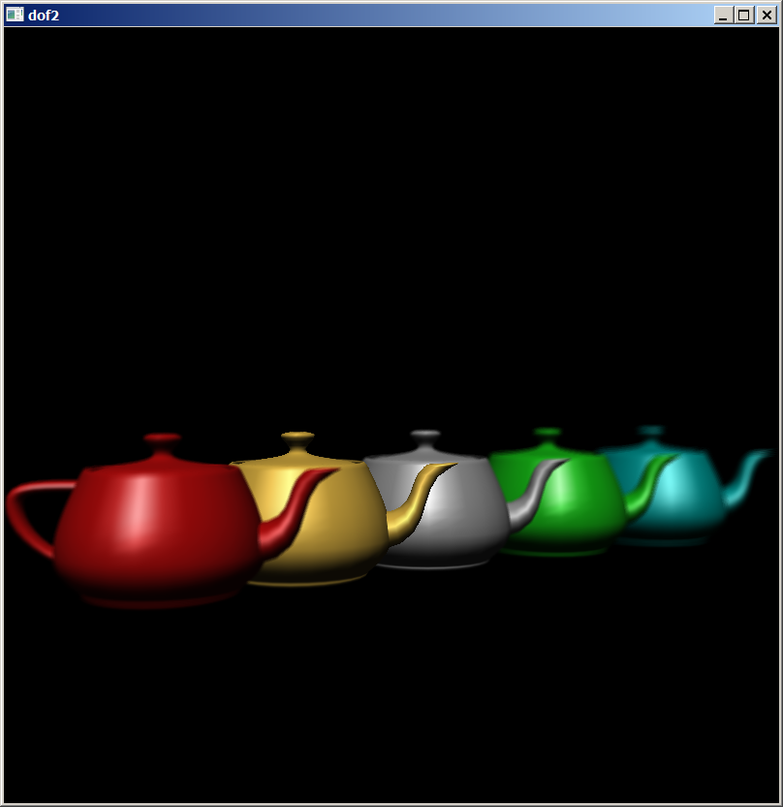

//dof3.cpp - grad2014
#include <cekeikon.h>
#include <GL/glut.h>
#include "jitter.h"

// haePerspective()
//
// The first 4 arguments are identical to the gluPerspective() call.
// The next 9 arguments are identical to the gluLookAt() call.
//
// pixdx and pixdy are anti-alias jitter in pixels.
// Set both equal to 0.0 for no anti-alias jitter.
// eyedx and eyedy are depth-of field jitter in distance units.
// Set both equal to 0.0 for no depth of field effects.
// focus plane is located at center point
void haePerspective(
GLdouble fovy, GLdouble aspect, GLdouble zNear, GLdouble zFar,
GLdouble eyex, GLdouble eyey, GLdouble eyez,
GLdouble centerx, GLdouble centery, GLdouble centerz,
GLdouble upx, GLdouble upy, GLdouble upz,
GLdouble pixdx, GLdouble pixdy,
GLdouble eyedx, GLdouble eyedy)
{
glMatrixMode(GL_PROJECTION);
glLoadIdentity();
gluPerspective(fovy, aspect, zNear, zFar);

GLdouble ywsize = 2.0 * zNear * tan(deg2rad(fovy/2.0));
GLdouble xwsize = aspect * ywsize;
GLint viewport[4];
glGetIntegerv(GL_VIEWPORT, viewport);
GLdouble pelPorMX = (GLdouble)viewport[2]/xwsize;
GLdouble pelPorMY = (GLdouble)viewport[3]/ywsize;

glMatrixMode(GL_MODELVIEW);
glLoadIdentity();
gluLookAt(eyex+pixdx/pelPorMX+eyedx, eyey+pixdy/pelPorMY+eyedy, eyez,
centerx+pixdx/pelPorMX, centery+pixdy/pelPorMY, centerz,
upx, upy, upz);
}

void init(void)
{ glLightModelfv(GL_LIGHT_MODEL_AMBIENT, move( (GLfloat[]){ 0,0,0,0 }) );

glLightfv(GL_LIGHT0, GL_AMBIENT, move( (GLfloat[]){ 1,1,1,1 }) );
glLightfv(GL_LIGHT0, GL_DIFFUSE, move( (GLfloat[]){ 1,1,1,1 }) );
glLightfv(GL_LIGHT0, GL_SPECULAR, move( (GLfloat[]){ 1,1,1,1 }) );
glLightfv(GL_LIGHT0, GL_POSITION, move( (GLfloat[]){ 9,9,9,0 }) );

glEnable(GL_LIGHTING);
glEnable(GL_LIGHT0);
glEnable(GL_DEPTH_TEST);
glShadeModel(GL_FLAT);

glClearColor(0.0, 0.0, 0.0, 0.0);
glClearAccum(0.0, 0.0, 0.0, 0.0);
}

void renderTeapot (GLfloat x, GLfloat y, GLfloat z,
GLfloat ambr, GLfloat ambg, GLfloat ambb,
GLfloat difr, GLfloat difg, GLfloat difb,
GLfloat specr, GLfloat specg, GLfloat specb, GLfloat shine)
{
GLfloat mat[4];
mat[0] = ambr; mat[1] = ambg; mat[2] = ambb; mat[3] = 1.0;
glMaterialfv (GL_FRONT, GL_AMBIENT, mat);
mat[0] = difr; mat[1] = difg; mat[2] = difb;
glMaterialfv (GL_FRONT, GL_DIFFUSE, mat);
mat[0] = specr; mat[1] = specg; mat[2] = specb;
glMaterialfv (GL_FRONT, GL_SPECULAR, mat);
glMaterialf (GL_FRONT, GL_SHININESS, shine*128.0);

glPushMatrix();
glTranslatef (x, y, z);
glutSolidTeapot(1);
glPopMatrix();
}

void display(void)
{
GLint viewport[4];
glGetIntegerv (GL_VIEWPORT, viewport);
glClear(GL_ACCUM_BUFFER_BIT);

for (int j = 0; j < 24; j++) {
glClear(GL_COLOR_BUFFER_BIT | GL_DEPTH_BUFFER_BIT);

// Faz antialiasing e focus blur ao mesmo tempo
haePerspective(70.0, (GLdouble)viewport[2]/(GLdouble)viewport[3], 1.0, 20.0,
0, 0, 10, 0, 0, 0, 0, 1, 0,
-10*j24[j].y, -10*j24[j].x, 0.6*j24[j].x, 0.6*j24[j].y);

/* ruby, gold, silver, emerald, and cyan teapots */
renderTeapot (0, 3, -4,
0.1745, 0.01175, 0.01175,
0.61424, 0.04136, 0.04136,
0.727811, 0.626959, 0.626959, 0.6);
renderTeapot (0, 1.5, -2,
0.24725, 0.1995, 0.0745,
0.75164, 0.60648, 0.22648,
0.628281, 0.555802, 0.366065, 0.4);
renderTeapot (0, 0, 0,
0.19225, 0.19225, 0.19225,
0.50754, 0.50754, 0.50754,
0.508273, 0.508273, 0.508273, 0.4);
renderTeapot (0, -1.5, 2,
0.0215, 0.1745, 0.0215,
0.07568, 0.61424, 0.07568,
0.633, 0.727811, 0.633, 0.6);
renderTeapot (0, -3, 4,
0.0, 0.1, 0.06,
0.0, 0.50980392, 0.50980392,
0.50196078, 0.50196078, 0.50196078, .25);
glAccum (GL_ACCUM, 1.0/24.0);
}
glAccum (GL_RETURN, 1.0);
glutSwapBuffers();
}

void reshape(int w, int h)
{ glViewport(0, 0, (GLsizei) w, (GLsizei) h); }

void keyboard(unsigned char key, int x, int y)
{ if (key==27) exit(0); }

int main(int argc, char** argv)
{ glutInit(&argc, argv);
glutInitDisplayMode (GLUT_DOUBLE | GLUT_RGB | GLUT_ACCUM | GLUT_DEPTH);
glutInitWindowSize(300,450);
glutInitWindowPosition(10,10);
glutCreateWindow (argv[0]);
//glutFullScreen();
init();
glutReshapeFunc(reshape);
glutDisplayFunc(display);
glutKeyboardFunc(keyboard);
glutMainLoop();
return 0;
}

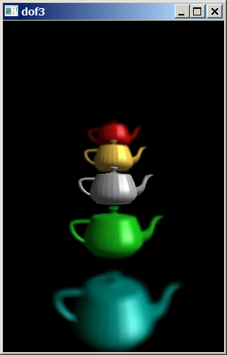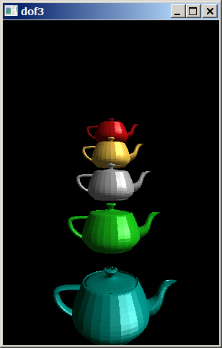
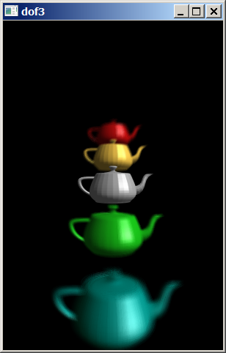
//diretorio blur
//mblur2.cpp - grad2014
#include <GL/glut.h>
#include <stdlib.h>
#include <stdio.h>
#include <MMSystem.h>
#include <windows.h>
#include <vector>
#include <cekeikon.h>

float raio=1; // raio da esfera (metros)
float lado2=5; // lado dividido por dois da caixa (metros)
float coefRest=0.99;
float decayFactor=0.95;

int nbolas=3;
vector<Vec3f> so(nbolas); // posicoes iniciais
vector<Vec3f> vo(nbolas); // velocidade inicial em m/s
vector<Vec3f> ao(nbolas); // aceleracao da gravidade m2/s
vector<Vec3f> sa(nbolas); // posicao atual da esfera
vector<Vec3f> va(nbolas); // velocidade atual da esfera
vector<float> t(nbolas,0.0);

int fps=300;
int cdQto=12;
float duracaoMs=1000.0/fps; //40ms - usado no timer
float duracaoS=(1.0/fps); //0.04s - usado para calcular posicao/velocidade

float vlim=0.3; //menor velocidade para continuar em m/s

//<<<<<<<<<<<<<<<<<<<<<<<<<<<<<<<<<<<<<<<<<<<<<<<<<<<<<<<<<<<<<<<<<<<<<<<
void caixa(void)
{ glutWireCube(10); }

void esfera(void)
{ glutSolidSphere(raio,30,24); }

void desenha(void (&f)(void), float red, float gre, float blu)
{ GLfloat mat_ambient[] = { red/2, gre/2, blu/2, 1.0 };
glMaterialfv(GL_FRONT, GL_AMBIENT, mat_ambient);
GLfloat mat_diffuse[] = { red, gre, blu, 1.0 };
glMaterialfv(GL_FRONT, GL_DIFFUSE, mat_diffuse);
GLfloat mat_specular[] = { 1.0, 1.0, 1.0, 1.0 };
glMaterialfv(GL_FRONT, GL_SPECULAR, mat_specular);
GLfloat mat_shininess[] = { 50.0 };
glMaterialfv(GL_FRONT, GL_SHININESS, mat_shininess);
f();
}

void display(void)
{ glAccum(GL_RETURN, 1.0);
glutSwapBuffers();
//glClear(GL_ACCUM_BUFFER_BIT);
}

void acumula(void)
{ glMatrixMode(GL_MODELVIEW);
glLoadIdentity();
gluLookAt(3.5*lado2, 2*lado2, 0, 0.0, 0.0, 0.0, 0.0, 1.0, 0.0);

glClear(GL_COLOR_BUFFER_BIT | GL_DEPTH_BUFFER_BIT);
desenha(caixa,0,0,0);

glPushMatrix();
glTranslatef(sa[0][0],sa[0][1],sa[0][2]);
desenha(esfera,0.5,1,1);
glPopMatrix();

glPushMatrix();
glTranslatef(sa[1][0],sa[1][1],sa[1][2]);
desenha(esfera,1,0.5,1);
glPopMatrix();

glPushMatrix();
glTranslatef(sa[2][0],sa[2][1],sa[2][2]);
desenha(esfera,1,1,0.5);
glPopMatrix();

//ac = ac*decayFactor + color*(1-decayFactor)
glAccum(GL_MULT, decayFactor); // ac = ac*decayFactor
glAccum(GL_ACCUM, (1.0-decayFactor)); // ac = ac + color*(1-decayFactor)
}

//<<<<<<<<<<<<<<<<<<<<<<<<<<<<<<<<<<<<<<<<<<<<<<<<<<<<<<<<<<<<<<<<<<<<<<<

void bateuCaixa(int i)
{ bool bateu=false;

Vec3f vt=vo[i]+ao[i]*t[i]; // velocidade atual temporaria - pode mudar
if (sa[i][0]<-lado2+raio && vt[0]<0) { vt[0]=-vt[0]; bateu=true; }
else if (lado2-raio<sa[i][0] && vt[0]>0) { vt[0]=-vt[0]; bateu=true; }

if (sa[i][1]<-lado2+raio && vt[1]<0) { vt[1]=-vt[1]; bateu=true; }
else if (lado2-raio<sa[i][1] && vt[1]>0) { vt[1]=-vt[1]; bateu=true; }

if (sa[i][2]<-lado2+raio && vt[2]<0) { vt[2]=-vt[2]; bateu=true; }
else if (lado2-raio<sa[i][2] && vt[2]>0) { vt[2]=-vt[2]; bateu=true; }

if (bateu) {
so[i]=sa[i];
vo[i]=coefRest*vt;
t[i]=0;
MessageBeep(0x00000010L);
//printf("bateuCaixa\n");
}
}

void bateuBola(int i, int j)
{ bool bateu=false;
float dist=norm(sa[i]-sa[j]); // distancia atual
if (dist<2*raio) { // pode ter batido
float ti=t[i]-duracaoS;
float tj=t[j]-duracaoS;
Vec3f si = so[i] + vo[i]*ti + 0.5*elev2(ti)*ao[i]; // posicao instante anterior i
Vec3f sj = so[j] + vo[j]*tj + 0.5*elev2(tj)*ao[j];
float distAnt = norm(si-sj); // distancia anterior
if (distAnt>dist) { // bateu com certeza, pois bolas estao aproximando
Vec3f P=0.5*(sa[i]+sa[j]); // ponto de batida
Vec3f Ni=versor(P-sa[i]); // normal a superficie da bola i - aponta em direcao a P
Vec3f Nj=versor(P-sa[j]);
Vec3f Ui=va[i]; // velocidade i antes da colisao
Vec3f Uj=va[j];
Vec3f Wi=(Ui*Ni)*Ni; // velocidade i normal a superficie antes da colisao
Vec3f Wj=(Uj*Nj)*Nj;
Vec3f Vi=Ui-Wi; // velocidade i paralela a superficies antes da colisao
Vec3f Vj=Uj-Wj;
Vec3f Xi = 0.5 * (Wi+Wj+coefRest*(Wj-Wi)); // velocidade normal a superficie depois da colisao
Vec3f Xj = 0.5 * (Wj+Wi+coefRest*(Wi-Wj));

vo[i] = Vi + Xi; // velocidade depois da colisao
vo[j] = Vj + Xj;
so[i] = sa[i];
so[j] = sa[j];
t[i] = 0;
t[j] = 0;

bateu=true;
}
}
if (bateu) {
MessageBeep(0x00000000L);
//printf("bateuBola\n");
}
}

void spinDisplay(int value)
{ static int conta=0;

sa[0] = so[0] + vo[0]*t[0] + 0.5*elev2(t[0])*ao[0];
sa[1] = so[1] + vo[1]*t[1] + 0.5*elev2(t[1])*ao[1];
sa[2] = so[2] + vo[2]*t[2] + 0.5*elev2(t[2])*ao[2];

va[0] = vo[0] + t[0]*ao[0];
va[1] = vo[1] + t[1]*ao[1];
va[2] = vo[2] + t[2]*ao[2];

bateuBola(0,1);
bateuBola(0,2);
bateuBola(1,2);

bateuCaixa(0);
bateuCaixa(1);
bateuCaixa(2);

t[0] += duracaoS;
t[1] += duracaoS;
t[2] += duracaoS;

if (norm(va[0])>vlim || norm(va[1])>vlim || norm(va[2])>vlim) { // condicao para continuar
glutTimerFunc(round(duracaoMs),spinDisplay,0);
if (conta>=cdQto) {
conta=0;
acumula();
glutPostRedisplay();
} else {
conta++;
acumula();
}
} else exit(0);
}

//<<<<<<<<<<<<<<<<<<<<<<<<<<<<<<<<<<<<<<<<<<<<<<<<<<<<<<<<<<<<<<<<<<<<<

void init(void)
{ so[0]=Vec3f(-lado2+raio, lado2-raio, lado2-raio);
so[1]=Vec3f( lado2-raio, lado2-raio, lado2-raio);
so[2]=Vec3f( lado2-raio, lado2-raio, -lado2+raio);

vo[0]=12.0*Vec3f( 0.7,-0.2, -0.5);
vo[1]=12.0*Vec3f(-1.0,-0.8, -0.7);
vo[2]=12.0*Vec3f( 0.8,-0.5, 0.9);

ao[0]=Vec3f(0,-10,0);
ao[1]=Vec3f(0,-10,0);
ao[2]=Vec3f(0,-10,0);

sa[0]=so[0];
sa[1]=so[1];
sa[2]=so[2];

va[0]=vo[0];
va[1]=vo[1];
va[2]=vo[2];

glClearColor(1.0, 1.0, 1.0, 1.0);
glClearAccum(1.0, 1.0, 1.0, 1.0);
glShadeModel(GL_SMOOTH);

GLfloat light_position[] = { 3.0, 5.0, 3.0, 0.0 };
glLightfv(GL_LIGHT0, GL_POSITION, light_position);

glEnable(GL_LIGHTING);
glEnable(GL_LIGHT0);
glEnable(GL_DEPTH_TEST);
glLightModeli(GL_LIGHT_MODEL_LOCAL_VIEWER, GL_TRUE); // true e false estao invertidos
}

void reshape(int w, int h)
{ glViewport(0, 0, (GLsizei) w, (GLsizei) h);
glMatrixMode(GL_PROJECTION);
glLoadIdentity();
gluPerspective(45.0, (GLfloat) w/(GLfloat) h, lado2/2.0, 10.0*lado2);
}

void keyboard(unsigned char key, int x, int y)
{ if(key==27) exit(0); }

int main(int argc, char** argv)
{ glutInit(&argc, argv);
glutInitDisplayMode(GLUT_DOUBLE | GLUT_RGB | GLUT_DEPTH | GLUT_ACCUM);
glutInitWindowSize(640, 480);
glutInitWindowPosition(0, 0);
glutCreateWindow(argv[0]);
init();
glutDisplayFunc(display);
glutReshapeFunc(reshape);
glutKeyboardFunc(keyboard);
glutTimerFunc(duracaoMs,spinDisplay,0);
glutMainLoop();
}

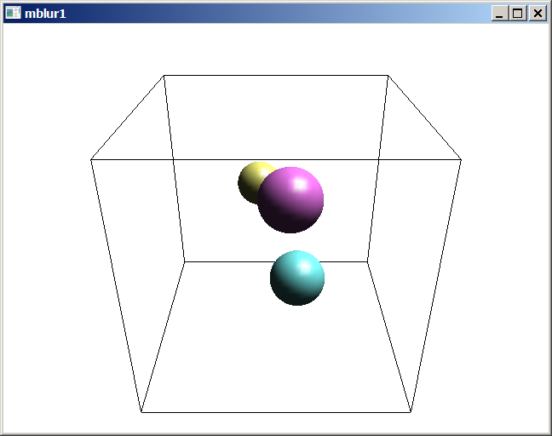
Sem motion blur.

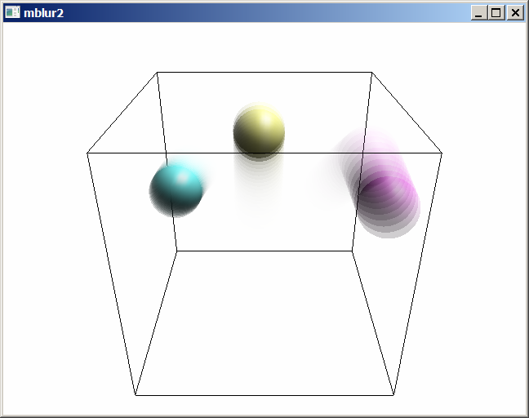
Com motion blur.

