Capítulo 6: Transparência e névoa
(Os programas estao no diretorio psa2\transp)

//alpha3d2.cpp - grad2014
#include <GL/glut.h>
#include <stdlib.h>
#include <stdio.h>
#include <windows.h>

#define MAXZ 1.0 // mexido pelo Hae
#define MINZ 0.0 // mexido pelo Hae
float ZINC = 0.02; // mexido pelo Hae
float solidZ = MAXZ;
float transparentZ = MINZ;

static void init(void)
{ GLfloat mat_specular[] = { 1.0, 1.0, 1.0, 0.15 };
GLfloat mat_shininess[] = { 100.0 };
GLfloat position[] = { 0.5, 0.5, 1.0, 0.0 };

glMaterialfv(GL_FRONT, GL_SPECULAR, mat_specular);
glMaterialfv(GL_FRONT, GL_SHININESS, mat_shininess);
glLightfv(GL_LIGHT0, GL_POSITION, position);

glEnable(GL_LIGHTING);
glEnable(GL_LIGHT0);
glEnable(GL_DEPTH_TEST);
}

void display(void)
{ GLfloat mat_solid[] = { 0.75, 0.75, 0.0, 1.0 };
GLfloat mat_zero[] = { 0.0, 0.0, 0.0, 1.0 };
GLfloat mat_transparent[] = { 0.0, 0.8, 0.8, 0.6 };
GLfloat mat_emission[] = { 0.0, 0.3, 0.3, 0.6 };

glClear (GL_COLOR_BUFFER_BIT | GL_DEPTH_BUFFER_BIT);

//Desenha primeiro objetos solidos
glPushMatrix ();
glTranslatef (-0.15, -0.15, solidZ);
glMaterialfv(GL_FRONT, GL_EMISSION, mat_zero);
glMaterialfv(GL_FRONT, GL_DIFFUSE, mat_solid);
glutSolidSphere(0.4, 16, 16);
glPopMatrix ();

//No fim, desenha objetos transparentes, primeiro o mais distante
glPushMatrix ();
glTranslatef (0.15, 0.15, transparentZ);
glRotatef (15.0, 1.0, 1.0, 0.0);
glRotatef (30.0, 0.0, 1.0, 0.0);
glMaterialfv(GL_FRONT, GL_EMISSION, mat_emission);
glMaterialfv(GL_FRONT, GL_DIFFUSE, mat_transparent);
glEnable (GL_BLEND);
glDepthMask (GL_FALSE);
glBlendFunc (GL_SRC_ALPHA, GL_ONE);
glutSolidCube(0.6);
glDepthMask (GL_TRUE);
glDisable (GL_BLEND);
glPopMatrix ();

glutSwapBuffers();
}

void reshape(int w, int h)
{ glViewport(0, 0, (GLint) w, (GLint) h);
glMatrixMode(GL_PROJECTION);
glLoadIdentity();
gluPerspective(50.0, (GLfloat)w/(GLfloat)h, 0.01, 30000.0);
glMatrixMode(GL_MODELVIEW);
glLoadIdentity();
gluLookAt(0, 0, 3, 0, 0.0, 0, 0, 1, 0);
}

void animate(void)
{ if (transparentZ < MINZ || transparentZ > MAXZ)
ZINC = -ZINC;
solidZ -= ZINC;
transparentZ += ZINC;
glutPostRedisplay();
Sleep(50);
}

void keyboard(unsigned char key, int x, int y)
{ switch (key) {
case 'r':
case 'R':
solidZ = MAXZ;
transparentZ = MINZ;
glutPostRedisplay();
break;
case 27:
exit(0);
}
}

int main(int argc, char** argv)
{ glutInit(&argc, argv);
glutInitDisplayMode (GLUT_DOUBLE | GLUT_RGB | GLUT_DEPTH);
glutInitWindowSize(500, 500);
glutCreateWindow(argv[0]);
init();
glutReshapeFunc(reshape);
glutKeyboardFunc(keyboard);
glutDisplayFunc(display);

solidZ = MAXZ;
transparentZ = MINZ;
glutIdleFunc(animate);

glutMainLoop();
}

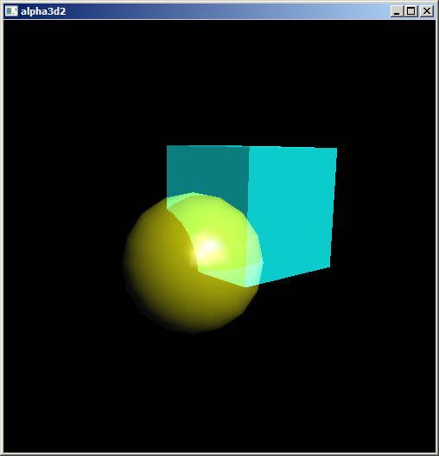

// Transp1.cpp: Transparencia. Grad-2014
#include <GL/glut.h>
#include <stdlib.h>
#include <cekeikon.h>

vector<GLuint> texturas(1);

void loadTexture(string nome, GLuint itexture)
{ glBindTexture(GL_TEXTURE_2D, itexture);
glTexParameteri(GL_TEXTURE_2D, GL_TEXTURE_WRAP_S, GL_REPEAT);
glTexParameteri(GL_TEXTURE_2D, GL_TEXTURE_WRAP_T, GL_REPEAT);
glTexParameteri(GL_TEXTURE_2D, GL_TEXTURE_MAG_FILTER, GL_LINEAR);
glTexParameteri(GL_TEXTURE_2D, GL_TEXTURE_MIN_FILTER, GL_LINEAR_MIPMAP_LINEAR);

// Usa piramide com 9 andares
const int npiramide=9;
Mat_<COR> a; le(a,nome);
Mat_<COR> mip;

for (int i=0; i<npiramide; i++) {
int tam=pow(2,npiramide-1-i);
resize(a, mip, Size(tam,tam),0,0,INTER_AREA);
mip=cv2gl(mip);
glTexImage2D(GL_TEXTURE_2D, i, GL_RGB, tam, tam, 0, GL_RGB, GL_UNSIGNED_BYTE, mip.data);
}

glTexEnvf(GL_TEXTURE_ENV, GL_TEXTURE_ENV_MODE, GL_MODULATE);
glEnable(GL_TEXTURE_2D);
glBindTexture(GL_TEXTURE_2D, 0);
}

void init(void)
{ glEnable(GL_DEPTH_TEST);
glShadeModel(GL_SMOOTH);
glPixelStorei(GL_UNPACK_ALIGNMENT, 1);
glGenTextures(texturas.size(), &texturas[0]);
loadTexture("texchess.jpg",texturas[0]);

// Selecting a Lighting Model
glLightModeli(GL_LIGHT_MODEL_LOCAL_VIEWER,GL_TRUE); //Nao parece mudar
glLightModelfv(GL_LIGHT_MODEL_AMBIENT, move((GLfloat[]){0.2,0.2,0.2,1.0}) );
glEnable(GL_LIGHTING);

// Creating Light Source
glLightfv(GL_LIGHT0, GL_AMBIENT, move((GLfloat[]){0,0,0,1}) ); // Funciona
glLightfv(GL_LIGHT0, GL_DIFFUSE, move((GLfloat[]){1,1,1,1}) ); // Funciona
glLightfv(GL_LIGHT0, GL_SPECULAR, move((GLfloat[]){1,1,1,1}) ); // Funciona
glLightfv(GL_LIGHT0, GL_POSITION, move((GLfloat[]){3,3,3,1}) ); // w=1 para posicional.
glEnable(GL_LIGHT0);
}

void display(void)
{ glClear(GL_COLOR_BUFFER_BIT | GL_DEPTH_BUFFER_BIT);

// Usa texturas[0]
glBindTexture(GL_TEXTURE_2D, texturas[0]);
glBegin(GL_QUADS);
glTexCoord2f(-8, -8); glVertex3f(-32, 0, 32);
glTexCoord2f(+8, -8); glVertex3f( 32, 0, 32);
glTexCoord2f(+8,+160); glVertex3f( 32, 0, -640);
glTexCoord2f(-8,+160); glVertex3f(-32, 0, -640);
glEnd();
glBindTexture(GL_TEXTURE_2D, 0); // unbind texture

glMaterialfv(GL_FRONT_AND_BACK, GL_AMBIENT, move((GLfloat[]){0.1, 0.3, 0.3, 1.0}) );
glMaterialfv(GL_FRONT_AND_BACK, GL_DIFFUSE, move((GLfloat[]){0.2, 0.6, 0.6, 1.0}) );
glMaterialfv(GL_FRONT_AND_BACK, GL_SPECULAR, move((GLfloat[]){0.6, 0.6, 0.6, 1.0}) );
glMaterialf(GL_FRONT_AND_BACK, GL_SHININESS, 50.0 );
glMaterialfv(GL_FRONT_AND_BACK, GL_EMISSION, move((GLfloat[]){0.0, 0.0, 0.0, 1.0}) );
glPushMatrix ();
glEnable(GL_BLEND);
glDepthMask(GL_FALSE); // depth buffer read-only
glBlendFunc(GL_ONE, GL_ONE);
glTranslatef(0, 0.5, 0);
glutSolidTeapot(1);
glDepthMask(GL_TRUE);
glDisable(GL_BLEND);
glPopMatrix ();

glFlush();
}

void reshape(int w, int h)
{ glViewport(0, 0, (GLsizei) w, (GLsizei) h);
glMatrixMode(GL_PROJECTION);
glLoadIdentity();
gluPerspective(50.0, (GLfloat)w/(GLfloat)h, 1.0, 30000.0);
glMatrixMode(GL_MODELVIEW);
glLoadIdentity();
gluLookAt(0, 3, 3, 0, 0.5, 0, 0, 1, 0);
}

void keyboard (unsigned char key, int x, int y)
{ if (key==27) exit(0); }

int main(int argc, char** argv)
{ glutInit(&argc, argv);
glutInitDisplayMode(GLUT_SINGLE | GLUT_RGB | GLUT_DEPTH);
glutInitWindowSize(500, 500);
glutInitWindowPosition(50, 50);
glutCreateWindow(argv[0]);
init();
glutDisplayFunc(display);
glutReshapeFunc(reshape);
glutKeyboardFunc(keyboard);
glutMainLoop();
return 0;
}

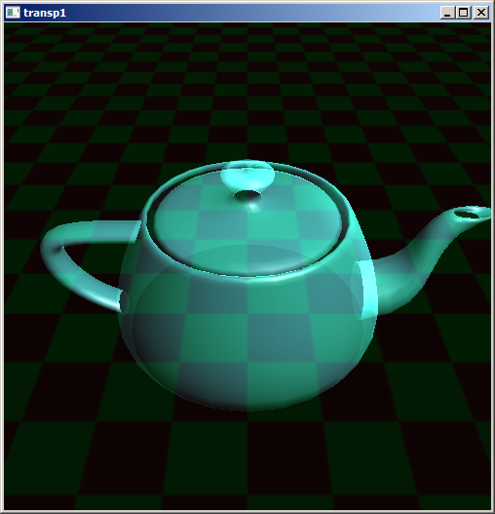

// Homer6.cpp - grad2014
// Este programa so compila em c++11
// g++ parametros -std=c++11
#include <GL/glut.h>
#include <cekeikon.h>

vector<GLuint> texturas(2);
float angulo=0;

void loadTexture(string nome, GLuint itexture)
{ glBindTexture(GL_TEXTURE_2D, itexture);
glTexParameteri(GL_TEXTURE_2D, GL_TEXTURE_WRAP_S, GL_REPEAT);
glTexParameteri(GL_TEXTURE_2D, GL_TEXTURE_WRAP_T, GL_REPEAT);
glTexParameteri(GL_TEXTURE_2D, GL_TEXTURE_MAG_FILTER, GL_LINEAR);
glTexParameteri(GL_TEXTURE_2D, GL_TEXTURE_MIN_FILTER, GL_LINEAR_MIPMAP_LINEAR);

// Usa piramide com 9 andares
const int npiramide=9;
Mat_<COR> a; le(a,nome);
Mat_<COR> mip;
for (int i=0; i<npiramide; i++) {
int tam=pow(2,npiramide-1-i);
resize(a, mip, Size(tam,tam),0,0,INTER_AREA);
//flip(mip,mip,-1);
//flip(mip,mip,1);
mip=cv2gl(mip);
glTexImage2D(GL_TEXTURE_2D, i, GL_RGB, tam, tam, 0, GL_RGB,
GL_UNSIGNED_BYTE, mip.data);
}

glTexEnvf(GL_TEXTURE_ENV, GL_TEXTURE_ENV_MODE, GL_MODULATE);
glEnable(GL_TEXTURE_2D);
glBindTexture(GL_TEXTURE_2D, 0);
}

void init(void)
{ glEnable(GL_DEPTH_TEST);
glShadeModel(GL_SMOOTH);
glPixelStorei(GL_UNPACK_ALIGNMENT, 1);
glGenTextures(texturas.size(), &texturas[0]);
loadTexture("homer_no_vitral.jpg",texturas[0]);
loadTexture("wall.jpg",texturas[1]);

glLightfv(GL_LIGHT0, GL_POSITION, move((GLfloat[]){ 0, 3, 0, 0 }));
glEnable(GL_LIGHTING);
glEnable(GL_LIGHT0);
glLightModeli(GL_LIGHT_MODEL_LOCAL_VIEWER,GL_TRUE);
glLightModeli(GL_LIGHT_MODEL_TWO_SIDE,GL_FALSE);
}

void display(void)
{ glClear(GL_COLOR_BUFFER_BIT | GL_DEPTH_BUFFER_BIT);

// Usa texturas[0]
glMaterialfv(GL_FRONT_AND_BACK, GL_SPECULAR, move((GLfloat[]){ 0.5, 0.5, 0.5, 1.0 }));
GLfloat mat_diffuse[] = { 0.3, 0.6, 0.6, 0.6 };
glMaterialfv(GL_FRONT_AND_BACK, GL_DIFFUSE, mat_diffuse);
GLfloat mat_ambient[] = { 0.3, 0.6, 0.6, 1.0 };
glMaterialfv(GL_FRONT_AND_BACK, GL_AMBIENT, mat_ambient);
glMaterialfv(GL_FRONT_AND_BACK, GL_SHININESS, move((GLfloat[]){ 10.0 }) );
glMaterialfv(GL_FRONT_AND_BACK, GL_EMISSION, move((GLfloat[]){ 0.6, 0.6, 0.6, 0.0 }) );

glPushMatrix();
glRotatef(angulo, 0.0, 1.0, 0.0);
glBindTexture(GL_TEXTURE_2D, texturas[1]);
glutSolidTeapot(1);
glBindTexture(GL_TEXTURE_2D, 0); // unbind texture - primeiro, objeto solido

glBindTexture(GL_TEXTURE_2D, texturas[0]);
glBlendFunc (GL_SRC_ALPHA, GL_ONE_MINUS_SRC_ALPHA);
glEnable (GL_BLEND);
glDepthMask (GL_FALSE);
glBegin(GL_QUADS);
glNormal3f(0,1,0); glTexCoord2f(0, 0); glVertex3f(-1, -1, 1);
glNormal3f(0,1,0); glTexCoord2f(1, 0); glVertex3f(+1, -1, 1);
glNormal3f(0,1,0); glTexCoord2f(1, 1); glVertex3f(+1, +1, 1);
glNormal3f(0,1,0); glTexCoord2f(0, 1); glVertex3f(-1, +1, 1);

glNormal3f(0,-1,0); glTexCoord2f(1, 0); glVertex3f(+1, -1, -1);
glNormal3f(0,-1,0); glTexCoord2f(0, 0); glVertex3f(-1, -1, -1);
glNormal3f(0,-1,0); glTexCoord2f(0, 1); glVertex3f(-1, +1, -1);
glNormal3f(0,-1,0); glTexCoord2f(1, 1); glVertex3f(+1, +1, -1);
glEnd();
glDepthMask (GL_TRUE);
glDisable (GL_BLEND);
glBindTexture(GL_TEXTURE_2D, 0); // unbind texture
glPopMatrix();

glutSwapBuffers();
}

void reshape(int w, int h)
{ glViewport(0, 0, (GLsizei) w, (GLsizei) h);
glMatrixMode(GL_PROJECTION);
glLoadIdentity();
gluPerspective(50.0, (GLfloat)w/(GLfloat)h, 0.2, 3000.0);
glMatrixMode(GL_MODELVIEW);
glLoadIdentity();
gluLookAt(0, 2, 3, 0, 0, 0, 0, 1, 0);
}

void keyboard (unsigned char key, int x, int y)
{ if (key==27) exit(0); }

void spinDisplay(int value)
{ angulo = angulo + 0.1;
if (angulo > 360.0) angulo = angulo - 360.0;
glutTimerFunc(16,spinDisplay,0);
glutPostRedisplay();
}

int main(int argc, char** argv)
{ glutInit(&argc, argv);
glutInitDisplayMode(GLUT_DOUBLE | GLUT_RGB | GLUT_DEPTH);
glutInitWindowSize(500, 500);
glutInitWindowPosition(50, 50);
glutCreateWindow(argv[0]);
init();
glutDisplayFunc(display);
glutReshapeFunc(reshape);
glutKeyboardFunc(keyboard);
glutTimerFunc(0,spinDisplay,0);
glutMainLoop();
return 0;
}
Os objetos transparentes de OpenGL não têm índice de refração. Calcula-se uma média aritmética entre o objeto de trás e o objeto transparente. Assim, somente objetos planos finos são pintados de forma aproximadamente correta.

Os pesos da média aritmética é controlado pela função:
void glBlendFunc(GLenum sfactor, GLenum dfactor);

Para pintar objetos transparentes corretamente, deve pintar primeiro todos os objetos sólidos com depth-test ligado. Depois, pinta os objetos transparentes de trás para frente, com dept-test desligado: “glDepthMask (GL_FALSE)”. Pois um objeto transparente não esconde os objetos que estão atrás.

Com depth-test desligado, o depth buffer (z-buffer) não é atualizado.

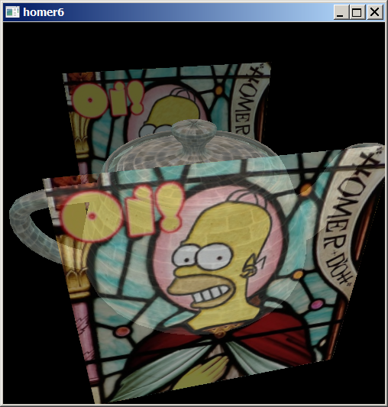

Pintando objetos transparentes primeiro com depth-test desligado e os objetos sólidos com depth test ligado: O objeto sólido aparece na frente mesmo que esteja atrás.

//homer7.cpp
glPushMatrix();
glRotatef(angulo, 0.0, 1.0, 0.0);

glBindTexture(GL_TEXTURE_2D, texturas[0]);
glBlendFunc (GL_SRC_ALPHA, GL_ONE_MINUS_SRC_ALPHA);
glEnable (GL_BLEND);
glDepthMask (GL_FALSE);
glBegin(GL_QUADS);
glNormal3f(0,1,0); glTexCoord2f(0, 0); glVertex3f(-1, -1, 1);
glNormal3f(0,1,0); glTexCoord2f(1, 0); glVertex3f(+1, -1, 1);
glNormal3f(0,1,0); glTexCoord2f(1, 1); glVertex3f(+1, +1, 1);
glNormal3f(0,1,0); glTexCoord2f(0, 1); glVertex3f(-1, +1, 1);

glNormal3f(0,-1,0); glTexCoord2f(1, 0); glVertex3f(+1, -1, -1);
glNormal3f(0,-1,0); glTexCoord2f(0, 0); glVertex3f(-1, -1, -1);
glNormal3f(0,-1,0); glTexCoord2f(0, 1); glVertex3f(-1, +1, -1);
glNormal3f(0,-1,0); glTexCoord2f(1, 1); glVertex3f(+1, +1, -1);
glEnd();
glDepthMask (GL_TRUE);
glDisable (GL_BLEND);
glBindTexture(GL_TEXTURE_2D, 0); // unbind texture

glBindTexture(GL_TEXTURE_2D, texturas[1]);
glutSolidTeapot(1);
glBindTexture(GL_TEXTURE_2D, 0); // unbind texture
glPopMatrix();

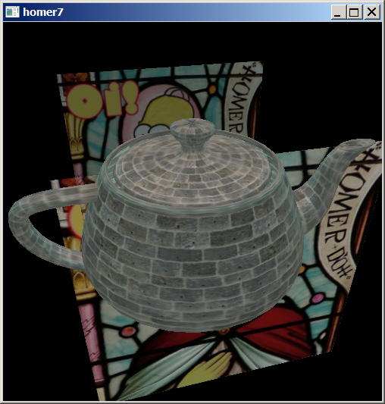

Pintando objetos transparentes primeiro com depth-test ligado e os objetos sólidos também com depth test ligado: Objeto transparente fica opaco para objeto sólido atrás, mas transparente ou opaco para objeto transparente atrás (dependendo da ordem em que os objetos são desenhados):

//homer8.cpp
glPushMatrix();
glRotatef(angulo, 0.0, 1.0, 0.0);

glBindTexture(GL_TEXTURE_2D, texturas[0]);
glBlendFunc (GL_SRC_ALPHA, GL_ONE_MINUS_SRC_ALPHA);
glEnable (GL_BLEND);
glDepthMask (GL_TRUE);
glBegin(GL_QUADS);
glNormal3f(0,1,0); glTexCoord2f(0, 0); glVertex3f(-1, -1, 1);
glNormal3f(0,1,0); glTexCoord2f(1, 0); glVertex3f(+1, -1, 1);
glNormal3f(0,1,0); glTexCoord2f(1, 1); glVertex3f(+1, +1, 1);
glNormal3f(0,1,0); glTexCoord2f(0, 1); glVertex3f(-1, +1, 1);

glNormal3f(0,-1,0); glTexCoord2f(1, 0); glVertex3f(+1, -1, -1);
glNormal3f(0,-1,0); glTexCoord2f(0, 0); glVertex3f(-1, -1, -1);
glNormal3f(0,-1,0); glTexCoord2f(0, 1); glVertex3f(-1, +1, -1);
glNormal3f(0,-1,0); glTexCoord2f(1, 1); glVertex3f(+1, +1, -1);
glEnd();
glDepthMask (GL_TRUE);
glDisable (GL_BLEND);
glBindTexture(GL_TEXTURE_2D, 0); // unbind texture

glBindTexture(GL_TEXTURE_2D, texturas[1]);
glutSolidTeapot(1);
glBindTexture(GL_TEXTURE_2D, 0); // unbind texture
glPopMatrix();

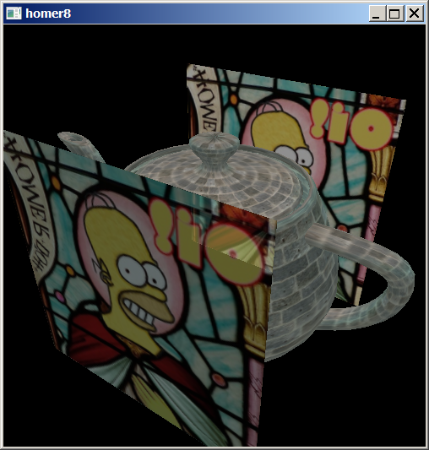

//fog2.cpp - Grad2014
#include <GL/glut.h>
#include <cmath>
#include <cstdlib>
#include <cstdio>
#include <iostream>
using namespace std;

GLint fogMode;

void init(void)
{ glEnable(GL_DEPTH_TEST);

glLightfv(GL_LIGHT0, GL_POSITION, move( (GLfloat[]){ 0.5, 0.5, 3.0, 0.0 }) );
glEnable(GL_LIGHTING);
glEnable(GL_LIGHT0);
glMaterialfv(GL_FRONT, GL_AMBIENT, move( (GLfloat[]){0.1745, 0.01175, 0.01175}) );
glMaterialfv(GL_FRONT, GL_DIFFUSE, move( (GLfloat[]){0.61424, 0.04136, 0.04136}) );
glMaterialfv(GL_FRONT, GL_SPECULAR, move( (GLfloat[]){0.727811, 0.626959, 0.626959}) );
glMaterialf(GL_FRONT, GL_SHININESS, 0.6*128.0);

glEnable(GL_FOG);
fogMode = GL_EXP;
glFogi(GL_FOG_MODE, fogMode);
glFogfv(GL_FOG_COLOR, move( (GLfloat[]){0.5, 0.5, 0.5, 1.0}) );
glFogf(GL_FOG_DENSITY, 0.2);
glHint(GL_FOG_HINT, GL_DONT_CARE);
glFogf(GL_FOG_START, 2.0);
glFogf(GL_FOG_END, 10.0);
glClearColor(0.5, 0.5, 0.5, 1.0); /* fog color */
}

void renderSphere (GLfloat x, GLfloat y, GLfloat z)
{ glPushMatrix();
glTranslatef (x, y, z);
glutSolidSphere(0.6, 16, 16);
glPopMatrix();
}

void display(void)
{ glClear(GL_COLOR_BUFFER_BIT | GL_DEPTH_BUFFER_BIT);
renderSphere(0, 0, +2);
renderSphere(0, 0, -0);
renderSphere(0, 0, -2);
renderSphere(0, 0, -4);
renderSphere(0, 0, -6);
renderSphere(0, 0, -8);
renderSphere(0, 0, -10);
glFlush();
}

void reshape(int w, int h)
{ glViewport(0, 0, (GLsizei) w, (GLsizei) h);
glMatrixMode(GL_PROJECTION);
glLoadIdentity();
gluPerspective(60.0, (GLfloat)w/(GLfloat)h, 1.0, 30000.0);
glMatrixMode(GL_MODELVIEW);
glLoadIdentity();
gluLookAt(0, 4, 4, 0, 0.5, 0, 0, 1, 0);
}

void keyboard(unsigned char key, int x, int y)
{
switch (key) {
case 'f':
case 'F':
if (fogMode == GL_EXP) {
fogMode = GL_EXP2;
printf ("Fog mode is GL_EXP2\n");
}
else if (fogMode == GL_EXP2) {
fogMode = GL_LINEAR;
printf ("Fog mode is GL_LINEAR\n");
}
else if (fogMode == GL_LINEAR) {
fogMode = GL_EXP;
printf ("Fog mode is GL_EXP\n");
}
glFogi (GL_FOG_MODE, fogMode);
glutPostRedisplay();
break;
case 27:
exit(0);
break;
default:
break;
}
}

int main(int argc, char** argv)
{ glutInit(&argc, argv);
glutInitDisplayMode (GLUT_SINGLE | GLUT_RGB | GLUT_DEPTH);
glutInitWindowSize(500, 500);
glutCreateWindow(argv[0]);
init();
glutReshapeFunc(reshape);
glutKeyboardFunc(keyboard);
glutDisplayFunc(display);
glutMainLoop();
}
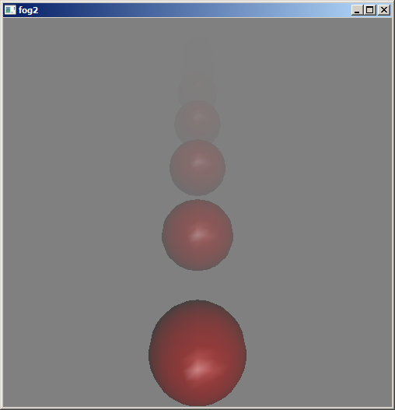

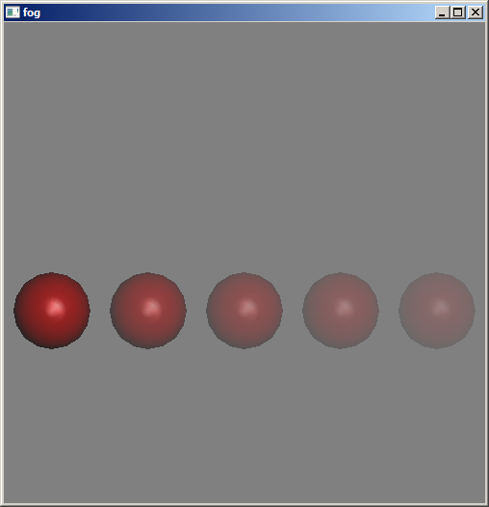

/*
* fog.cpp
* This program draws 5 red spheres, each at a different
* z distance from the eye, in different types of fog.
* Pressing the f key chooses between 3 types of
* fog: exponential, exponential squared, and linear.
* In this program, there is a fixed density value, as well
* as fixed start and end values for the linear fog.
*/
#include <GL/glut.h>
#include <math.h>
#include <stdlib.h>
#include <stdio.h>

static GLint fogMode;

/* Initialize depth buffer, fog, light source,
* material property, and lighting model.
*/
static void init(void)
{
GLfloat position[] = { 0.5, 0.5, 3.0, 0.0 };
glEnable(GL_DEPTH_TEST);
glLightfv(GL_LIGHT0, GL_POSITION, position);
glEnable(GL_LIGHTING);
glEnable(GL_LIGHT0);
{
GLfloat mat[3] = {0.1745, 0.01175, 0.01175};
glMaterialfv (GL_FRONT, GL_AMBIENT, mat);
mat[0] = 0.61424; mat[1] = 0.04136; mat[2] = 0.04136;
glMaterialfv (GL_FRONT, GL_DIFFUSE, mat);
mat[0] = 0.727811; mat[1] = 0.626959; mat[2] = 0.626959;
glMaterialfv (GL_FRONT, GL_SPECULAR, mat);
glMaterialf (GL_FRONT, GL_SHININESS, 0.6*128.0);
}

glEnable(GL_FOG);
{
GLfloat fogColor[4] = {0.5, 0.5, 0.5, 1.0};

fogMode = GL_EXP;
glFogi (GL_FOG_MODE, fogMode);
glFogfv (GL_FOG_COLOR, fogColor);
glFogf (GL_FOG_DENSITY, 0.35);
glHint (GL_FOG_HINT, GL_DONT_CARE);
glFogf (GL_FOG_START, 1.0);
glFogf (GL_FOG_END, 5.0);
}
glClearColor(0.5, 0.5, 0.5, 1.0); /* fog color */
}

static void renderSphere (GLfloat x, GLfloat y, GLfloat z)
{
glPushMatrix();
glTranslatef (x, y, z);
glutSolidSphere(0.4, 16, 16);
glPopMatrix();
}

/* display() draws 5 spheres at different z positions.
*/
void display(void)
{
glClear(GL_COLOR_BUFFER_BIT | GL_DEPTH_BUFFER_BIT);
renderSphere (-2., -0.5, -1.0);
renderSphere (-1., -0.5, -2.0);
renderSphere (0., -0.5, -3.0);
renderSphere (1., -0.5, -4.0);
renderSphere (2., -0.5, -5.0);
glFlush();
}

void reshape(int w, int h)
{
glViewport(0, 0, (GLsizei) w, (GLsizei) h);
glMatrixMode(GL_PROJECTION);
glLoadIdentity();
if (w <= h)
glOrtho (-2.5, 2.5, -2.5*(GLfloat)h/(GLfloat)w,
2.5*(GLfloat)h/(GLfloat)w, -10.0, 10.0);
else
glOrtho (-2.5*(GLfloat)w/(GLfloat)h,
2.5*(GLfloat)w/(GLfloat)h, -2.5, 2.5, -10.0, 10.0);
glMatrixMode(GL_MODELVIEW);
glLoadIdentity ();
}

void keyboard(unsigned char key, int x, int y)
{
switch (key) {
case 'f':
case 'F':
if (fogMode == GL_EXP) {
fogMode = GL_EXP2;
printf ("Fog mode is GL_EXP2\n");
}
else if (fogMode == GL_EXP2) {
fogMode = GL_LINEAR;
printf ("Fog mode is GL_LINEAR\n");
}
else if (fogMode == GL_LINEAR) {
fogMode = GL_EXP;
printf ("Fog mode is GL_EXP\n");
}
glFogi (GL_FOG_MODE, fogMode);
glutPostRedisplay();
break;
case 27:
exit(0);
break;
default:
break;
}
}

/* Main Loop
* Open window with initial window size, title bar,
* RGBA display mode, depth buffer, and handle input events.
*/
int main(int argc, char** argv)
{
glutInit(&argc, argv);
glutInitDisplayMode (GLUT_SINGLE | GLUT_RGB | GLUT_DEPTH);
glutInitWindowSize(500, 500);
glutCreateWindow(argv[0]);
init();
glutReshapeFunc (reshape);
glutKeyboardFunc (keyboard);
glutDisplayFunc (display);
glutMainLoop();
return 0;
}

