light.cpp original do livro:

#include <GL/gl.h>
#include <GL/glu.h>
#include <GL/glut.h>

void init(void)
{ GLfloat mat_specular[] = { 1.0, 1.0, 1.0, 1.0 };
GLfloat mat_shininess[] = { 50.0 };
GLfloat light_position[] = { 1.0, 1.0, 1.0, 0.0 };
glClearColor (0.0, 0.0, 0.0, 0.0);
glShadeModel (GL_SMOOTH);

glMaterialfv(GL_FRONT, GL_SPECULAR, mat_specular);
glMaterialfv(GL_FRONT, GL_SHININESS, mat_shininess);
glLightfv(GL_LIGHT0, GL_POSITION, light_position);

glEnable(GL_LIGHTING);
glEnable(GL_LIGHT0);
glEnable(GL_DEPTH_TEST);
}

void display(void)
{ glClear (GL_COLOR_BUFFER_BIT | GL_DEPTH_BUFFER_BIT);
glutSolidSphere (1.0, 40, 32);
glFlush ();
}

void reshape (int w, int h)
{ glViewport (0, 0, (GLsizei) w, (GLsizei) h);
glMatrixMode (GL_PROJECTION);
glLoadIdentity();
if (w <= h)
glOrtho (-1.5, 1.5, -1.5*(GLfloat)h/(GLfloat)w,
1.5*(GLfloat)h/(GLfloat)w, -10.0, 10.0);
else
glOrtho (-1.5*(GLfloat)w/(GLfloat)h,
1.5*(GLfloat)w/(GLfloat)h, -1.5, 1.5, -10.0, 10.0);
glMatrixMode(GL_MODELVIEW);
glLoadIdentity();
}

int main(int argc, char** argv)
{ glutInit(&argc, argv);
glutInitDisplayMode (GLUT_SINGLE | GLUT_RGB | GLUT_DEPTH);
glutInitWindowSize (500, 500);
glutInitWindowPosition (100, 100);
glutCreateWindow (argv[0]);
init ();
glutDisplayFunc(display);
glutReshapeFunc(reshape);
glutMainLoop();
return 0;
}

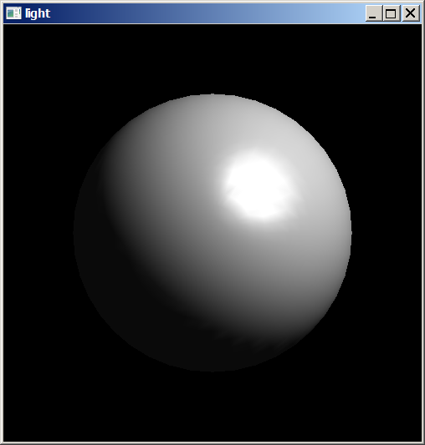
light_amb.cpp (só reflexão ambiente) (grad2013):

void init(void)
{ GLfloat mat_specular[] = { 0.0, 0.0, 0.0, 1.0 };
GLfloat mat_shininess[] = { 50.0 };
GLfloat mat_diffuse[] = { 0.0, 0.0, 0.0, 1.0 };
GLfloat mat_ambient[] = { 1.0, 1.0, 0.0, 1.0 };
GLfloat light_position[] = { 1.0, 1.0, 1.0, 0.0 };
glClearColor (0.0, 0.0, 0.0, 0.0);
glShadeModel (GL_SMOOTH);

glMaterialfv(GL_FRONT, GL_SPECULAR, mat_specular);
glMaterialfv(GL_FRONT, GL_SHININESS, mat_shininess);
glMaterialfv(GL_FRONT, GL_DIFFUSE, mat_diffuse);
glMaterialfv(GL_FRONT, GL_AMBIENT, mat_ambient);
glLightfv(GL_LIGHT0, GL_POSITION, light_position);

glEnable(GL_LIGHTING);
glEnable(GL_LIGHT0);
glEnable(GL_DEPTH_TEST);
}

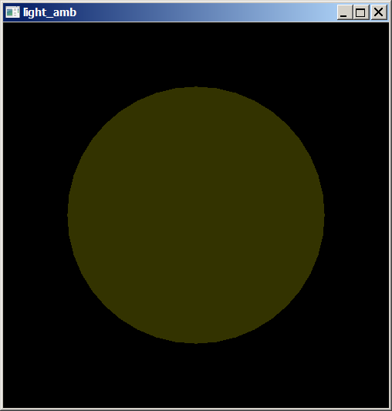
light_dif.cpp (só reflexão difusa) (grad2013):

void init(void)
{ GLfloat mat_specular[] = { 0.0, 0.0, 0.0, 1.0 };
GLfloat mat_shininess[] = { 50.0 };
GLfloat mat_diffuse[] = { 1.0, 1.0, 0.0, 1.0 };
GLfloat mat_ambient[] = { 0.0, 0.0, 0.0, 1.0 };
GLfloat light_position[] = { 1.0, 1.0, 1.0, 0.0 };
glClearColor (0.0, 0.0, 0.0, 0.0);
glShadeModel (GL_SMOOTH);

glMaterialfv(GL_FRONT, GL_SPECULAR, mat_specular);
glMaterialfv(GL_FRONT, GL_SHININESS, mat_shininess);
glMaterialfv(GL_FRONT, GL_DIFFUSE, mat_diffuse);
glMaterialfv(GL_FRONT, GL_AMBIENT, mat_ambient);
glLightfv(GL_LIGHT0, GL_POSITION, light_position);

glEnable(GL_LIGHTING);
glEnable(GL_LIGHT0);
glEnable(GL_DEPTH_TEST);
}

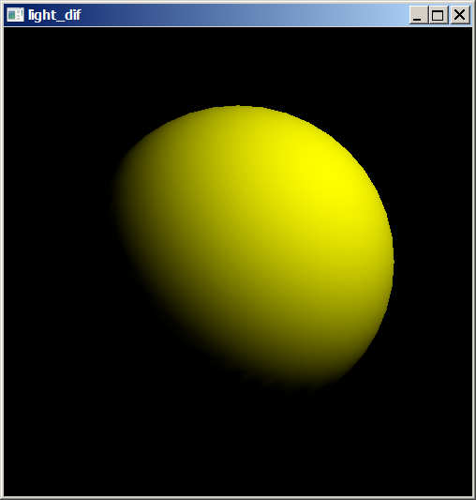

light_spe050.cpp (só reflexão especular shiness 50) (grad2013):

void init(void)
{ GLfloat mat_specular[] = { 1.0, 1.0, 1.0, 1.0 };
GLfloat mat_shininess[] = { 50.0 };
GLfloat mat_diffuse[] = { 0.0, 0.0, 0.0, 1.0 };
GLfloat mat_ambient[] = { 0.0, 0.0, 0.0, 1.0 };
GLfloat light_position[] = { 1.0, 1.0, 1.0, 0.0 };
glClearColor (0.0, 0.0, 0.0, 0.0);
glShadeModel (GL_SMOOTH);

glMaterialfv(GL_FRONT, GL_SPECULAR, mat_specular);
glMaterialfv(GL_FRONT, GL_SHININESS, mat_shininess);
glMaterialfv(GL_FRONT, GL_DIFFUSE, mat_diffuse);
glMaterialfv(GL_FRONT, GL_AMBIENT, mat_ambient);
glLightfv(GL_LIGHT0, GL_POSITION, light_position);

glEnable(GL_LIGHTING);
glEnable(GL_LIGHT0);
glEnable(GL_DEPTH_TEST);
}

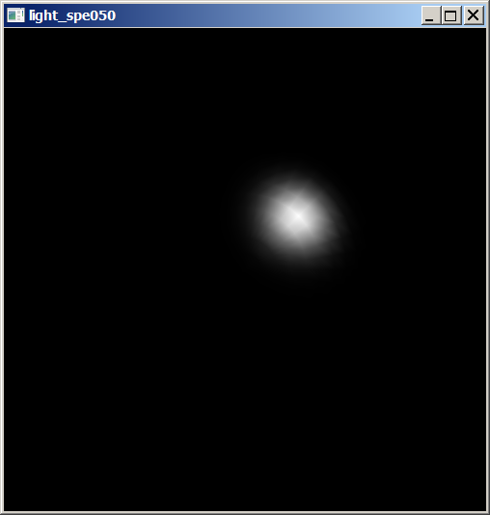
light_spe250.cpp (só reflexão especular shiness 250) (grad2013):

void init(void)
{ GLfloat mat_specular[] = { 1.0, 1.0, 1.0, 1.0 };
GLfloat mat_shininess[] = { 250.0 };
GLfloat mat_diffuse[] = { 0.0, 0.0, 0.0, 1.0 };
GLfloat mat_ambient[] = { 0.0, 0.0, 0.0, 1.0 };
GLfloat light_position[] = { 1.0, 1.0, 1.0, 0.0 };
glClearColor (0.0, 0.0, 0.0, 0.0);
glShadeModel (GL_SMOOTH);

glMaterialfv(GL_FRONT, GL_SPECULAR, mat_specular);
glMaterialfv(GL_FRONT, GL_SHININESS, mat_shininess);
glMaterialfv(GL_FRONT, GL_DIFFUSE, mat_diffuse);
glMaterialfv(GL_FRONT, GL_AMBIENT, mat_ambient);
glLightfv(GL_LIGHT0, GL_POSITION, light_position);

glEnable(GL_LIGHTING);
glEnable(GL_LIGHT0);
glEnable(GL_DEPTH_TEST);
}

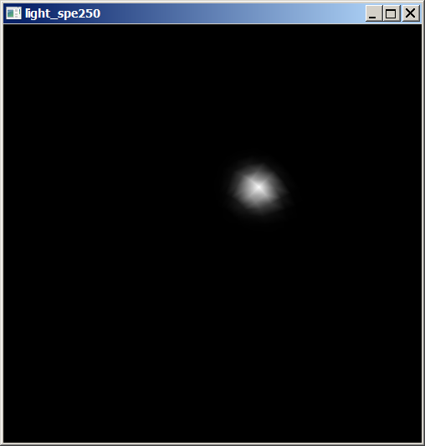
light_spe010.cpp (só reflexão especular shiness 010) (grad2013):

void init(void)
{ GLfloat mat_specular[] = { 1.0, 1.0, 1.0, 1.0 };
GLfloat mat_shininess[] = { 010.0 };
GLfloat mat_diffuse[] = { 0.0, 0.0, 0.0, 1.0 };
GLfloat mat_ambient[] = { 0.0, 0.0, 0.0, 1.0 };
GLfloat light_position[] = { 1.0, 1.0, 1.0, 0.0 };
glClearColor (0.0, 0.0, 0.0, 0.0);
glShadeModel (GL_SMOOTH);

glMaterialfv(GL_FRONT, GL_SPECULAR, mat_specular);
glMaterialfv(GL_FRONT, GL_SHININESS, mat_shininess);
glMaterialfv(GL_FRONT, GL_DIFFUSE, mat_diffuse);
glMaterialfv(GL_FRONT, GL_AMBIENT, mat_ambient);
glLightfv(GL_LIGHT0, GL_POSITION, light_position);

glEnable(GL_LIGHTING);
glEnable(GL_LIGHT0);
glEnable(GL_DEPTH_TEST);
}

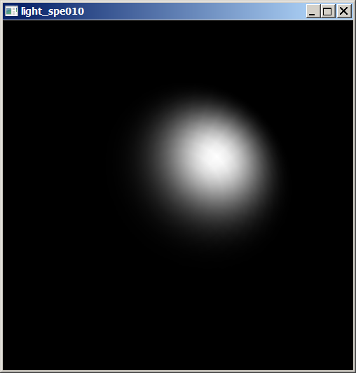

light_amb_dif (reflexão ambiente+ difusa) (grad2013):

void init(void)
{ GLfloat mat_specular[] = { 0.0, 0.0, 0.0, 1.0 };
GLfloat mat_shininess[] = { 50.0 };
GLfloat mat_diffuse[] = { 1.0, 1.0, 0.0, 1.0 };
GLfloat mat_ambient[] = { 1.0, 1.0, 0.0, 1.0 };
GLfloat light_position[] = { 1.0, 1.0, 1.0, 0.0 };
glClearColor (0.0, 0.0, 0.0, 0.0);
glShadeModel (GL_SMOOTH);

glMaterialfv(GL_FRONT, GL_SPECULAR, mat_specular);
glMaterialfv(GL_FRONT, GL_SHININESS, mat_shininess);
glMaterialfv(GL_FRONT, GL_DIFFUSE, mat_diffuse);
glMaterialfv(GL_FRONT, GL_AMBIENT, mat_ambient);
glLightfv(GL_LIGHT0, GL_POSITION, light_position);

glEnable(GL_LIGHTING);
glEnable(GL_LIGHT0);
glEnable(GL_DEPTH_TEST);
}

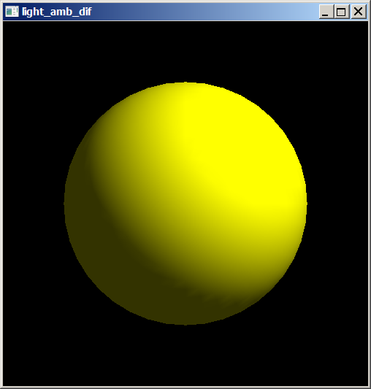

light_dif_spe050 (reflexão difusa + especular shiness 50) (grad2013):

void init(void)
{ GLfloat mat_specular[] = { 1.0, 1.0, 1.0, 1.0 };
GLfloat mat_shininess[] = { 50.0 };
GLfloat mat_diffuse[] = { 1.0, 1.0, 0.0, 1.0 };
GLfloat mat_ambient[] = { 0.0, 0.0, 0.0, 1.0 };
GLfloat light_position[] = { 1.0, 1.0, 1.0, 0.0 };
glClearColor (0.0, 0.0, 0.0, 0.0);
glShadeModel (GL_SMOOTH);

glMaterialfv(GL_FRONT, GL_SPECULAR, mat_specular);
glMaterialfv(GL_FRONT, GL_SHININESS, mat_shininess);
glMaterialfv(GL_FRONT, GL_DIFFUSE, mat_diffuse);
glMaterialfv(GL_FRONT, GL_AMBIENT, mat_ambient);
glLightfv(GL_LIGHT0, GL_POSITION, light_position);

glEnable(GL_LIGHTING);
glEnable(GL_LIGHT0);
glEnable(GL_DEPTH_TEST);
}

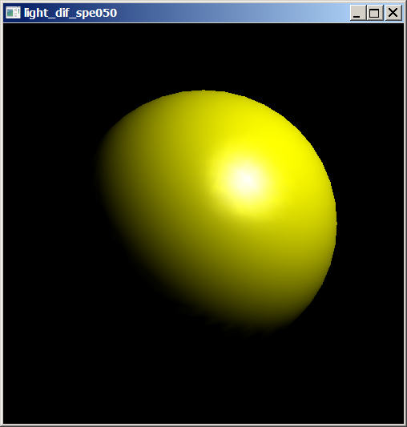
light_amb_dif_spe050 (reflexão ambiente + difusa + especular shiness 50) (grad2013):

void init(void)
{ GLfloat mat_specular[] = { 1.0, 1.0, 1.0, 1.0 };
GLfloat mat_shininess[] = { 50.0 };
GLfloat mat_diffuse[] = { 1.0, 1.0, 0.0, 1.0 };
GLfloat mat_ambient[] = { 1.0, 1.0, 0.0, 1.0 };
GLfloat light_position[] = { 1.0, 1.0, 1.0, 0.0 };
glClearColor (0.0, 0.0, 0.0, 0.0);
glShadeModel (GL_SMOOTH);

glMaterialfv(GL_FRONT, GL_SPECULAR, mat_specular);
glMaterialfv(GL_FRONT, GL_SHININESS, mat_shininess);
glMaterialfv(GL_FRONT, GL_DIFFUSE, mat_diffuse);
glMaterialfv(GL_FRONT, GL_AMBIENT, mat_ambient);
glLightfv(GL_LIGHT0, GL_POSITION, light_position);

glEnable(GL_LIGHTING);
glEnable(GL_LIGHT0);
glEnable(GL_DEPTH_TEST);
}

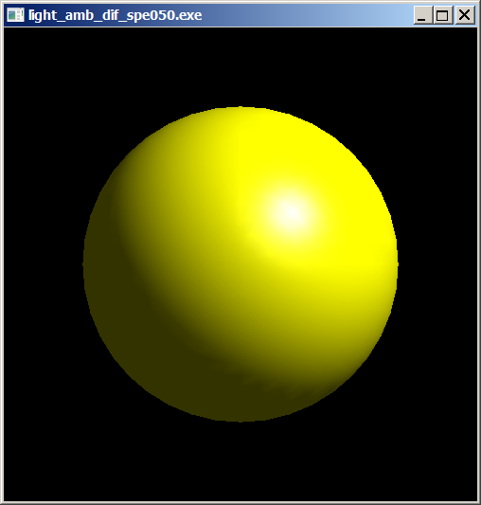
Veja o capítulo 7 da minha dissertação de mestrado:
http://www.lps.usp.br/~hae/dissert.pdf

Modelo de iluminação local de Phong:

(reflexão especular)

(reflexão difusa)

(reflexão luz ambiente)

(soma de todos os termos)

Capítulo 5: Descrição de objetos e iluminação (grad 2013)

OpenCV contém um objeto chamado Vec3f, usado para representar vetores em R³. A definição dele é algo como:

class Vec3f {
float val[3];
Vec3f(float x, float y, float z) { val[0]=x; val[1]=y; val[2]=z; }
Vec3f() { }
float& operator[] (int i) { return val[i]; }
...
};

Vec3f possui as seguintes operações:

- v1 = v2 + v3
- v1 = v2 - v3
- v1 = v2 * scale
- v1 = scale * v2
- v1 = -v2
- v1 += v2 and other augmenting operations
- v1 == v2, v1 != v2
- norm(v1) (Euclidean norm)

Além disso, eu implementei as seguintes funções no Cekeikon:

- Vec3f ret2esf(Vec3f p); // coordenada retangular para esférica
- Vec3f esf2ret(Vec3f esf); // coordenada esférica para retangular
- double norm1(Vec3f v); // norma L1
- Vec3f versor1(Vec3f v); // versor usando norma L1
- Vec3f versor(Vec3f v); // versor usando norma euclidiana L2
- float operator*(Vec3f v, Vec3f w); // produto escalar
- Vec3f multee(Vec3f a, Vec3f b); // produto elemento a elemento
- Vec3f produtoVet(Vec3f a, Vec3f b); // produto vetorial
- Vec3f normalTri(Vec3f a, Vec3f b, Vec3f c);
// Vetor unitário normal ao triangulo abc.

Coordenadas esféricas (ρ,θ,φ)
Para compilar um programa e linkar com OpenGL, OpenCV e Cekeikon, o comando é:

c:\diretorio>compila programa.cpp -ogl -cek
Tetra2.cpp: O tetraedro com modelo de iluminação flat. Roda com teclas ‘s’ e ‘d’.

#include <GL/glut.h>
#include <cekeikon.h>

float angulo=0.0;

void init(void)
{ glClearColor(1.0, 1.0, 1.0, 1.0);
glShadeModel(GL_FLAT);

GLfloat light_position[] = { 5.0, 5.0, 5.0, 0.0 };
glLightfv(GL_LIGHT0, GL_POSITION, light_position);

glEnable(GL_LIGHTING);
glEnable(GL_LIGHT0);
glEnable(GL_DEPTH_TEST);
}

void tetra(void)
{ const float rd=1.0/sqrt(2.0);
static Vec3f vertices[4] = {
Vec3f(+1, 0, -rd), //0 A
Vec3f(-1, 0, -rd), //1 B
Vec3f( 0,+1, rd), //2 C
Vec3f( 0,-1, rd) };//3 D

glBegin(GL_TRIANGLES);
// ACD
Vec3f n=normalTri(vertices[0],vertices[2],vertices[3]);
glNormal3fv(n.val); // glNormal3fv(&n[0]);
glVertex3fv(vertices[0].val);
glVertex3fv(vertices[2].val);
glVertex3fv(vertices[3].val);
// DCB
n=normalTri(vertices[3],vertices[2],vertices[1]);
glNormal3fv(n.val);
glVertex3fv(vertices[3].val);
glVertex3fv(vertices[2].val);
glVertex3fv(vertices[1].val);
// CAB
n=normalTri(vertices[2],vertices[0],vertices[1]);
glNormal3fv(n.val);
glVertex3fv(vertices[2].val);
glVertex3fv(vertices[0].val);
glVertex3fv(vertices[1].val);
// DBA
n=normalTri(vertices[3],vertices[1],vertices[0]);
glNormal3fv(n.val);
glVertex3fv(vertices[3].val);
glVertex3fv(vertices[1].val);
glVertex3fv(vertices[0].val);
glEnd();
}

void desenha(float red, float gre, float blu)
{ GLfloat mat_ambient[] = { red/2, gre/2, blu/2, 1.0 };
glMaterialfv(GL_FRONT, GL_AMBIENT, mat_ambient);
GLfloat mat_diffuse[] = { red, gre, blu, 1.0 };
glMaterialfv(GL_FRONT, GL_DIFFUSE, mat_diffuse);
GLfloat mat_specular[] = { 0.5, 0.5, 0.5, 1.0 };
glMaterialfv(GL_FRONT, GL_SPECULAR, mat_specular);
GLfloat mat_shininess[] = { 50.0 };
glMaterialfv(GL_FRONT, GL_SHININESS, mat_shininess);
tetra();
}

void display(void)
{ glClear(GL_COLOR_BUFFER_BIT | GL_DEPTH_BUFFER_BIT);
glPolygonMode(GL_FRONT, GL_FILL);
desenha(0.5,0.5,1);
glutSwapBuffers();
}

void reshape(int w, int h)
{ glViewport(0, 0,(GLsizei) w,(GLsizei) h);
glMatrixMode(GL_PROJECTION);
glLoadIdentity();
gluPerspective(30.0,(GLfloat) w/(GLfloat) h, 1.5, 20.0);
glMatrixMode(GL_MODELVIEW);
gluLookAt(0, 0, 5.0, 0.0, 0.0, 0.0, 0.0, 1.0, 0.0);
glPushMatrix();
}

void keyboard(unsigned char key, int x, int y)
{ if(key==27) {
exit(0);
} else if(key=='s') {
angulo = angulo-10;
if(angulo<0) angulo=angulo+360;
glPopMatrix();
glPushMatrix();
glRotatef(angulo, 0,1,0);
glutPostRedisplay();
} else if(key=='d') {
angulo = angulo+10;
if(angulo>360) angulo=angulo-360;
glPopMatrix();
glPushMatrix();
glRotatef(angulo, 0,1,0);
glutPostRedisplay();
}
}

int main(int argc, char** argv)
{ glutInit(&argc, argv);
glutInitDisplayMode(GLUT_DOUBLE | GLUT_RGB | GLUT_DEPTH);
glutInitWindowSize(500, 500);
glutInitWindowPosition(100, 100);
glutCreateWindow(argv[0]);
init();
glutDisplayFunc(display);
glutReshapeFunc(reshape);
glutKeyboardFunc(keyboard);
glutMainLoop();
}
}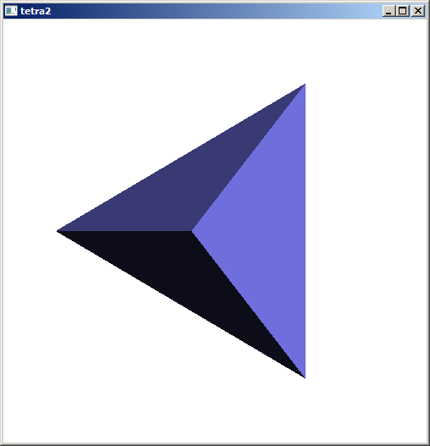

icosa7.cpp: Definição de um icosaedro com modelo de iluminação e desenho de wireframe.

//icosa7.cpp
#include <GL/glut.h>
#include <cekeikon.h>

float angulo=0.0;

void init(void)
{ glClearColor(0.0, 0.0, 0.0, 0.0);
glShadeModel(GL_FLAT);
GLfloat light_position[] = { 5.0, 5.0, 5.0, 0.0 };
glLightfv(GL_LIGHT0, GL_POSITION, light_position);

glEnable(GL_LIGHTING);
glEnable(GL_LIGHT0);
glEnable(GL_DEPTH_TEST);
}

void icosa(void)
{ const float X=0.525731112119133606;
const float Z=0.850650808352039932;

Vec3f vdata[12] = {
Vec3f(-X, 0.0, Z), Vec3f(X, 0.0, Z), Vec3f(-X, 0.0, -Z), Vec3f(X, 0.0, -Z),
Vec3f(0.0, Z, X), Vec3f(0.0, Z, -X), Vec3f(0.0, -Z, X), Vec3f(0.0, -Z, -X),
Vec3f(Z, X, 0.0), Vec3f(-Z, X, 0.0), Vec3f(Z, -X, 0.0), Vec3f(-Z, -X, 0.0)
};
vector< Vec3f > vertice(vdata,vdata+sizeof(vdata)/sizeof(Vec3f));

static GLuint tindices[20][3] = {
{4,0,1}, {9,0,4}, {5,9,4}, {5,4,8}, {8,4,1},
{10,8,1}, {3,8,10}, {3,5,8}, {2,5,3}, {7,2,3},
{10,7,3}, {6,7,10}, {11,7,6}, {0,11,6}, {1,0,6},
{1,6,10}, {0,9,11}, {11,9,2}, {2,9,5}, {2,7,11}
};
glBegin(GL_TRIANGLES);
for (int i=0; i<20; i++) {
Vec3f n=normalTri(vertice[tindices[i][0]],
vertice[tindices[i][1]],
vertice[tindices[i][2]]);
glNormal3fv(n.val);
glVertex3fv(vertice[tindices[i][0]].val);
glVertex3fv(vertice[tindices[i][1]].val);
glVertex3fv(vertice[tindices[i][2]].val);
}
glEnd();
glBegin(GL_LINES);
for (int i=0; i<20; i++) {
glVertex3fv(vertice[tindices[i][0]].val);
glVertex3fv(vertice[tindices[i][1]].val);
glVertex3fv(vertice[tindices[i][0]].val);
glVertex3fv(vertice[tindices[i][2]].val);
glVertex3fv(vertice[tindices[i][1]].val);
glVertex3fv(vertice[tindices[i][2]].val);
}
glEnd();
}

void desenha(float red, float gre, float blu)
{ glDisable(GL_LIGHTING);
glColor3f(0,0,1);
glPolygonMode(GL_FRONT, GL_LINE);
icosa();

glEnable(GL_LIGHTING);
glPolygonMode(GL_FRONT, GL_FILL);
GLfloat mat_ambient[] = { red/2, gre/2, blu/2, 1.0 };
glMaterialfv(GL_FRONT, GL_AMBIENT, mat_ambient);
GLfloat mat_diffuse[] = { red, gre, blu, 1.0 };
glMaterialfv(GL_FRONT, GL_DIFFUSE, mat_diffuse);
GLfloat mat_specular[] = { 1.0, 1.0, 1.0, 1.0 };
glMaterialfv(GL_FRONT, GL_SPECULAR, mat_specular);
GLfloat mat_shininess[] = { 50.0 };
glMaterialfv(GL_FRONT, GL_SHININESS, mat_shininess);
glPolygonMode(GL_FRONT, GL_FILL);
glEnable(GL_POLYGON_OFFSET_FILL);
glPolygonOffset(1.0, 1.0);
icosa();
glDisable(GL_POLYGON_OFFSET_FILL);
}

void display(void)
{ glClear(GL_COLOR_BUFFER_BIT | GL_DEPTH_BUFFER_BIT);
desenha(0.5,1.0,1.0);
glutSwapBuffers();
}

void reshape(int w, int h)
{ glViewport(0, 0,(GLsizei) w,(GLsizei) h);
glMatrixMode(GL_PROJECTION);
glLoadIdentity();
gluPerspective(30.0,(GLfloat) w/(GLfloat) h, 1.5, 20.0);
glMatrixMode(GL_MODELVIEW);
glLoadIdentity();
gluLookAt(0, 0, 5.0, 0.0, 0.0, 0.0, 0.0, 1.0, 0.0);
glPushMatrix();
}

void keyboard(unsigned char key, int x, int y)
{ if(key==27) {
exit(0);
} else if(key=='s') {
angulo = angulo-1;
if(angulo<0) angulo=angulo+360;
glPopMatrix();
glPushMatrix();
glRotatef(angulo, 0,1,0);
//printf("angulo=%f\n",angulo);
glutPostRedisplay();
} else if(key=='d') {
angulo = angulo+1;
if(angulo>360) angulo=angulo-360;
glPopMatrix();
glPushMatrix();
glRotatef(angulo, 0,1,0);
//printf("angulo=%f\n",angulo);
glutPostRedisplay();
}
}

int main(int argc, char** argv)
{ glutInit(&argc, argv);
glutInitDisplayMode(GLUT_DOUBLE | GLUT_RGB | GLUT_DEPTH);
glutInitWindowSize(500, 500);
glutInitWindowPosition(100, 100);
glutCreateWindow(argv[0]);
init();
glutDisplayFunc(display);
glutReshapeFunc(reshape);
glutKeyboardFunc(keyboard);
glutMainLoop();
}
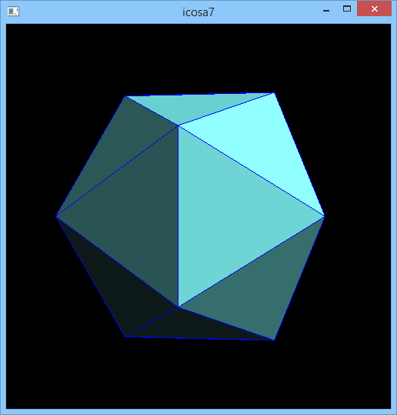

//icosa8.cpp - so wireframe
#include <GL/glut.h>
#include <cekeikon.h>

float angulo=0.0;

void init(void)
{ glClearColor(0.0, 0.0, 0.0, 0.0);
glShadeModel(GL_FLAT);
GLfloat light_position[] = { 5.0, 5.0, 5.0, 0.0 };
glLightfv(GL_LIGHT0, GL_POSITION, light_position);

glEnable(GL_LIGHTING);
glEnable(GL_LIGHT0);
glEnable(GL_DEPTH_TEST);
}

void icosa(void)
{ const float X=0.525731112119133606;
const float Z=0.850650808352039932;

Vec3f vdata[12] = {
Vec3f(-X, 0.0, Z), Vec3f(X, 0.0, Z), Vec3f(-X, 0.0, -Z), Vec3f(X, 0.0, -Z),
Vec3f(0.0, Z, X), Vec3f(0.0, Z, -X), Vec3f(0.0, -Z, X), Vec3f(0.0, -Z, -X),
Vec3f(Z, X, 0.0), Vec3f(-Z, X, 0.0), Vec3f(Z, -X, 0.0), Vec3f(-Z, -X, 0.0)
};
vector< Vec3f > vertice(vdata,vdata+sizeof(vdata)/sizeof(Vec3f));

static GLuint tindices[20][3] = {
{4,0,1}, {9,0,4}, {5,9,4}, {5,4,8}, {8,4,1},
{10,8,1}, {3,8,10}, {3,5,8}, {2,5,3}, {7,2,3},
{10,7,3}, {6,7,10}, {11,7,6}, {0,11,6}, {1,0,6},
{1,6,10}, {0,9,11}, {11,9,2}, {2,9,5}, {2,7,11}
};
// glBegin(GL_TRIANGLES);
// for (int i=0; i<20; i++) {
// Vec3f n=normalTri(vertice[tindices[i][0]],
// vertice[tindices[i][1]],
// vertice[tindices[i][2]]);
// glNormal3fv(n.val);
// glVertex3fv(vertice[tindices[i][0]].val);
// glVertex3fv(vertice[tindices[i][1]].val);
// glVertex3fv(vertice[tindices[i][2]].val);
// }
// glEnd();
glBegin(GL_LINES);
for (int i=0; i<20; i++) {
glVertex3fv(vertice[tindices[i][0]].val);
glVertex3fv(vertice[tindices[i][1]].val);
glVertex3fv(vertice[tindices[i][0]].val);
glVertex3fv(vertice[tindices[i][2]].val);
glVertex3fv(vertice[tindices[i][1]].val);
glVertex3fv(vertice[tindices[i][2]].val);
}
glEnd();
}

void desenha(float red, float gre, float blu)
{ glDisable(GL_LIGHTING);
glColor3f(0,0,1);
glPolygonMode(GL_FRONT, GL_LINE);
icosa();

// glEnable(GL_LIGHTING);
// glPolygonMode(GL_FRONT, GL_FILL);
// GLfloat mat_ambient[] = { red/2, gre/2, blu/2, 1.0 };
// glMaterialfv(GL_FRONT, GL_AMBIENT, mat_ambient);
// GLfloat mat_diffuse[] = { red, gre, blu, 1.0 };
// glMaterialfv(GL_FRONT, GL_DIFFUSE, mat_diffuse);
// GLfloat mat_specular[] = { 1.0, 1.0, 1.0, 1.0 };
// glMaterialfv(GL_FRONT, GL_SPECULAR, mat_specular);
// GLfloat mat_shininess[] = { 50.0 };
// glMaterialfv(GL_FRONT, GL_SHININESS, mat_shininess);
// glPolygonMode(GL_FRONT, GL_FILL);
// glEnable(GL_POLYGON_OFFSET_FILL);
// glPolygonOffset(1.0, 1.0);
// icosa();
// glDisable(GL_POLYGON_OFFSET_FILL);
}

void display(void)
{ glClear(GL_COLOR_BUFFER_BIT | GL_DEPTH_BUFFER_BIT);
desenha(0.5,1.0,1.0);
glutSwapBuffers();
}

void reshape(int w, int h)
{ glViewport(0, 0,(GLsizei) w,(GLsizei) h);
glMatrixMode(GL_PROJECTION);
glLoadIdentity();
gluPerspective(30.0,(GLfloat) w/(GLfloat) h, 1.5, 20.0);
glMatrixMode(GL_MODELVIEW);
glLoadIdentity();
gluLookAt(0, 0, 5.0, 0.0, 0.0, 0.0, 0.0, 1.0, 0.0);
glPushMatrix();
}

void keyboard(unsigned char key, int x, int y)
{ if(key==27) {
exit(0);
} else if(key=='s') {
angulo = angulo-1;
if(angulo<0) angulo=angulo+360;
glPopMatrix();
glPushMatrix();
glRotatef(angulo, 0,1,0);
//printf("angulo=%f\n",angulo);
glutPostRedisplay();
} else if(key=='d') {
angulo = angulo+1;
if(angulo>360) angulo=angulo-360;
glPopMatrix();
glPushMatrix();
glRotatef(angulo, 0,1,0);
//printf("angulo=%f\n",angulo);
glutPostRedisplay();
}
}

int main(int argc, char** argv)
{ glutInit(&argc, argv);
glutInitDisplayMode(GLUT_DOUBLE | GLUT_RGB | GLUT_DEPTH);
glutInitWindowSize(500, 500);
glutInitWindowPosition(100, 100);
glutCreateWindow(argv[0]);
init();
glutDisplayFunc(display);
glutReshapeFunc(reshape);
glutKeyboardFunc(keyboard);
glutMainLoop();
}

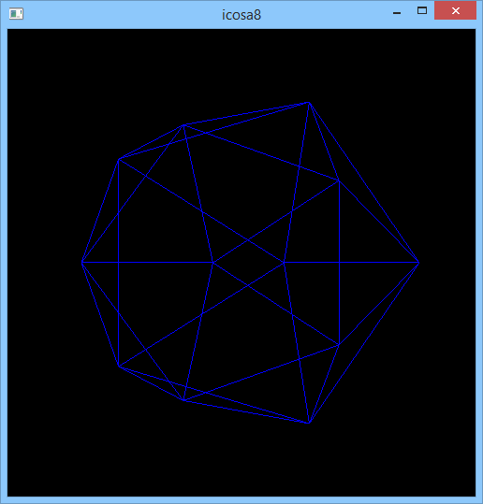

//icosa9.cpp - so faces
#include <GL/glut.h>
#include <cekeikon.h>

float angulo=0.0;

void init(void)
{ glClearColor(0.0, 0.0, 0.0, 0.0);
glShadeModel(GL_FLAT);
GLfloat light_position[] = { 5.0, 5.0, 5.0, 0.0 };
glLightfv(GL_LIGHT0, GL_POSITION, light_position);

glEnable(GL_LIGHTING);
glEnable(GL_LIGHT0);
glEnable(GL_DEPTH_TEST);
}

void icosa(void)
{ const float X=0.525731112119133606;
const float Z=0.850650808352039932;

Vec3f vdata[12] = {
Vec3f(-X, 0.0, Z), Vec3f(X, 0.0, Z), Vec3f(-X, 0.0, -Z), Vec3f(X, 0.0, -Z),
Vec3f(0.0, Z, X), Vec3f(0.0, Z, -X), Vec3f(0.0, -Z, X), Vec3f(0.0, -Z, -X),
Vec3f(Z, X, 0.0), Vec3f(-Z, X, 0.0), Vec3f(Z, -X, 0.0), Vec3f(-Z, -X, 0.0)
};
vector< Vec3f > vertice(vdata,vdata+sizeof(vdata)/sizeof(Vec3f));

static GLuint tindices[20][3] = {
{4,0,1}, {9,0,4}, {5,9,4}, {5,4,8}, {8,4,1},
{10,8,1}, {3,8,10}, {3,5,8}, {2,5,3}, {7,2,3},
{10,7,3}, {6,7,10}, {11,7,6}, {0,11,6}, {1,0,6},
{1,6,10}, {0,9,11}, {11,9,2}, {2,9,5}, {2,7,11}
};
glBegin(GL_TRIANGLES);
for (int i=0; i<20; i++) {
Vec3f n=normalTri(vertice[tindices[i][0]],
vertice[tindices[i][1]],
vertice[tindices[i][2]]);
glNormal3fv(n.val);
glVertex3fv(vertice[tindices[i][0]].val);
glVertex3fv(vertice[tindices[i][1]].val);
glVertex3fv(vertice[tindices[i][2]].val);
}
glEnd();
// glBegin(GL_LINES);
// for (int i=0; i<20; i++) {
// glVertex3fv(vertice[tindices[i][0]].val);
// glVertex3fv(vertice[tindices[i][1]].val);
// glVertex3fv(vertice[tindices[i][0]].val);
// glVertex3fv(vertice[tindices[i][2]].val);
// glVertex3fv(vertice[tindices[i][1]].val);
// glVertex3fv(vertice[tindices[i][2]].val);
// }
// glEnd();
}

void desenha(float red, float gre, float blu)
{
// glDisable(GL_LIGHTING);
// glColor3f(0,0,1);
// glPolygonMode(GL_FRONT, GL_LINE);
// icosa();

glEnable(GL_LIGHTING);
glPolygonMode(GL_FRONT, GL_FILL);
GLfloat mat_ambient[] = { red/2, gre/2, blu/2, 1.0 };
glMaterialfv(GL_FRONT, GL_AMBIENT, mat_ambient);
GLfloat mat_diffuse[] = { red, gre, blu, 1.0 };
glMaterialfv(GL_FRONT, GL_DIFFUSE, mat_diffuse);
GLfloat mat_specular[] = { 1.0, 1.0, 1.0, 1.0 };
glMaterialfv(GL_FRONT, GL_SPECULAR, mat_specular);
GLfloat mat_shininess[] = { 50.0 };
glMaterialfv(GL_FRONT, GL_SHININESS, mat_shininess);
// glEnable(GL_POLYGON_OFFSET_FILL);
// glPolygonOffset(1.0, 1.0);
icosa();
// glDisable(GL_POLYGON_OFFSET_FILL);
}

void display(void)
{ glClear(GL_COLOR_BUFFER_BIT | GL_DEPTH_BUFFER_BIT);
desenha(0.5,1.0,1.0);
glutSwapBuffers();
}

void reshape(int w, int h)
{ glViewport(0, 0,(GLsizei) w,(GLsizei) h);
glMatrixMode(GL_PROJECTION);
glLoadIdentity();
gluPerspective(30.0,(GLfloat) w/(GLfloat) h, 1.5, 20.0);
glMatrixMode(GL_MODELVIEW);
glLoadIdentity();
gluLookAt(0, 0, 5.0, 0.0, 0.0, 0.0, 0.0, 1.0, 0.0);
glPushMatrix();
}

void keyboard(unsigned char key, int x, int y)
{ if(key==27) {
exit(0);
} else if(key=='s') {
angulo = angulo-1;
if(angulo<0) angulo=angulo+360;
glPopMatrix();
glPushMatrix();
glRotatef(angulo, 0,1,0);
//printf("angulo=%f\n",angulo);
glutPostRedisplay();
} else if(key=='d') {
angulo = angulo+1;
if(angulo>360) angulo=angulo-360;
glPopMatrix();
glPushMatrix();
glRotatef(angulo, 0,1,0);
//printf("angulo=%f\n",angulo);
glutPostRedisplay();
}
}

int main(int argc, char** argv)
{ glutInit(&argc, argv);
glutInitDisplayMode(GLUT_DOUBLE | GLUT_RGB | GLUT_DEPTH);
glutInitWindowSize(500, 500);
glutInitWindowPosition(100, 100);
glutCreateWindow(argv[0]);
init();
glutDisplayFunc(display);
glutReshapeFunc(reshape);
glutKeyboardFunc(keyboard);
glutMainLoop();
}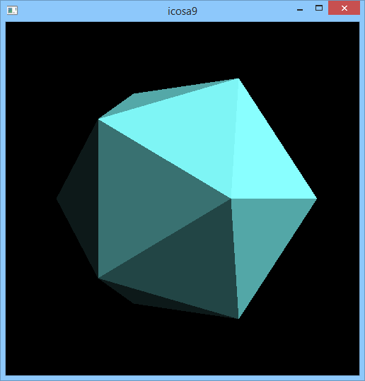
Onda4.cpp: Mostra uma função R² → R desenhando usando modelo de iluminação e quadrados planos (flat). Calcula função em cada quadro. Grad-2013

// Desenha funcao usando quadrados planos
// Chama a funcao a cada quadro
#include <GL/glut.h>
#include <cekeikon.h>

int fps=30;
float duracaoMs=1000.0/fps; //40ms
float duracaoS=1.0/fps; //0.04s
float olho=0;
float olhoM=1;

float lado2=10; // lado dividido por dois. minx, maxx, miny, maxy.
float delta=0.1; // passo
float delta2=delta/2; // passo

void spinDisplay(int value)
{ olho += olhoM;
if (olho>360) olho=olho-360;
glutTimerFunc(round(duracaoMs),spinDisplay,0);
glutPostRedisplay();
}

float f(float x, float y)
{ float r=sqrt(x*x+y*y);
float v=cos(x)*cos(y);
return log(1/(r+1))*v;
}

void solidFunction(void)
{ for (float x=-lado2; x<=lado2+delta2; x+=delta)
for (float y=-lado2; y<=lado2+delta2; y+=delta) {
Vec3f a(x,y,f(x,y));
Vec3f b(x+delta,y,f(x+delta,y));
Vec3f c(x+delta,y+delta,f(x+delta,y+delta));
Vec3f d(x,y+delta,f(x,y+delta));
glBegin(GL_QUADS);
Vec3f n=normalTri(a,b,d);
Vec3f m=normalTri(b,c,d);
n=(n+m)/2;
glNormal3fv(&n[0]);

glVertex3fv(&a[0]);
glVertex3fv(&b[0]);
glVertex3fv(&c[0]);
glVertex3fv(&d[0]);
glEnd();
}
}

void desenha(float red, float gre, float blu)
{ GLfloat mat_ambient[] = { red/2, gre/2, blu/2, 1.0 };
glMaterialfv(GL_FRONT, GL_AMBIENT, mat_ambient);
GLfloat mat_diffuse[] = { red, gre, blu, 1.0 };
glMaterialfv(GL_FRONT, GL_DIFFUSE, mat_diffuse);
GLfloat mat_specular[] = { 0.5, 0.5, 0.5, 1.0 };
glMaterialfv(GL_FRONT, GL_SPECULAR, mat_specular);
GLfloat mat_shininess[] = { 50.0 };
glMaterialfv(GL_FRONT, GL_SHININESS, mat_shininess);
solidFunction();
}

void display(void)
{ glMatrixMode(GL_MODELVIEW);
glLoadIdentity();
gluLookAt(0, 7, 15, 0.0, 0.0, 0.0, 0.0, 1.0, 0.0);
glRotatef(olho,0,1,0);
glRotatef(-90,1,0,0);

glClear(GL_COLOR_BUFFER_BIT|GL_DEPTH_BUFFER_BIT);
glPolygonMode(GL_FRONT, GL_FILL);
desenha(0.3,0.7,0.7);

glutSwapBuffers();
}

void init(void)
{ glClearColor(1.0, 1.0, 1.0, 1.0);
glShadeModel(GL_FLAT);

GLfloat light_position[] = { 5.0, 5.0, 5.0, 0.0 };
glLightfv(GL_LIGHT0, GL_POSITION, light_position);

glEnable(GL_LIGHTING);
glEnable(GL_LIGHT0);
glEnable(GL_DEPTH_TEST);
}

void reshape(int w, int h)
{ glViewport(0, 0, (GLsizei) w, (GLsizei) h);
glMatrixMode(GL_PROJECTION);
glLoadIdentity();
gluPerspective(45.0, (GLfloat) w/(GLfloat) h, 3, 50);
}

void keyboard(unsigned char key, int x, int y)
{ if (key==27) exit(0); }

int main(int argc, char** argv)
{ glutInit(&argc, argv);
glutInitDisplayMode (GLUT_DOUBLE|GLUT_RGB|GLUT_DEPTH);
glutInitWindowSize(640+320, 480+240);
glutInitWindowPosition(0, 0);
glutCreateWindow(argv[0]);
init();
glutDisplayFunc(display);
glutReshapeFunc(reshape);
glutTimerFunc(40,spinDisplay,0);
glutKeyboardFunc(keyboard);
glutMainLoop();
return 0;
}
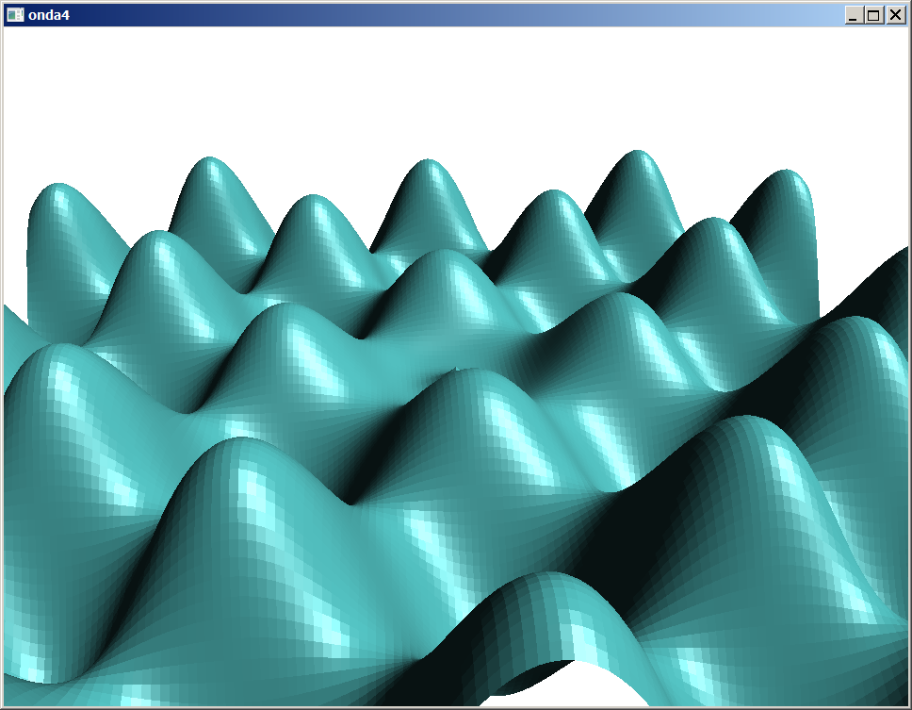
Onda4b.cpp: Cria duas faces para cada quadrado: permite visualizar de cima ou de baixo. Grad-2014

// Desenha funcao usando quadrados planos
// Chama a funcao a cada quadro
#include <GL/glut.h>
#include <cekeikon.h>

int fps=30;
float duracaoMs=1000.0/fps; //40ms
float duracaoS=1.0/fps; //0.04s
float olho=0;
float olhoM=1;

float lado2=10; // lado dividido por dois. minx, maxx, miny, maxy.
float delta=0.1; // passo
float delta2=delta/2; // passo

void spinDisplay(int value)
{ olho += olhoM;
if (olho>360) olho=olho-360;
glutTimerFunc(round(duracaoMs),spinDisplay,0);
glutPostRedisplay();
}

float f(float x, float y)
{ float r=sqrt(x*x+y*y);
float v=cos(x)*cos(y);
return log(1/(r+1))*v;
}

void solidFunction(void)
{ for (float x=-lado2; x<=lado2-delta2; x+=delta)
for (float y=-lado2; y<=lado2-delta2; y+=delta) {
Vec3f a(x,y,f(x,y));
Vec3f b(x+delta,y,f(x+delta,y));
Vec3f c(x+delta,y+delta,f(x+delta,y+delta));
Vec3f d(x,y+delta,f(x,y+delta));
glBegin(GL_QUADS);
Vec3f n=normalTri(a,b,d);
Vec3f m=normalTri(b,c,d);
n=(n+m)/2;
glNormal3fv(n.val);
glVertex3fv(a.val);
glVertex3fv(b.val);
glVertex3fv(c.val);
glVertex3fv(d.val);

n=-n;
Vec3f eps(0,0,-1e-2);
glNormal3fv(n.val);
glVertex3fv((d+eps).val);
glVertex3fv((c+eps).val);
glVertex3fv((b+eps).val);
glVertex3fv((a+eps).val);

glEnd();
}
}

void desenha(float red, float gre, float blu)
{ GLfloat mat_ambient[] = { red/2, gre/2, blu/2, 1.0 };
glMaterialfv(GL_FRONT, GL_AMBIENT, mat_ambient);
GLfloat mat_diffuse[] = { red, gre, blu, 1.0 };
glMaterialfv(GL_FRONT, GL_DIFFUSE, mat_diffuse);
GLfloat mat_specular[] = { 0.5, 0.5, 0.5, 1.0 };
glMaterialfv(GL_FRONT, GL_SPECULAR, mat_specular);
GLfloat mat_shininess[] = { 50.0 };
glMaterialfv(GL_FRONT, GL_SHININESS, mat_shininess);
solidFunction();
}

void display(void)
{ glMatrixMode(GL_MODELVIEW);
glLoadIdentity();
gluLookAt(15, 15, 15, 0.0, 0.0, 0.0, 0.0, 0.0, 1.0);
glRotatef(olho,0,1,0);
//glRotatef(-90,1,0,0);

glClear(GL_COLOR_BUFFER_BIT|GL_DEPTH_BUFFER_BIT);
glPolygonMode(GL_FRONT_AND_BACK, GL_FILL);
desenha(0.3,0.7,0.7);

glutSwapBuffers();
}

void init(void)
{ glClearColor(1.0, 1.0, 1.0, 1.0);
glShadeModel(GL_FLAT);

GLfloat light_position[] = { 5.0, 5.0, 5.0, 1.0 };
glLightfv(GL_LIGHT0, GL_POSITION, light_position);

glEnable(GL_LIGHTING);
glEnable(GL_LIGHT0);
glEnable(GL_DEPTH_TEST);
}

void reshape(int w, int h)
{ glViewport(0, 0, (GLsizei) w, (GLsizei) h);
glMatrixMode(GL_PROJECTION);
glLoadIdentity();
gluPerspective(45.0, (GLfloat) w/(GLfloat) h, 3, 50);
}

void keyboard(unsigned char key, int x, int y)
{ if (key==27) exit(0); }

int main(int argc, char** argv)
{ glutInit(&argc, argv);
glutInitDisplayMode (GLUT_DOUBLE|GLUT_RGB|GLUT_DEPTH);
glutInitWindowSize(640+320, 480+240);
glutInitWindowPosition(0, 0);
glutCreateWindow(argv[0]);
init();
glutDisplayFunc(display);
glutReshapeFunc(reshape);
glutTimerFunc(40,spinDisplay,0);
glutKeyboardFunc(keyboard);
glutMainLoop();
return 0;
}

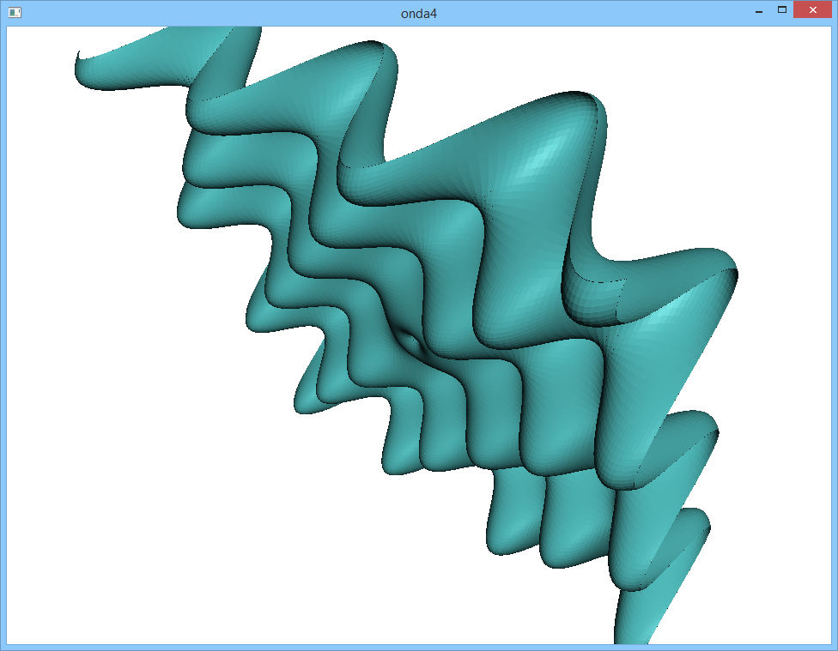

Onda5.cpp: Mostra uma função R² → R desenhando usando modelo de iluminação e quadrados suavizados pelo método de Gouraud (smooth). Pré-calcula a função. Grad-2013.
// Desenha funcao usando suavizacao de Gouraud
// Pre-calcula funcao e vetores normais
#include <GL/glut.h>
#include <cekeikon.h>

int fps=30;
float duracaoMs=1000.0/fps; //40ms
float duracaoS=1.0/fps; //0.04s
float olho=0;
float olhoM=1;

float lado2=10; // lado dividido por dois. minx, maxx, miny, maxy.
float delta=0.1; // passo
float delta2=delta/2; // passo

int n=2*round(lado2/delta)+1;
Mat_<Vec3f> vertices(n+2,n+2,Vec3f(0,0,0));
Mat_<Vec3f> norquad(n+1,n+1,Vec3f(0,0,0));
Mat_<Vec3f> norvert(n,n,Vec3f(0,0,0));

// v v v v
// q q q
// v V V v
// q q q
// v V V v
// q q q
// v v v v

void spinDisplay(int value)
{ olho += olhoM;
if (olho>360) olho=olho-360;
glutTimerFunc(round(duracaoMs),spinDisplay,0);
glutPostRedisplay();
}

float f(float x, float y)
{ float r=sqrt(x*x+y*y);
float v=cos(x)*cos(y);
return log(1/(r+1))*v;
}

void solidFunction(void)
{ for (int xi=0; xi<n-1; xi++)
for (int yi=0; yi<n-1; yi++) {
glBegin(GL_QUADS);
glNormal3fv(&norvert(xi,yi)[0]);
glVertex3fv(&vertices(xi,yi)[0]);
glNormal3fv(&norvert(xi+1,yi)[0]);
glVertex3fv(&vertices(xi+1,yi)[0]);
glNormal3fv(&norvert(xi+1,yi+1)[0]);
glVertex3fv(&vertices(xi+1,yi+1)[0]);
glNormal3fv(&norvert(xi,yi+1)[0]);
glVertex3fv(&vertices(xi,yi+1)[0]);
glEnd();
}
}

// void solidFunction(void)
// { for (float x=-lado2; x<=lado2+delta2; x+=delta)
// for (float y=-lado2; y<=lado2+delta2; y+=delta) {
// Vec3f a(x,y,f(x,y));
// Vec3f b(x+delta,y,f(x+delta,y));
// Vec3f c(x+delta,y+delta,f(x+delta,y+delta));
// Vec3f d(x,y+delta,f(x,y+delta));
// glBegin(GL_QUADS);
// Vec3f n=normalTri(a,b,d);
// Vec3f m=normalTri(b,c,d);
// n=(n+m)/2;
// glNormal3fv(&n[0]);

// glVertex3fv(&a[0]);
// glVertex3fv(&b[0]);
// glVertex3fv(&c[0]);
// glVertex3fv(&d[0]);
// glEnd();
// }
// }

void desenha(float red, float gre, float blu)
{ GLfloat mat_ambient[] = { red/2, gre/2, blu/2, 1.0 };
glMaterialfv(GL_FRONT, GL_AMBIENT, mat_ambient);
GLfloat mat_diffuse[] = { red, gre, blu, 1.0 };
glMaterialfv(GL_FRONT, GL_DIFFUSE, mat_diffuse);
GLfloat mat_specular[] = { 0.5, 0.5, 0.5, 1.0 };
glMaterialfv(GL_FRONT, GL_SPECULAR, mat_specular);
GLfloat mat_shininess[] = { 50.0 };
glMaterialfv(GL_FRONT, GL_SHININESS, mat_shininess);
solidFunction();
}

void display(void)
{ glMatrixMode(GL_MODELVIEW);
glLoadIdentity();
gluLookAt(0, 7, 15, 0.0, 0.0, 0.0, 0.0, 1.0, 0.0);
glRotatef(olho,0,1,0);
glRotatef(-90,1,0,0);

glClear(GL_COLOR_BUFFER_BIT|GL_DEPTH_BUFFER_BIT);
glPolygonMode(GL_FRONT, GL_FILL);
desenha(0.3,0.7,0.7);

glutSwapBuffers();
}

void init(void)
{
// v v v v (n+2)
// q q q (n+1)
// v V V v (n)
// q q q
// v V V v
// q q q
// v v v v

int xi,yi; float x,y;
for (x=-lado2-delta, xi=0; xi<n+2; x+=delta, xi++) {
for (y=-lado2-delta, yi=0; yi<n+2; y+=delta, yi++) {
vertices(xi,yi)=Vec3f(x,y,f(x,y));
}
}

for (xi=0; xi<n; xi++)
for (yi=0; yi<n; yi++) {
Vec3f a=vertices(xi,yi);
Vec3f b=vertices(xi+1,yi);
Vec3f c=vertices(xi+1,yi+1);
Vec3f d=vertices(xi,yi+1);
Vec3f n=normalTri(a,b,d);
Vec3f m=normalTri(b,c,d);
norquad(xi,yi) = 0.5*(n+m);
}

for (xi=0; xi<n; xi++)
for (yi=0; yi<n; yi++)
norvert(xi,yi) = 0.25*( norquad(xi,yi)+norquad(xi+1,yi)+norquad(xi+1,yi+1)+norquad(xi,yi+1) );

glClearColor(1.0, 1.0, 1.0, 1.0);
glShadeModel(GL_SMOOTH);

GLfloat light_position[] = { 5.0, 5.0, 5.0, 0.0 };
glLightfv(GL_LIGHT0, GL_POSITION, light_position);

glEnable(GL_LIGHTING);
glEnable(GL_LIGHT0);
glEnable(GL_DEPTH_TEST);
}

void reshape(int w, int h)
{ glViewport(0, 0, (GLsizei) w, (GLsizei) h);
glMatrixMode(GL_PROJECTION);
glLoadIdentity();
gluPerspective(45.0, (GLfloat) w/(GLfloat) h, 3, 50);
}

void keyboard(unsigned char key, int x, int y)
{ if (key==27) exit(0); }

int main(int argc, char** argv)
{ glutInit(&argc, argv);
glutInitDisplayMode (GLUT_DOUBLE|GLUT_RGB|GLUT_DEPTH);
glutInitWindowSize(640+320, 480+240);
glutInitWindowPosition(0, 0);
glutCreateWindow(argv[0]);
init();
glutDisplayFunc(display);
glutReshapeFunc(reshape);
glutTimerFunc(40,spinDisplay,0);
glutKeyboardFunc(keyboard);
glutMainLoop();
return 0;
}
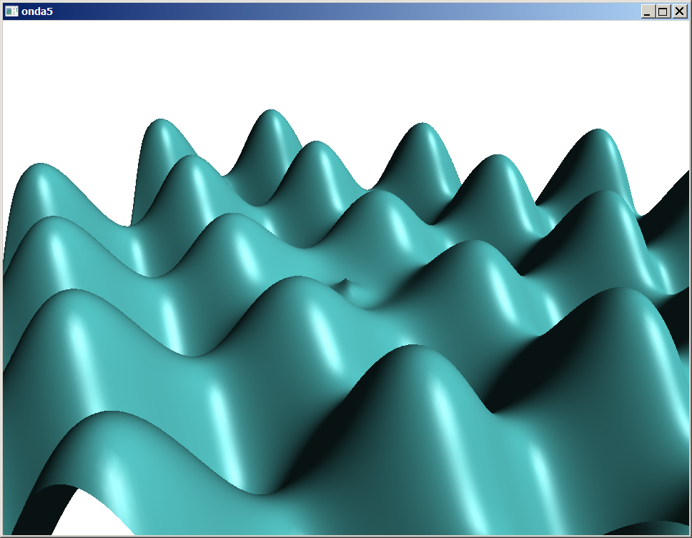
Funcao6.cpp: Os vértices e normais sao precalculados, para acelerar o processamento. Cada retangulo é renderizado como um quadrilatero com modelo de suavizacao de Gouraud. Utiliza OpenCV para obter matriz de vetores. grad-2012.

#include <GL/glut.h>
#include <cstdlib>
#include <cmath>
#include <vector>
#include <cekeikon.h>

int fps=30;
float duracaoMs=1000.0/fps; //40ms
float duracaoS=1.0/fps; //0.04s
float olho=0;
float olhoM=0.1;

float lado2=10; // lado dividido por dois. minx, maxx, miny, maxy.
float delta=0.1; // passo
float delta2=delta/2; // passo
int n=2*round(lado2/delta)+1;

Mat_<Vec3f> vertices(n,n,Vec3f(0,0,0));
Mat_<Vec3f> norquad(n-1,n-1,Vec3f(0,0,0));
Mat_<Vec3f> norvert(n,n,Vec3f(0,0,0));

void spinDisplay(int value)
{
olho += olhoM;
if (olho>360) olho=olho-360;
glutTimerFunc(round(duracaoMs),spinDisplay,0);
glutPostRedisplay();
}

// float f(float x, float y)
// { float r=sqrt(x*x+y*y);
// return 10*sin(r)/(r+1);
// }

float f(float x, float y)
{ float r=sqrt(3*x*x+y*y);
return 14*cos(1.2*r)/(r+3);
}

Vec3f normal(Vec3f a, Vec3f b, Vec3f c)
{ Vec3f d1=b-a;
Vec3f d2=c-a;
Vec3f d=versor(produtoVet(d1,d2));
return d;
}

void solidFunction(void)
{ for (int xi=0; xi<n-1; xi++)
for (int yi=0; yi<n-1; yi++) {
glBegin(GL_QUADS);
glNormal3fv(&norvert(xi,yi)[0]);
glVertex3fv(&vertices(xi,yi)[0]);

glNormal3fv(&norvert(xi+1,yi)[0]);
glVertex3fv(&vertices(xi+1,yi)[0]);

glNormal3fv(&norvert(xi+1,yi+1)[0]);
glVertex3fv(&vertices(xi+1,yi+1)[0]);

glNormal3fv(&norvert(xi,yi+1)[0]);
glVertex3fv(&vertices(xi,yi+1)[0]);
glEnd();
}
}

void wireFunction(void)
{ glutSolidSphere(1,30,24); }

void desenha(void (&fig)(void), float red, float gre, float blu)
{
GLfloat mat_ambient[] = { red/2, gre/2, blu/2, 1.0 };
glMaterialfv(GL_FRONT, GL_AMBIENT, mat_ambient);
GLfloat mat_diffuse[] = { red, gre, blu, 1.0 };
glMaterialfv(GL_FRONT, GL_DIFFUSE, mat_diffuse);
GLfloat mat_specular[] = { 0.3, 0.3, 0.3, 1.0 };
glMaterialfv(GL_FRONT, GL_SPECULAR, mat_specular);
GLfloat mat_shininess[] = { 10.0 };
glMaterialfv(GL_FRONT, GL_SHININESS, mat_shininess);
fig();
}

void display(void)
{ glMatrixMode(GL_MODELVIEW);
glLoadIdentity();
gluLookAt(0, 7, 15, 0.0, 0.0, 0.0, 0.0, 1.0, 0.0);
glRotatef(olho,0,1,0);
glRotatef(-90,1,0,0);

glClear(GL_COLOR_BUFFER_BIT|GL_DEPTH_BUFFER_BIT);
glPolygonMode(GL_FRONT, GL_FILL);
desenha(solidFunction,1,0.6,0.6);

glutSwapBuffers();
}

void init(void)
{
// IMG_<Vec3f> pvertices(vertices,0,0);
// IMG_<Vec3f> pnorquad(norquad,0,0);
// IMG_<Vec3f> pnorvert(norvert,0,0);

int xi,yi; float x,y;
for (x=-lado2, xi=0; xi<n; x+=delta, xi++) {
for (y=-lado2, yi=0; yi<n; y+=delta, yi++) {
vertices(xi,yi)=Vec3f(x,y,f(x,y));
}
}

for (xi=0; xi<n-1; xi++)
for (yi=0; yi<n-1; yi++) {
Vec3f a=vertices(xi,yi);
Vec3f b=vertices(xi+1,yi);
Vec3f c=vertices(xi+1,yi+1);
Vec3f d=vertices(xi,yi+1);
Vec3f n=normal(a,b,d);
Vec3f m=normal(b,c,d);
n = 0.5 * (n+m);
norquad(xi,yi)=n;
}

// v v v v
// q q q
// v v v v
// q q q
// v v v v

for (xi=1; xi<n-1; xi++)
for (yi=1; yi<n-1; yi++)
norvert(xi,yi) = 0.25*( norquad(xi-1,yi-1)+norquad(xi,yi-1)+norquad(xi,yi)+norquad(xi-1,yi) );

for (xi=1; xi<n-1; xi++) {
norvert(xi,0) = 0.5*( norquad(xi-1,0)+norquad(xi,0) );
norvert(xi,n-1) = 0.5*( norquad(xi-1,n-2)+norquad(xi,n-2) );
}

for (yi=1; yi<n-1; yi++) {
norvert(0,yi) = 0.5*( norquad(0,yi-1)+norquad(0,yi) );
norvert(n-1,yi) = 0.5*( norquad(n-2,yi-1)+norquad(n-2,yi) );
}

norvert(0,0) = norquad(0,0);
norvert(n-1,0) = norquad(n-2,0);
norvert(n-1,n-1) = norquad(n-2,n-2);
norvert(0,n-1) = norquad(0,n-2);

glClearColor(1.0, 1.0, 1.0, 1.0);
glShadeModel(GL_SMOOTH);

GLfloat light_position[] = { 5.0, 5.0, 5.0, 0.0 };
glLightfv(GL_LIGHT0, GL_POSITION, light_position);

glEnable(GL_LIGHTING);
glEnable(GL_LIGHT0);
glEnable(GL_DEPTH_TEST);
}

void reshape(int w, int h)
{ glViewport(0, 0, (GLsizei) w, (GLsizei) h);
glMatrixMode(GL_PROJECTION);
glLoadIdentity();
gluPerspective(45.0, (GLfloat) w/(GLfloat) h, 3, 50);
}

void keyboard(unsigned char key, int x, int y)
{ if (key==27) exit(0); }

int main(int argc, char** argv)
{ glutInit(&argc, argv);
glutInitDisplayMode (GLUT_DOUBLE|GLUT_RGB|GLUT_DEPTH);
glutInitWindowSize(640+320, 480+240);
glutInitWindowPosition(0, 0);
glutCreateWindow(argv[0]);
init();
glutDisplayFunc(display);
glutReshapeFunc(reshape);
glutTimerFunc(40,spinDisplay,0);
glutKeyboardFunc(keyboard);
glutMainLoop();
glutMainLoop();
return 0;
}

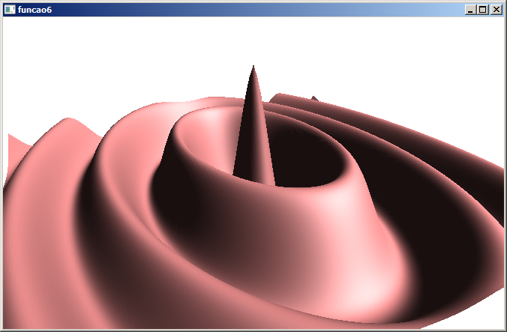

Filtro1.cpp: Filtro passa-baixa com 3 pólos. grad-2015.

#include <GL/glut.h>
#include <cstdlib>
#include <cmath>
#include <vector>
#include <cekeikon.h>

int fps=30;
float duracaoMs=1000.0/fps; //40ms
//float duracaoS=1.0/fps; //0.04s
float olho=0;
float olhoM=0.5;

float lado2=4; // lado dividido por dois. minx, maxx, miny, maxy.
float delta=0.1; // passo
float delta2=delta/2; // passo
int n=2*round(lado2/delta)+1;

Mat_<Vec3f> vertices(n,n,Vec3f(0,0,0));
Mat_<Vec3f> norquad(n-1,n-1,Vec3f(0,0,0));
Mat_<Vec3f> norvert(n,n,Vec3f(0,0,0));

void spinDisplay(int value)
{
olho += olhoM;
if (olho>360) olho=olho-360;
glutTimerFunc(round(duracaoMs),spinDisplay,0);
glutPostRedisplay();
}

float f(float x, float y) {
CPX s(x,y);
CPX h = CPX(1,0) /
( ( s-CPX(-1,0) ) *
( s-CPX(-sqrt(2)/2,-sqrt(2)/2) ) *
( s-CPX(-sqrt(2)/2,+sqrt(2)/2) )
);
return abs(h);
}

// float f(float x, float y)
// { float r=sqrt(x*x+y*y);
// return 10*sin(r)/(r+1);
// }

// float f(float x, float y)
// { float r=sqrt(3*x*x+y*y);
// return 14*cos(1.2*r)/(r+3);
// }

Vec3f normal(Vec3f a, Vec3f b, Vec3f c)
{ Vec3f d1=b-a;
Vec3f d2=c-a;
Vec3f d=versor(produtoVet(d1,d2));
return d;
}

void solidFunction(void)
{ for (int xi=0; xi<n-1; xi++)
for (int yi=0; yi<n-1; yi++) {
glBegin(GL_QUADS);
glNormal3fv(&norvert(xi,yi)[0]);
glVertex3fv(&vertices(xi,yi)[0]);

glNormal3fv(&norvert(xi+1,yi)[0]);
glVertex3fv(&vertices(xi+1,yi)[0]);

glNormal3fv(&norvert(xi+1,yi+1)[0]);
glVertex3fv(&vertices(xi+1,yi+1)[0]);

glNormal3fv(&norvert(xi,yi+1)[0]);
glVertex3fv(&vertices(xi,yi+1)[0]);
glEnd();
}
}

void wireFunction(void)
{ glutSolidSphere(1,30,24); }

void desenha(void (&fig)(void), float red, float gre, float blu)
{
GLfloat mat_ambient[] = { red/2, gre/2, blu/2, 1.0 };
glMaterialfv(GL_FRONT, GL_AMBIENT, mat_ambient);
GLfloat mat_diffuse[] = { red, gre, blu, 1.0 };
glMaterialfv(GL_FRONT, GL_DIFFUSE, mat_diffuse);
GLfloat mat_specular[] = { 0.3, 0.3, 0.3, 1.0 };
glMaterialfv(GL_FRONT, GL_SPECULAR, mat_specular);
GLfloat mat_shininess[] = { 10.0 };
glMaterialfv(GL_FRONT, GL_SHININESS, mat_shininess);
fig();
}

void display(void)
{ glMatrixMode(GL_MODELVIEW);
glLoadIdentity();
gluLookAt(0, 7, 15, 0.0, 0.0, 0.0, 0.0, 1.0, 0.0);
glRotatef(olho,0,1,0);
glRotatef(-90,1,0,0);

glClear(GL_COLOR_BUFFER_BIT|GL_DEPTH_BUFFER_BIT);
glPolygonMode(GL_FRONT, GL_FILL);
desenha(solidFunction,1,0.6,0.6);

glutSwapBuffers();
}

void init(void)
{
// IMG_<Vec3f> pvertices(vertices,0,0);
// IMG_<Vec3f> pnorquad(norquad,0,0);
// IMG_<Vec3f> pnorvert(norvert,0,0);

int xi,yi; float x,y;
for (x=-lado2, xi=0; xi<n; x+=delta, xi++) {
for (y=-lado2, yi=0; yi<n; y+=delta, yi++) {
vertices(xi,yi)=Vec3f(x,y,f(x,y));
}
}

for (xi=0; xi<n-1; xi++)
for (yi=0; yi<n-1; yi++) {
Vec3f a=vertices(xi,yi);
Vec3f b=vertices(xi+1,yi);
Vec3f c=vertices(xi+1,yi+1);
Vec3f d=vertices(xi,yi+1);
Vec3f n=normal(a,b,d);
Vec3f m=normal(b,c,d);
n = 0.5 * (n+m);
norquad(xi,yi)=n;
}

// v v v v
// q q q
// v v v v
// q q q
// v v v v

for (xi=1; xi<n-1; xi++)
for (yi=1; yi<n-1; yi++)
norvert(xi,yi) = 0.25*( norquad(xi-1,yi-1)+norquad(xi,yi-1)+norquad(xi,yi)+norquad(xi-1,yi) );

for (xi=1; xi<n-1; xi++) {
norvert(xi,0) = 0.5*( norquad(xi-1,0)+norquad(xi,0) );
norvert(xi,n-1) = 0.5*( norquad(xi-1,n-2)+norquad(xi,n-2) );
}

for (yi=1; yi<n-1; yi++) {
norvert(0,yi) = 0.5*( norquad(0,yi-1)+norquad(0,yi) );
norvert(n-1,yi) = 0.5*( norquad(n-2,yi-1)+norquad(n-2,yi) );
}

norvert(0,0) = norquad(0,0);
norvert(n-1,0) = norquad(n-2,0);
norvert(n-1,n-1) = norquad(n-2,n-2);
norvert(0,n-1) = norquad(0,n-2);

glClearColor(1.0, 1.0, 1.0, 1.0);
glShadeModel(GL_SMOOTH);

GLfloat light_position[] = { 5.0, 5.0, 5.0, 0.0 };
glLightfv(GL_LIGHT0, GL_POSITION, light_position);

glEnable(GL_LIGHTING);
glEnable(GL_LIGHT0);
glEnable(GL_DEPTH_TEST);
}

void reshape(int w, int h)
{ glViewport(0, 0, (GLsizei) w, (GLsizei) h);
glMatrixMode(GL_PROJECTION);
glLoadIdentity();
gluPerspective(30.0, (GLfloat) w/(GLfloat) h, 3, 50);
}

void keyboard(unsigned char key, int x, int y)
{ if (key==27) exit(0); }

int main(int argc, char** argv)
{ glutInit(&argc, argv);
glutInitDisplayMode (GLUT_DOUBLE|GLUT_RGB|GLUT_DEPTH);
glutInitWindowSize(640+320, 480+240);
glutInitWindowPosition(0, 0);
glutCreateWindow(argv[0]);
init();
glutDisplayFunc(display);
glutReshapeFunc(reshape);
glutTimerFunc(40,spinDisplay,0);
glutKeyboardFunc(keyboard);
glutMainLoop();
glutMainLoop();
return 0;
}

