Capítulo 3: Visualização

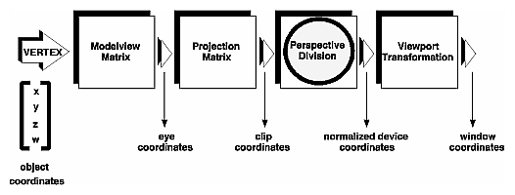

$$\underset{\text{Modelview}}{\underbrace{\underset{\text{Projection}}{\underbrace{\left[\begin{matrix}a & b & c & d \\ e & & & \\ i & & & \\ m & & & \end{matrix}\right]}}×\left[\begin{matrix}A & B & C & D \\ E & & & \\ I & & & \\ M & & & \end{matrix}\right]}}×\left[\begin{matrix}x_{0} & x_{1} & ⋯ & & & & & x_{n−1} \\ y_{0} & y_{1} & ⋯ & & & & & y_{n−1} \\ z_{0} & z_{1} & ⋯ & & & & & z_{n−1} \\ w_{0} & w_{1} & ⋯ & & & & & w_{n−1}\end{matrix}\right]$$
modelview and projection -> clip coordinate

object coordinate and eye coordinate
clip coordinate and perspective division

window coordinate

cube.cpp

#include <GL/glut.h>
#include <stdlib.h>

void init(void)
{ glClearColor (0.0, 0.0, 0.0, 0.0);
glShadeModel (GL_FLAT);
}

void display(void)
{ glClear (GL_COLOR_BUFFER_BIT);
glColor3f (1.0, 1.0, 1.0);
glLoadIdentity ();
gluLookAt (0.0, 0.0, 5.0, 0.0, 0.0, 0.0, 0.0, 1.0, 0.0);
glScalef (1.0, 2.0, 1.0);
glutWireCube (1.0);
glFlush ();
}

void reshape (int w, int h)
{ glViewport (0, 0, (GLsizei) w, (GLsizei) h);
glMatrixMode (GL_PROJECTION);
glLoadIdentity ();
glFrustum (-1.0, 1.0, -1.0, 1.0, 1.5, 20.0);
// Ha uma funcao mais intuitiva para a mesma finalidade.
// Veja o proximo programa
glMatrixMode (GL_MODELVIEW);
}

void keyboard(unsigned char key, int x, int y)
{ switch (key) {
case 27:
exit(0);
break;
}
}

int main(int argc, char** argv)
{ glutInit(&argc, argv);
glutInitDisplayMode (GLUT_SINGLE | GLUT_RGB);
glutInitWindowSize (500, 500);
glutInitWindowPosition (100, 100);
glutCreateWindow (argv[0]);
init ();
glutDisplayFunc(display);
glutReshapeFunc(reshape);
glutKeyboardFunc(keyboard);
glutMainLoop();
return 0;
}

bule1.cpp

Alterações em relação ao cube.cpp:
- Eliminação de mudança de escala.
- Cubo foi substituído pelo bule.
- glFrustum foi substituído pelo gluPerspective (mais fácil de entender).
- A posição do observador foi alterada.

//bule1.cpp grad2013
#include <GL/glut.h>

void init(void)
{ glClearColor (1.0, 1.0, 1.0, 0.0);
glShadeModel (GL_FLAT);
}

void display(void)
{ glClear (GL_COLOR_BUFFER_BIT);
glColor3f (0.0, 0.0, 1.0);
glLoadIdentity (); /* clear the matrix */
gluLookAt (0.0, 3.0, 5.0, 0.0, 0.0, 0.0, 0.0, 1.0, 0.0);
glutWireTeapot(1.0);
glFlush ();
}

void reshape (int w, int h)
{ glViewport (0, 0, (GLsizei) w, (GLsizei) h);
glMatrixMode (GL_PROJECTION);
glLoadIdentity (); //Pode ser desnecessario. Nao tenho certeza.
//glFrustum (-1.0, 1.0, -1.0, 1.0, 1.5, 20.0);
gluPerspective(35.0, (GLfloat) w/(GLfloat) h, 1.5, 20.0);
glMatrixMode (GL_MODELVIEW);
}

int main(int argc, char** argv)
{ glutInit(&argc, argv);
glutInitDisplayMode (GLUT_SINGLE | GLUT_RGB);
glutInitWindowSize (500, 500);
glutInitWindowPosition (100, 100);
glutCreateWindow (argv[0]);
init ();
glutDisplayFunc(display);
glutReshapeFunc(reshape);
glutMainLoop();
return 0;
}
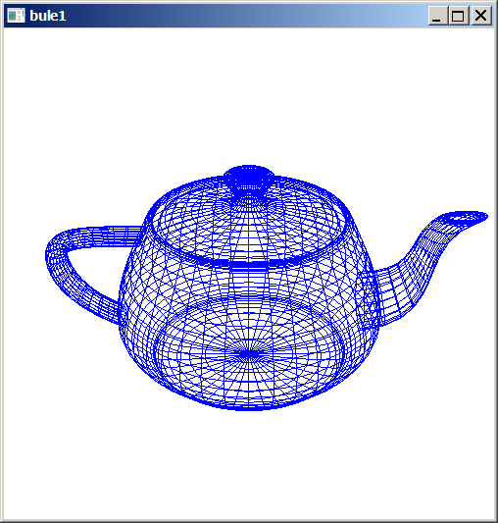

//bule1b.cpp grad2015 - roda bule
#include <GL/glut.h>

void init(void)
{ glClearColor (1.0, 1.0, 1.0, 0.0);
glShadeModel (GL_FLAT);
glMatrixMode (GL_MODELVIEW);
glLoadIdentity (); /* clear the matrix */
gluLookAt (0.0, 3.0, 5.0, 0.0, 0.0, 0.0, 0.0, 1.0, 0.0);
}

void display(void)
{ glClear (GL_COLOR_BUFFER_BIT);
glColor3f (1.0, 0.0, 0.0);

glRotatef(1, 0.0, 1.0, 0.0);

glutWireTeapot(1.0);
glutSwapBuffers ();
Sleep(5);
}

void idle(void)
{ glutPostRedisplay();
}

void reshape (int w, int h)
{ glViewport (0, 0, (GLsizei) w, (GLsizei) h);
glMatrixMode (GL_PROJECTION);
glLoadIdentity (); // Pode ser que seja desnecessario
//glFrustum (-1.0, 1.0, -1.0, 1.0, 1.5, 20.0);
gluPerspective(35.0, (GLfloat) w/(GLfloat) h, 1.5, 20.0);

glMatrixMode (GL_MODELVIEW);
}

int main(int argc, char** argv)
{ glutInit(&argc, argv);
glutInitDisplayMode (GLUT_DOUBLE | GLUT_RGB);
glutInitWindowSize (500, 500);
glutInitWindowPosition (100, 100);
glutCreateWindow (argv[0]);
init ();
glutDisplayFunc(display);
glutReshapeFunc(reshape);
glutIdleFunc(idle);
glutMainLoop();
return 0;
}

bule3.cpp
Alterações: Eliminação de arestas escondidas.

#include <stdlib.h>
#include <GL/glut.h>

void init(void)
{ glClearColor (1.0, 1.0, 1.0, 0.0);
glShadeModel (GL_FLAT);
}

void display(void)
{ glClear (GL_COLOR_BUFFER_BIT | GL_DEPTH_BUFFER_BIT);
// desenha wireframe de preto
glEnable(GL_DEPTH_TEST);
glPolygonMode(GL_FRONT_AND_BACK, GL_LINE);
glColor3f (0.0, 0.0, 0.0);
glutSolidTeapot(1.0);
// Funciona tambem com glutWireTeapot(1.0);
glPolygonMode(GL_FRONT_AND_BACK, GL_FILL);
glEnable(GL_POLYGON_OFFSET_FILL);
// empurra objeto solido para tras
glPolygonOffset(1.0, 1.0);
glColor3f (0.0, 1.0, 1.0);
glutSolidTeapot(1.0);
glDisable(GL_POLYGON_OFFSET_FILL);
glFlush();
}

void reshape (int w, int h)
{ glViewport (0, 0, (GLsizei) w, (GLsizei) h);
glMatrixMode (GL_PROJECTION);
glLoadIdentity ();
gluPerspective(30.0, (GLfloat) w/(GLfloat) h, 1.5, 20.0);
glMatrixMode (GL_MODELVIEW);
glLoadIdentity (); /* clear the matrix */
gluLookAt (3.0, 4.0, 5.0, 0.0, 0.0, 0.0, 0.0, 1.0, 0.0);
}

int main(int argc, char** argv)
{ glutInit(&argc, argv);
glutInitDisplayMode (GLUT_SINGLE | GLUT_RGB | GLUT_DEPTH);
glutInitWindowSize (500, 500);
glutInitWindowPosition (100, 100);
glutCreateWindow(argv[0]);
init();
glutDisplayFunc(display);
glutReshapeFunc(reshape);
glutMainLoop();
return 0;
}
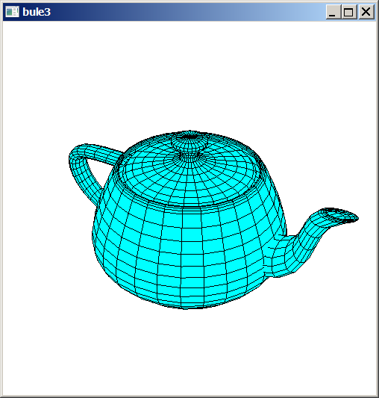
bule4.cpp: Rotaciona bule em torno de z com teclas ‘s’ e ‘d’

#include <stdlib.h>
#include <GL/glut.h>

float angulo=0;

void init(void)
{ glClearColor (1.0, 1.0, 1.0, 0.0);
glShadeModel (GL_FLAT);
}

void display(void)
{ glClear (GL_COLOR_BUFFER_BIT);
glColor3f (0.0, 0.0, 0.0); // Desenha wireframe de preto

glPushMatrix(); // Salva a matriz Modelview na pilha
glRotatef(angulo, 0.0, 1.0, 0.0);
// Rotaciona o bule, estragando a transformacao
glutWireTeapot(1.0); // Desenha o bule
glPopMatrix(); // Restaura a matriz Modelview antes da rotacao
glutSwapBuffers(); // Mostra na tela
}

void reshape (int w, int h)
{ glViewport(0, 0, (GLsizei) w, (GLsizei) h);
glMatrixMode(GL_PROJECTION);
glLoadIdentity();
gluPerspective(27.0, (GLfloat) w/(GLfloat) h, 1.5, 20.0);
glMatrixMode(GL_MODELVIEW);
glLoadIdentity();
gluLookAt(3.0, 4.0, 5.0, 0.0, 0.0, 0.0, 0.0, 1.0, 0.0);
}

void keyboard(unsigned char key, int x, int y)
{ if (key==27) {
exit(0);
} else if (key=='s') {
angulo=angulo-1;
if (angulo<0) angulo+=360;
glutPostRedisplay();
} else if (key=='d') {
angulo=angulo+1;
if (angulo>360) angulo-=360;
glutPostRedisplay();
}
}

int main(int argc, char** argv)
{ glutInit(&argc, argv);
glutInitDisplayMode (GLUT_DOUBLE | GLUT_RGB);
glutInitWindowSize (500, 500);
glutInitWindowPosition (100, 100);
glutCreateWindow(argv[0]);
init();
glutDisplayFunc(display);
glutReshapeFunc(reshape);
glutKeyboardFunc(keyboard);
glutMainLoop();
return 0;
}
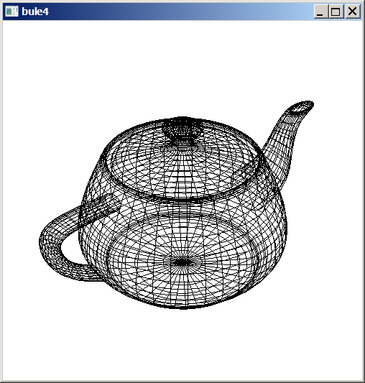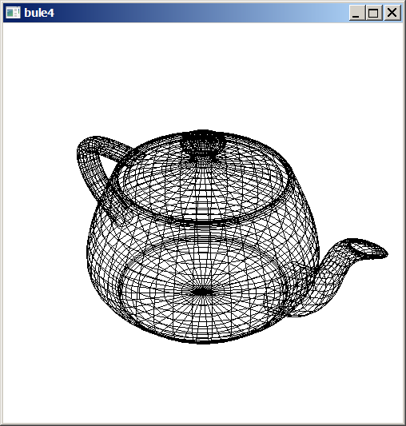

//bule5: Rotaciona bule com ‘s’ e ‘d’, eliminando linhas escondidas.
#include <stdlib.h>
#include <GL/glut.h>

float angulo=0;

void init(void)
{ glClearColor (1.0, 1.0, 1.0, 0.0);
glShadeModel (GL_FLAT);
}

void display(void)
{ glClear (GL_COLOR_BUFFER_BIT | GL_DEPTH_BUFFER_BIT);
glColor3f (0.0, 0.0, 0.0); // Desenha wireframe de preto

glPushMatrix(); // Salva a transformacao atual na pilha
glRotatef(angulo, 0.0, 1.0, 0.0); // Rotaciona o bule, estragando a transformacao
glEnable(GL_DEPTH_TEST);
glPolygonMode(GL_FRONT_AND_BACK, GL_LINE);
glutSolidTeapot(1.0);
glPolygonMode(GL_FRONT_AND_BACK, GL_FILL);
glEnable(GL_POLYGON_OFFSET_FILL);
glPolygonOffset(1.0, 1.0); // empurra objeto solido para tras
glColor3f(0.0, 1.0, 1.0);
glutSolidTeapot(1.0);
glDisable(GL_POLYGON_OFFSET_FILL);
glPopMatrix(); // Restaura a transformacao antes da rotacao

glutSwapBuffers(); // Mostra na tela
}

void reshape (int w, int h)
{ glViewport(0, 0, (GLsizei) w, (GLsizei) h);
glMatrixMode(GL_PROJECTION);
glLoadIdentity();
gluPerspective(27.0, (GLfloat) w/(GLfloat) h, 1.5, 20.0);
glMatrixMode(GL_MODELVIEW);
glLoadIdentity();
gluLookAt(3.0, 4.0, 5.0, 0.0, 0.0, 0.0, 0.0, 1.0, 0.0);
}

void keyboard(unsigned char key, int x, int y)
{ if (key==27) {
exit(0);
} else if (key=='s') {
angulo=angulo-0.5;
if (angulo<0) angulo+=360;
glutPostRedisplay();
} else if (key=='d') {
angulo=angulo+0.5;
if (angulo>360) angulo-=360;
glutPostRedisplay();
}
}

int main(int argc, char** argv)
{ glutInit(&argc, argv);
glutInitDisplayMode (GLUT_DOUBLE | GLUT_RGB | GLUT_DEPTH);
glutInitWindowSize (500, 500);
glutInitWindowPosition (100, 100);
glutCreateWindow(argv[0]);
init();
glutDisplayFunc(display);
glutReshapeFunc(reshape);
glutKeyboardFunc(keyboard);
glutMainLoop();
return 0;
}

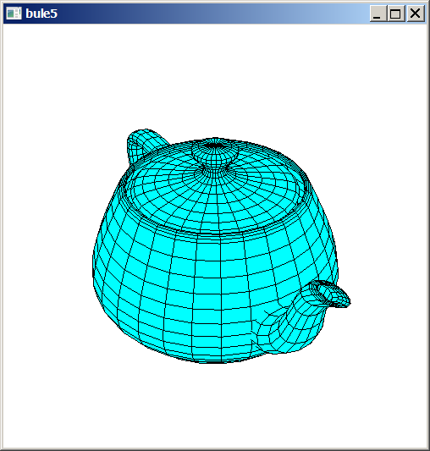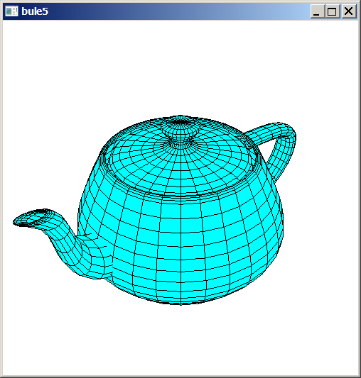

//bule6.cpp: Rotaciona continuamente bule em torno de y
#include <stdlib.h>
#include <GL/glut.h>

float angulo=0;

void init(void)
{ glClearColor (1.0, 1.0, 1.0, 0.0);
glShadeModel (GL_FLAT);
}

void display(void)
{ glClear (GL_COLOR_BUFFER_BIT | GL_DEPTH_BUFFER_BIT);
glColor3f (0.0, 0.0, 0.0); // Desenha wireframe de preto

glPushMatrix(); // Salva a transformacao atual na pilha
glRotatef(angulo, 0.0, 1.0, 0.0); // Rotaciona o bule, estragando a transformacao
glEnable(GL_DEPTH_TEST);
glPolygonMode(GL_FRONT_AND_BACK, GL_LINE);
glutSolidTeapot(1.0);
glPolygonMode(GL_FRONT_AND_BACK, GL_FILL);
glEnable(GL_POLYGON_OFFSET_FILL);
glPolygonOffset(1.0, 1.0); // empurra objeto solido para tras
glColor3f(0.0, 1.0, 1.0);
glutSolidTeapot(1.0);
glDisable(GL_POLYGON_OFFSET_FILL);

glPopMatrix(); // Restaura a transformacao antes da rotacao
glutSwapBuffers(); // Mostra na tela
}

void reshape (int w, int h)
{ glViewport(0, 0, (GLsizei) w, (GLsizei) h);
glMatrixMode(GL_PROJECTION);
glLoadIdentity();
gluPerspective(27.0, (GLfloat) w/(GLfloat) h, 1.5, 20.0);
glMatrixMode(GL_MODELVIEW);
glLoadIdentity();
gluLookAt(3.0, 4.0, 5.0, 0.0, 0.0, 0.0, 0.0, 1.0, 0.0);
}

void spinDisplay(int value)
{ angulo = angulo + 1;
if (angulo > 360.0) angulo = angulo - 360.0;
glutTimerFunc(16,spinDisplay,0);
glutPostRedisplay();
}

int main(int argc, char** argv)
{ glutInit(&argc, argv);
glutInitDisplayMode (GLUT_DOUBLE | GLUT_RGB | GLUT_DEPTH);
glutInitWindowSize (500, 500);
glutInitWindowPosition (100, 100);
glutCreateWindow(argv[0]);
init();
glutDisplayFunc(display);
glutReshapeFunc(reshape);
glutTimerFunc(0,spinDisplay,0);
glutMainLoop();
return 0;
}
planet.cpp: Ilustra rotação em torno de diferentes eixos. Teclas ‘d’, ‘D’, ‘y’, ‘Y’.

#include <GL/glut.h>
#include <stdlib.h>

static int year = 0, day = 0;

void init(void)
{
glClearColor (0.0, 0.0, 0.0, 0.0);
glShadeModel (GL_FLAT);
}

void display(void)
{
glClear (GL_COLOR_BUFFER_BIT);
glColor3f (1.0, 1.0, 1.0);

glPushMatrix();
glutWireSphere(1.0, 20, 16); /* draw sun */
glRotatef ((GLfloat) year, 0.0, 1.0, 0.0);
glTranslatef (2.0, 0.0, 0.0);
glRotatef ((GLfloat) day, 0.0, 1.0, 0.0);
glutWireSphere(0.2, 10, 8); /* draw smaller planet */
glPopMatrix();
glutSwapBuffers();
}

void reshape (int w, int h)
{
glViewport (0, 0, (GLsizei) w, (GLsizei) h);
glMatrixMode (GL_PROJECTION);
glLoadIdentity ();
gluPerspective(60.0, (GLfloat) w/(GLfloat) h, 1.0, 20.0);
glMatrixMode(GL_MODELVIEW);
glLoadIdentity();
gluLookAt (0.0, 0.0, 5.0, 0.0, 0.0, 0.0, 0.0, 1.0, 0.0);
}

void keyboard (unsigned char key, int x, int y)
{
switch (key) {
case 'd':
day = (day + 10) % 360;
glutPostRedisplay();
break;
case 'D':
day = (day - 10) % 360;
glutPostRedisplay();
break;
case 'y':
year = (year + 5) % 360;
glutPostRedisplay();
break;
case 'Y':
year = (year - 5) % 360;
glutPostRedisplay();
break;
case 27:
exit(0);
break;
default:
break;
}
}

int main(int argc, char** argv)
{
glutInit(&argc, argv);
glutInitDisplayMode (GLUT_DOUBLE | GLUT_RGB);
glutInitWindowSize (500, 500);
glutInitWindowPosition (100, 100);
glutCreateWindow (argv[0]);
init ();
glutDisplayFunc(display);
glutReshapeFunc(reshape);
glutKeyboardFunc(keyboard);
glutMainLoop();
return 0;
}

planet3.cpp: Ilustra rotação em torno de diferentes eixos. Pilha de matrizes.
Teclas: s S d D y Y

// planet3.cpp
#include <GL/glut.h>
#include <stdlib.h>

static int year = 0, day = 0, sun=0;

void init(void)
{ glClearColor (1.0, 1.0, 1.0, 0.0);
glShadeModel (GL_FLAT);
}

void desenha(void)
{ glPushMatrix();
glRotatef ((GLfloat) sun, 0.0, 1.0, 0.0); // transformacao do Sol
glutSolidTeapot(1.0); // draw sun - com transformacao Sun
glPopMatrix();

glPushMatrix();
glRotatef((GLfloat) year, 0.0, 1.0, 0.0); // 3a transformacao
glTranslatef (2.0, 0.0, 0.0); // 2a transformacao
glRotatef ((GLfloat) day, 0.0, 1.0, 0.0); // 1a transformacao
glutSolidTeapot(0.2); // draw smaller planet - com transformacoes
glPopMatrix();
}

void display(void)
{ glClear (GL_COLOR_BUFFER_BIT | GL_DEPTH_BUFFER_BIT);

// desenha wireframe de preto
glEnable(GL_DEPTH_TEST);
glPolygonMode(GL_FRONT_AND_BACK, GL_LINE);
glColor3f(0.0, 0.0, 0.0);
desenha();

glPolygonMode(GL_FRONT_AND_BACK, GL_FILL);
glEnable(GL_POLYGON_OFFSET_FILL);
// empurra objeto solido para tras
glPolygonOffset(1.0, 1.0);
glColor3f (0.4, 0.7, 0.7);
desenha();
glDisable(GL_POLYGON_OFFSET_FILL);

glutSwapBuffers();
}

void reshape (int w, int h)
{ glViewport(0, 0, (GLsizei) w, (GLsizei) h);
glMatrixMode(GL_PROJECTION);
glLoadIdentity();
gluPerspective(60.0, (GLfloat) w/(GLfloat) h, 1.0, 20.0);
glMatrixMode(GL_MODELVIEW);
glLoadIdentity();
gluLookAt(2.0, 2.0, 4.0, 0.0, 0.0, 0.0, 0.0, 1.0, 0.0);
}

void keyboard (unsigned char key, int x, int y)
{ switch (key) {
case 'd':
day = (day + 10) % 360;
glutPostRedisplay();
break;
case 'D':
day = (day - 10) % 360;
glutPostRedisplay();
break;
case 'y':
year = (year + 5) % 360;
glutPostRedisplay();
break;
case 'Y':
year = (year - 5) % 360;
glutPostRedisplay();
break;
case 's':
sun = (sun + 5) % 360;
glutPostRedisplay();
break;
case 'S':
sun = (sun - 5) % 360;
glutPostRedisplay();
break;
case 27:
exit(0);
break;
}
}

int main(int argc, char** argv)
{ glutInit(&argc, argv);
glutInitDisplayMode(GLUT_DOUBLE | GLUT_RGB | GLUT_DEPTH);
glutInitWindowSize(500, 500);
glutInitWindowPosition(100, 100);
glutCreateWindow(argv[0]);
init();
glutDisplayFunc(display);
glutReshapeFunc(reshape);
glutKeyboardFunc(keyboard);
glutMainLoop();
return 0;
}

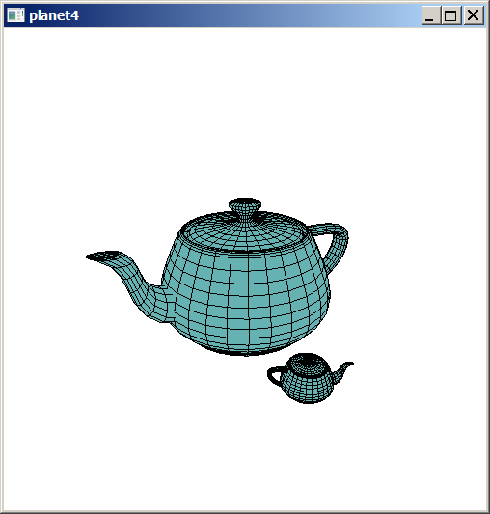

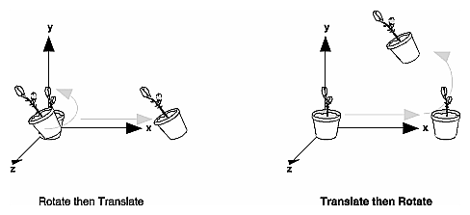

void glTranslate{fd}(TYPEx, TYPE y, TYPEz);
void glRotate{fd}(TYPE angle, TYPE x, TYPE y, TYPE z);
Ex: glRotatef(45.0, 0.0, 0.0, 1.0)
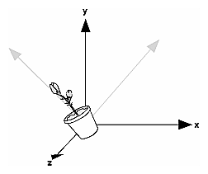
void glScale{fd}(TYPEx, TYPE y, TYPEz);
Ex: glScalef(2.0, -0.5, 1.0).
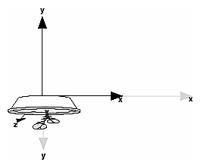
gluLookat (0.0, 0.0, 0.0, 0.0, 0.0, -100.0, 0.0, 1.0, 0.0);
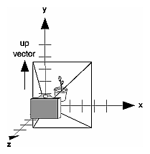
gluLookAt(4.0, 2.0, 1.0, 2.0, 4.0, -3.0, 2.0, 2.0, -1.0);
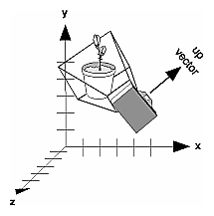

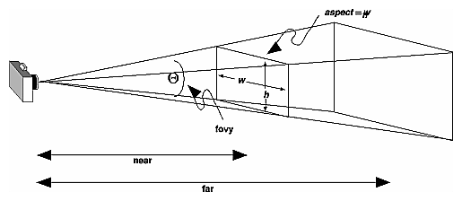
void gluPerspective(GLdouble fovy, GLdouble aspect, GLdouble near, GLdouble far);

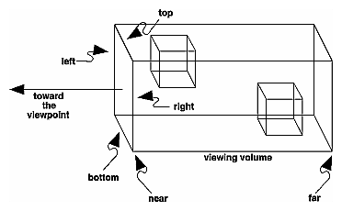
void glOrtho(GLdouble left, GLdouble right, GLdouble bottom,
GLdouble top, GLdouble near, GLdouble far);

By default the viewport is set to the entire pixel rectangle of the window that's opened. You use the glViewport() command to choose a smaller drawing region; for example, you can subdivide the window to create a split-screen effect for multiple views in the same window.
void glViewport(GLint x, GLint y, GLsizei width, GLsizei height);
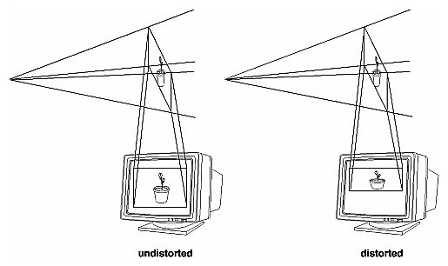
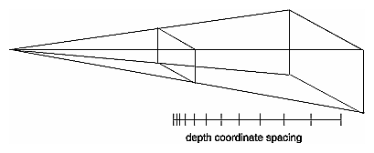

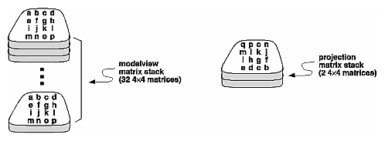
Além das duas pilhas, há duas matrizes “atuais”. Não parece ser verdade que as matrizes atuais estão no topo da pilha.
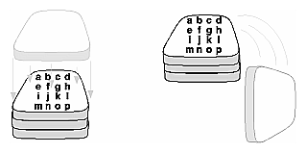
push e pop

Draws an automobile, assuming the existence of routines that draw the car body, a wheel, and a bolt.
draw_wheel_and_bolts()
{
long i;

draw_wheel();
for(i=0;i<5;i++){
glPushMatrix();
glRotatef(72.0*i,0.0,0.0,1.0);
glTranslatef(3.0,0.0,0.0);
draw_bolt();
glPopMatrix();
}
}

draw_body_and_wheel_and_bolts()
{
draw_car_body();
glPushMatrix();
glTranslatef(40,0,30); /*move to first wheel position*/
draw_wheel_and_bolts();
glPopMatrix();
glPushMatrix();
glTranslatef(40,0,-30); /*move to 2nd wheel position*/
draw_wheel_and_bolts();
glPopMatrix();
... /*draw last two wheels similarly*/
}

//Robot.cpp:
#include <GL/glut.h>
#include <stdlib.h>

static int shoulder = 0, elbow = 0;

void init(void)
{
glClearColor (0.0, 0.0, 0.0, 0.0);
glShadeModel (GL_FLAT);
}

void display(void)
{
glClear (GL_COLOR_BUFFER_BIT);
glPushMatrix();
glTranslatef (-1.0, 0.0, 0.0);
glRotatef ((GLfloat) shoulder, 0.0, 0.0, 1.0);
glTranslatef (1.0, 0.0, 0.0);
glPushMatrix();
glScalef (2.0, 0.4, 1.0);
glutWireCube (1.0);
glPopMatrix();

glTranslatef (1.0, 0.0, 0.0);
glRotatef ((GLfloat) elbow, 0.0, 0.0, 1.0);
glTranslatef (1.0, 0.0, 0.0);
glPushMatrix();
glScalef (2.0, 0.4, 1.0);
glutWireCube (1.0);
glPopMatrix();

glPopMatrix();
glutSwapBuffers();
}

void reshape (int w, int h)
{
glViewport (0, 0, (GLsizei) w, (GLsizei) h);
glMatrixMode (GL_PROJECTION);
glLoadIdentity ();
gluPerspective(65.0, (GLfloat) w/(GLfloat) h, 1.0, 20.0);
glMatrixMode(GL_MODELVIEW);
glLoadIdentity();
glTranslatef (0.0, 0.0, -5.0);
}

void keyboard (unsigned char key, int x, int y)
{
switch (key) {
case 's':
shoulder = (shoulder + 5) % 360;
glutPostRedisplay();
break;
case 'S':
shoulder = (shoulder - 5) % 360;
glutPostRedisplay();
break;
case 'e':
elbow = (elbow + 5) % 360;
glutPostRedisplay();
break;
case 'E':
elbow = (elbow - 5) % 360;
glutPostRedisplay();
break;
case 27:
exit(0);
break;
default:
break;
}
}

int main(int argc, char** argv)
{
glutInit(&argc, argv);
glutInitDisplayMode (GLUT_DOUBLE | GLUT_RGB);
glutInitWindowSize (500, 500);
glutInitWindowPosition (100, 100);
glutCreateWindow (argv[0]);
init ();
glutDisplayFunc(display);
glutReshapeFunc(reshape);
glutKeyboardFunc(keyboard);
glutMainLoop();
return 0;
}
Additional Clipping Planes
In addition to the six clipping planes of the viewing, you can define up to six additional clipping planes to further restrict the viewing volume. This is useful for removing extraneous objects in a scene.
Each plane is specified by the coefficients of its equation: Ax+By+Cz+D = 0. The clipping planes are automatically transformed appropriately by modeling and viewing transformations.
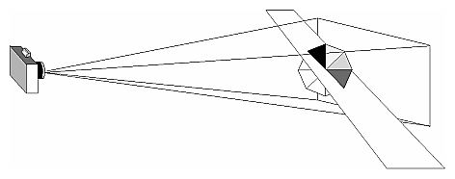
void glClipPlane(GLenum plane, const GLdouble *equation);
You need to enable each additional clipping plane you define:
glEnable(GL_CLIP_PLANEi);
You can disable a plane with
glDisable(GL_CLIP_PLANEi);
All implementations of OpenGL must support at least six additional clipping planes.
Note: Clipping performed as a result of glClipPlane() is done in eye coordinates, not in clip coordinates.

//clip.cpp
#include <GL/glut.h>
#include <stdlib.h>

void init(void)
{ glClearColor (0.0, 0.0, 0.0, 0.0);
glShadeModel (GL_FLAT);
}

void display(void)
{ GLdouble eqn[4] = {0.0, 1.0, 0.0, 0.0};
GLdouble eqn2[4] = {1.0, 0.0, 0.0, 0.0};
glClear(GL_COLOR_BUFFER_BIT);

glColor3f (1.0, 1.0, 1.0);
glPushMatrix();
glTranslatef (0.0, 0.0, -5.0);

// clip lower half -- y < 0
glClipPlane (GL_CLIP_PLANE0, eqn);
glEnable (GL_CLIP_PLANE0);
// clip left half -- x < 0
glClipPlane (GL_CLIP_PLANE1, eqn2);
glEnable (GL_CLIP_PLANE1);

glRotatef (90.0, 1.0, 0.0, 0.0);
glutWireSphere(1.0, 20, 16);
glPopMatrix();

glFlush ();
}

void reshape (int w, int h)
{ glViewport (0, 0, (GLsizei) w, (GLsizei) h);
glMatrixMode (GL_PROJECTION);
glLoadIdentity ();
gluPerspective(60.0, (GLfloat) w/(GLfloat) h, 1.0, 20.0);
glMatrixMode (GL_MODELVIEW);
}

void keyboard(unsigned char key, int x, int y)
{ if (key==27) exit(0);
}

int main(int argc, char** argv)
{ glutInit(&argc, argv);
glutInitDisplayMode (GLUT_SINGLE | GLUT_RGB);
glutInitWindowSize (500, 500);
glutInitWindowPosition (100, 100);
glutCreateWindow (argv[0]);
init ();
glutDisplayFunc(display);
glutReshapeFunc(reshape);
glutKeyboardFunc(keyboard);
glutMainLoop();
return 0;
}

//clip2.cpp - fica mais facil de entender.
#include <GL/glut.h>
#include <stdlib.h>

void init(void)
{ glClearColor (0.0, 0.0, 0.0, 0.0);
glShadeModel (GL_FLAT);
}

void display(void)
{ GLdouble eqn[4] = {0.0, 1.0, 0.0, 0.0};
GLdouble eqn2[4] = {1.0, 0.0, 0.0, 0.0};
glClear(GL_COLOR_BUFFER_BIT);

glColor3f (1.0, 1.0, 1.0);
glPushMatrix();

// clip lower half -- y < 0
glClipPlane (GL_CLIP_PLANE0, eqn);
glEnable (GL_CLIP_PLANE0);
// clip left half -- x < 0
//glClipPlane (GL_CLIP_PLANE1, eqn2);
//glEnable (GL_CLIP_PLANE1);

glutWireSphere(1.0, 20, 16);
glPopMatrix();

glFlush ();
}

void reshape (int w, int h)
{ glViewport (0, 0, (GLsizei) w, (GLsizei) h);
glMatrixMode (GL_PROJECTION);
glLoadIdentity ();
gluPerspective(30.0, (GLfloat) w/(GLfloat) h, 1.0, 20.0);
glMatrixMode (GL_MODELVIEW);
glLoadIdentity ();
gluLookAt(0,3,3, 0,0,0, 0,1,0);
}

void keyboard(unsigned char key, int x, int y)
{ if (key==27) exit(0);
}

int main(int argc, char** argv)
{ glutInit(&argc, argv);
glutInitDisplayMode (GLUT_SINGLE | GLUT_RGB);
glutInitWindowSize (500, 500);
glutInitWindowPosition (100, 100);
glutCreateWindow (argv[0]);
init ();
glutDisplayFunc(display);
glutReshapeFunc(reshape);
glutKeyboardFunc(keyboard);
glutMainLoop();
return 0;
}
clip3.cpp:

//clip3.cpp - com eliminacao de aresta escondida
#include <GL/glut.h>
#include <stdlib.h>

void init(void)
{ glClearColor (1.0, 1.0, 1.0, 0.0);
glShadeModel (GL_FLAT);
}

void display(void)
{ GLdouble eqn[4] = {0.0, 1.0, 0.0, 0.0};
GLdouble eqn2[4] = {1.0, 0.0, 0.0, 0.0};
glClear(GL_COLOR_BUFFER_BIT|GL_DEPTH_BUFFER_BIT);

glColor3f (1.0, 1.0, 1.0);
glPushMatrix();

// clip lower half -- y < 0 */
glClipPlane (GL_CLIP_PLANE0, eqn);
glEnable (GL_CLIP_PLANE0);
// clip left half -- x < 0 */
glClipPlane (GL_CLIP_PLANE1, eqn2);
glEnable (GL_CLIP_PLANE1);

glEnable(GL_DEPTH_TEST);
glPolygonMode(GL_FRONT_AND_BACK, GL_LINE);
glColor3f(0.0, 0.0, 0.0);
glutSolidSphere(1.0,30,24);

glPolygonMode(GL_FRONT_AND_BACK, GL_FILL);
glEnable(GL_POLYGON_OFFSET_FILL);
// empurra objeto solido para tras
glPolygonOffset(1.0, 1.0);
glColor3f (0.3, 0.6, 0.6);
glutSolidSphere(1.0,30,24);
glDisable(GL_POLYGON_OFFSET_FILL);

glPopMatrix();
glFlush ();
}

void reshape (int w, int h)
{ glViewport (0, 0, (GLsizei) w, (GLsizei) h);
glMatrixMode (GL_PROJECTION);
glLoadIdentity ();
gluPerspective(30.0, (GLfloat) w/(GLfloat) h, 1.0, 20.0);
glMatrixMode (GL_MODELVIEW);
glLoadIdentity ();
gluLookAt(0,3,3, 0,0,0, 0,1,0);
}

void keyboard(unsigned char key, int x, int y)
{ if (key==27) exit(0);
}

int main(int argc, char** argv)
{ glutInit(&argc, argv);
glutInitDisplayMode (GLUT_SINGLE | GLUT_RGB | GLUT_DEPTH);
glutInitWindowSize (500, 500);
glutInitWindowPosition (100, 100);
glutCreateWindow (argv[0]);
init ();
glutDisplayFunc(display);
glutReshapeFunc(reshape);
glutKeyboardFunc(keyboard);
glutMainLoop();
return 0;
}
