Filtros nebulosos:

Escrever bibliografia

// Aumenta contraste - pós 2007
#include <proeikon>

//FFN black(-1,0,0,1);
FFN white(0,1,1,2);

void wop(IMGGRY &ent, IMGGRY &sai)
{ ent.backg()=0;
IMGFLT entf=ent;
IMGFLT saif(ent.nl(),ent.nc()); saif.backg()=0;

for (int l=0; l<ent.nl(); ++l)
for (int c=0; c<ent.nc(); ++c) {
OUTVAR y; y.v=0;
fifelse( entf(l,c)==white, 1, y, 1.3, -0.3 );
saif(l,c)=y.v;
}

sai=saif;
}

int main(int argc, char **argv)
{ if (argc!=3) erro("Contras ent.tga sai.tga\n");

IMGGRY ent;
le(ent,argv[1]);

IMGGRY sai;
wop(ent,sai);

imp(sai,argv[2]);
}

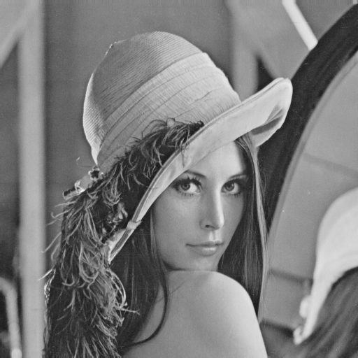 | 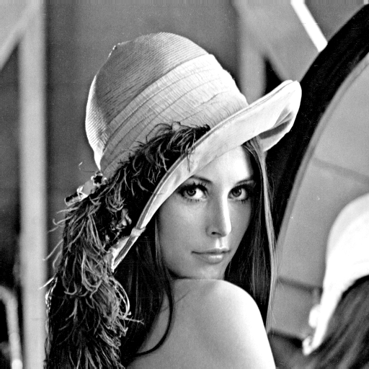

Se o pixel for branco, deixe-o mais branco;
Se o pixel for preto, deixe-o mais preto;
// Pinta rato de branco, urso de preto e resto de cinza - pós 2007
// Baseado somente na cor do pixel
#include <proeikon>

double v=0.439;
double d=0.015;

FFN rato(v-2*d,v-d,v+d,v+2*d);

double v2=0.282;
FFN urso(v2-2*d,v2-d,v2+d,v2+2*d);

IMGGRY wop(IMGGRY ent)
{ IMGFLT entf=ent; entf.backg()=0.0;
IMGFLT saif(ent.nl(),ent.nc()); saif.backg()=0.0;

for (int l=0; l<ent.nl(); ++l)
for (int c=0; c<ent.nc(); ++c) {
OUTVAR y; y.v=0;
fifelse( entf(l,c)==rato, 1, y, 1.0, 0.5 );
fifelse( entf(l,c)==urso, 1, y, 0.0, 0.5 );
saif(l,c)=y.v;
}

IMGGRY sai=saif;
return sai;
}

int main(int argc, char **argv)
{ if (argc!=3) erro("112 ent.tga sai.tga\n");

IMGGRY ent;
le(ent,argv[1]);

IMGGRY sai=wop(ent);

imp(normaliza(sai),argv[2]);
}

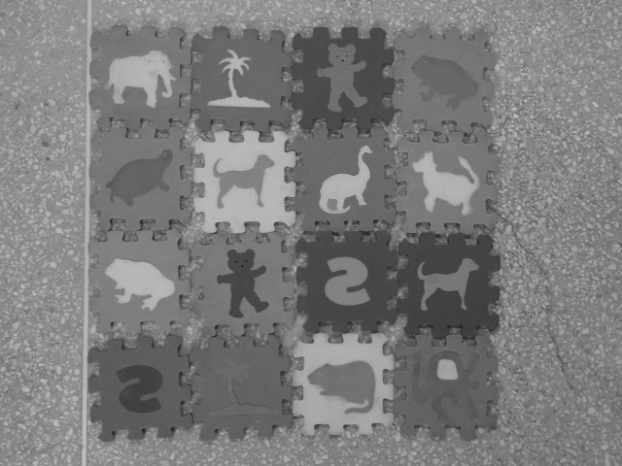 | 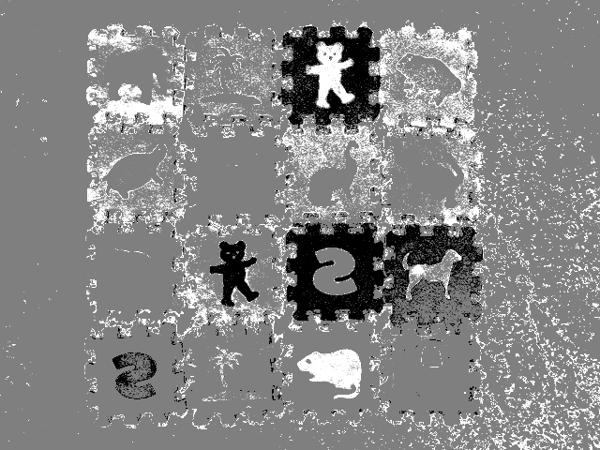

// Find edge nebuloso - pós 2007
#include <proeikon>

FFN black(-1,0,0,1);
FFN white(0,1,1,2);

void wop(IMGGRY &ent, IMGGRY &sai)
{ ent.backg()=0;
IMGFLT entf=ent;
IMGFLT saif(ent.nl(),ent.nc()); saif.backg()=0;

for (int l=0; l<ent.nl(); ++l)
for (int c=0; c<ent.nc(); ++c) {

OUTVAR y;
double d=fabs(entf(l,c)-entf(l,c+1, 'x'))+
fabs(entf(l,c)-entf(l+1,c, 'x'))+
fabs(entf(l,c)-entf(l+1,c+1, 'x'));
fif( d==black, 1, y, 1.14 );
fif( d==white, 5.1, y, -0.14 );

saif(l,c)=y.v;
}

sai=saif;
}

int main(int argc, char **argv)
{ if (argc!=3) erro("FE ent.tga sai.tga\n");

IMGGRY ent;
le(ent,argv[1]);

IMGGRY sai;
wop(ent,sai);

imp(sai,argv[2]);
}

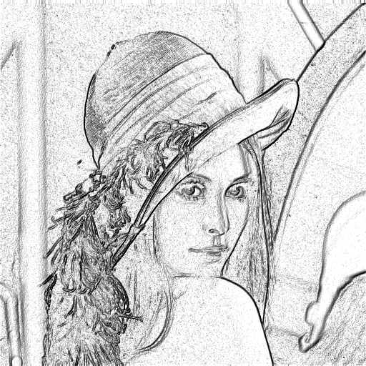

// Detecta arestas
void wop(IMGGRY &ent, IMGGRY &sai)
{ ent.backg()=0;
IMGFLT entf=ent;
IMGFLT saif(ent.nl(),ent.nc()); saif.backg()=0;

for (int l=0; l<ent.nl(); ++l)
for (int c=0; c<ent.nc(); ++c) {
OUTVAR y; y.v=0;

double d=abs(entf(l,c)-entf(l,c+1, 'x'))+
abs(entf(l,c)-entf(l+1,c, 'x'))+
abs(entf(l,c)-entf(l+1,c+1, 'x'));

fif( d==grande, 1, y, 0 );
fif( d==pequeno, 1, y, 1 );
saif(l,c)=y.v;
}

sai=normaliza(saif);
}

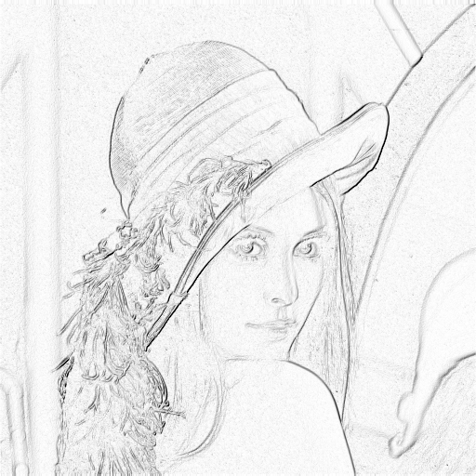
Filtro de estatística de ordem com peso

A mediana do vetor $\left\{a_{1},\text{.}\text{.}\text{.},a_{n}\right\}$ de é o elemento que ficaria no meio do vetor se esse vetor fosse ordenado.

A mediana minimiza o erro absoluto. Seja $\hat{a}=\text{mediana}\left\{a_{1},\text{.}\text{.}\text{.},a_{n}\right\}$. Então:
$$\hat{a}=\underset{x}{\text{argmin}}\left[\sum_{i=1}^{n}{|x−a_{i}|}\right]$$

É possível construir filtro mediana com peso. Considere os pesos muito usados em filtros lineares::

$$\frac{1}{9}×\begin{matrix}1 & 1 & 1 \\ 1 & −8 & 1 \\ 1 & 1 & 1\end{matrix}$$  Highpass spatial filter | $$\frac{1}{\text{10}}×\begin{matrix}−1 & −1 & −1 \\ −1 & \text{18} & −1 \\ −1 & −1 & −1\end{matrix}$$  Enfatiza arestas
$\begin{matrix}1 & 0 \\ 0 & −1\end{matrix}$ $\begin{matrix}0 & 1 \\ −1 & 0\end{matrix}$  Gradiente de Roberts | $\begin{matrix}−1 & −1 & −1 \\ 0 & 0 & 0 \\ 1 & 1 & 1\end{matrix}$ $\begin{matrix}−1 & 0 & 1 \\ −1 & 0 & 1 \\ −1 & 0 & 1\end{matrix}$  Gradiente de Prewitt
$\begin{matrix}−1 & −2 & −1 \\ 0 & 0 & 0 \\ 1 & 2 & 1\end{matrix}$ $\begin{matrix}−1 & 0 & 1 \\ −2 & 0 & 2 \\ −1 & 0 & 1\end{matrix}$  Gradiente de Sobel | $$\begin{matrix}0 & −1 & 0 \\ −1 & 4 & −1 \\ 0 & −1 & 0\end{matrix}$$  Laplace 3×3
$$\begin{matrix}0 & 1 & 0 \\ 1 & 4 & 1 \\ 0 & 1 & 0\end{matrix}$$ | $$\begin{matrix}1 & 1 & 1 \\ 1 & 1 & 1 \\ 1 & 1 & 1\end{matrix}$$

Todos eles podem ter um equivalente “weighted median”. Basta minimizar:
$$\hat{a}=\underset{x}{\text{argmin}}\left[\sum_{i=1}^{n}{w_{i}|x−a_{i}|}\right]$$
onde w_{i} e a_{i} são respectivamente o peso e o valor do pixel i dentro da janela.

Exemplo.

Falta falar:

Alpha-trimmed means
Sigma filter
Wiener filter
SUSAN

